|  |  |
| --- | --- |
| Sl No | **Users** |
| 1 | Super Admin |
| 2 | Admin |
| 3 | Change Analyst |
| 4 | Approver |
| 5 | Support Engineer |

1. **Super Admin: -** is the one who has the access and who can control and give the permission/access to all other users.
2. **Admin: -** Admin is the one can share the access with others.
3. **Change Analyst: -** is capable of initiating and Closing a Change Request.
4. **Approver: -** is authorized solely to approve the various levels.
5. **Support Engineer: -** is responsible for implementing a specified number of tasks and Follow ups for the assigned CR.

Search:

The CR can be searched based on the Plant ID, category, classification, priority, start date, end date, Status and based on the RFC no of the CR

**Login Page**

**Steps to be followed:**

**1.** Login with your Unnati Portal Credential.

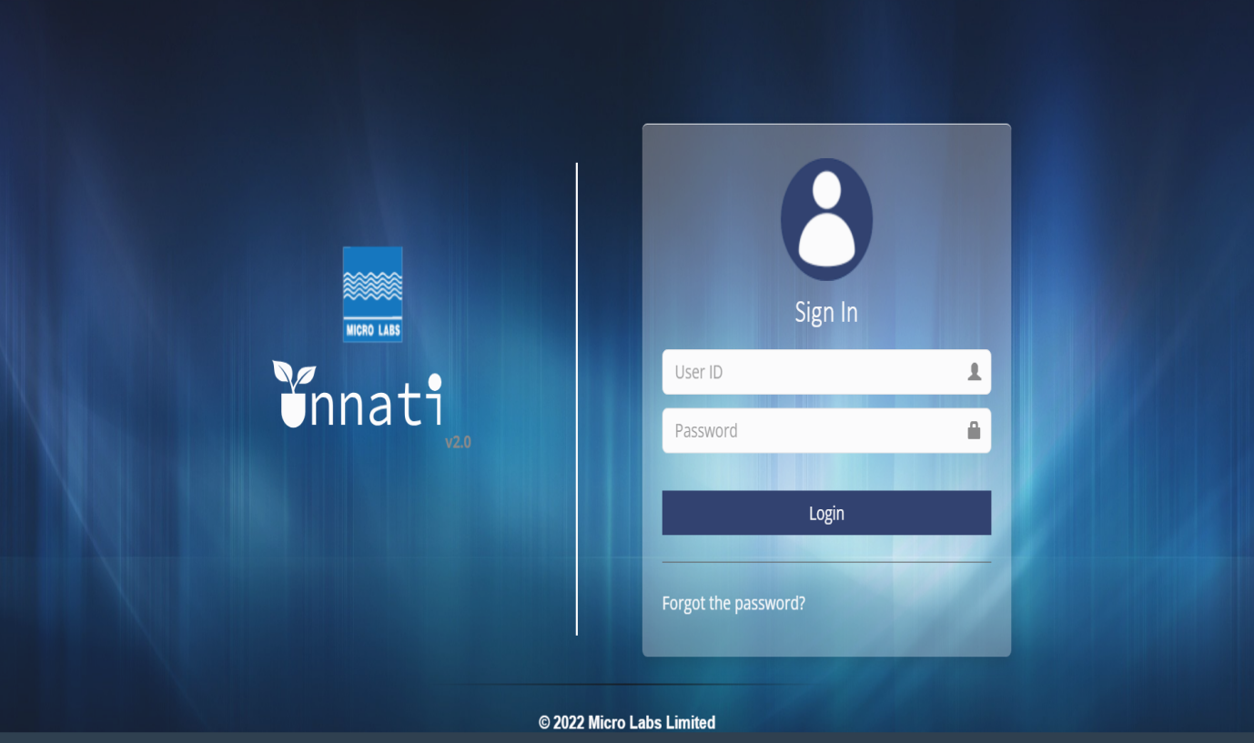

2.Login as an Analyst to Create a Change request(CR).

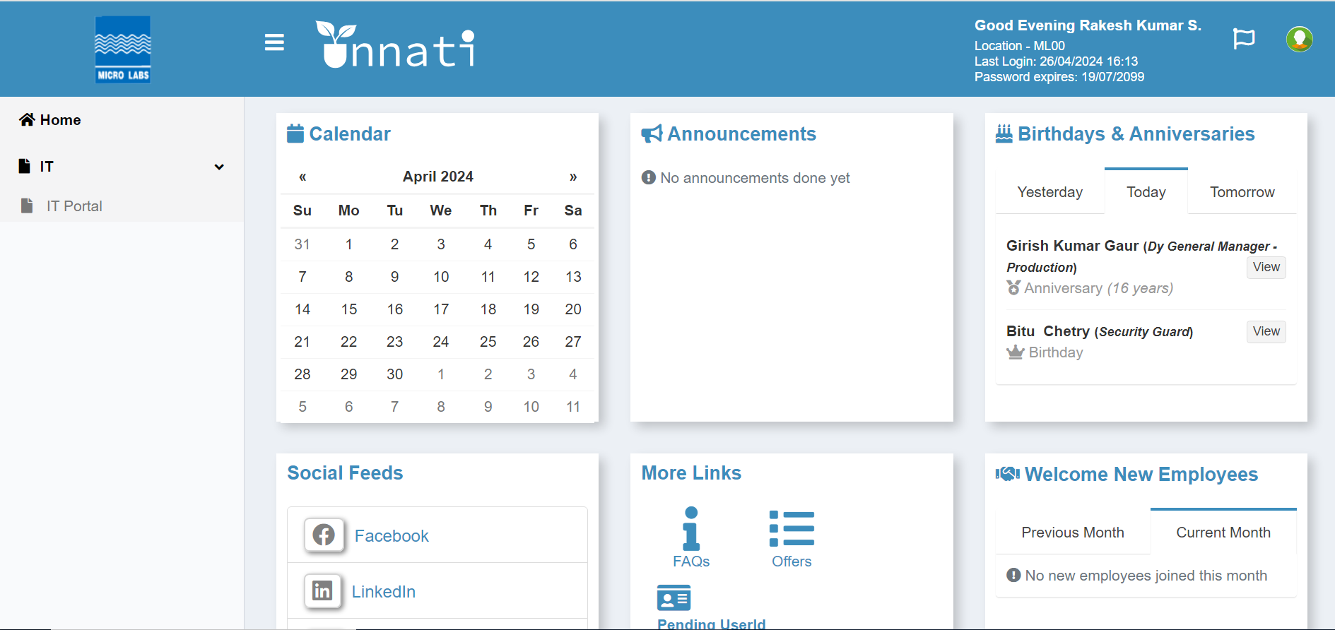

3. From the drop-down menu, select IT and then IT Portal.

4. Click the IT Portal Button.

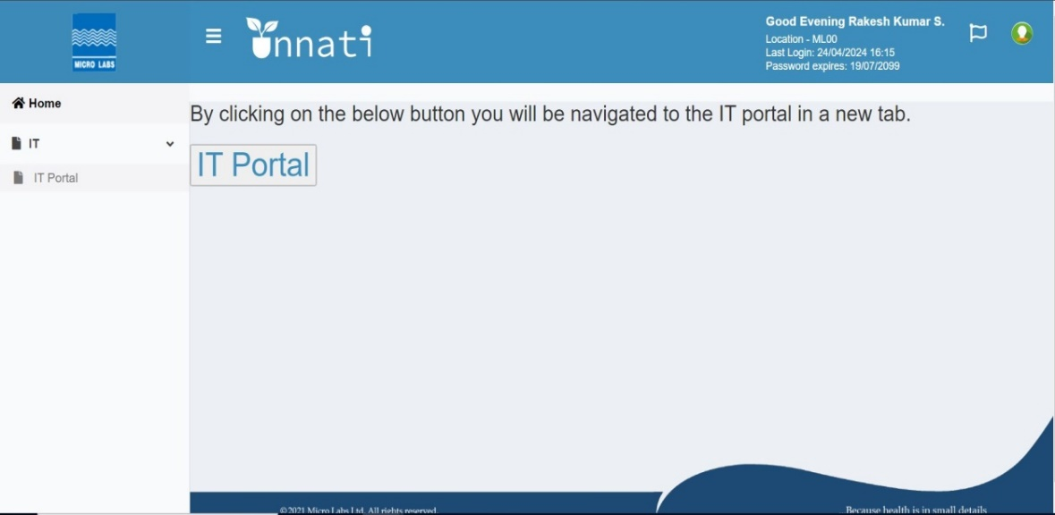

When you click on the IT portal button, the Dashboard will appear. Click to create a new CR, and the Dashboard will remain the same for all users.

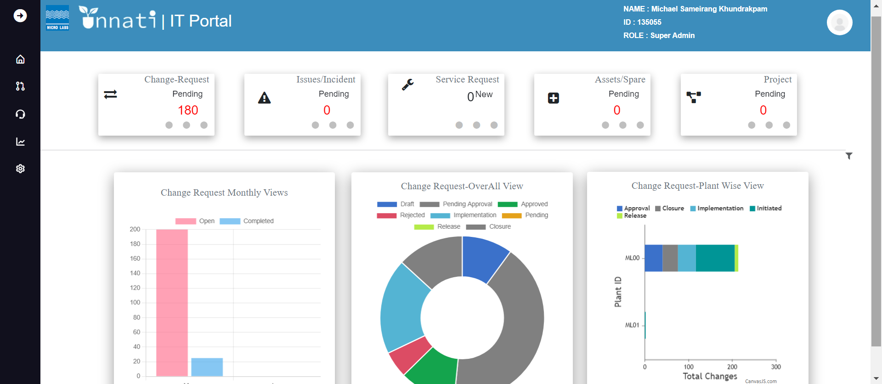

Then click the button (Change New Request) to make a new request.

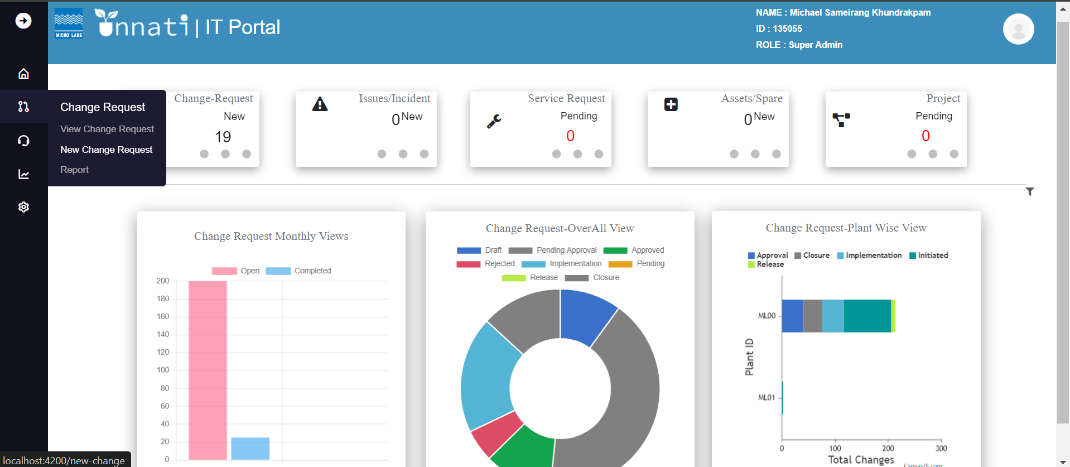

When you click on new change request, you will be taken to a form that asks for the required information.

(Change owner's name, initiator's name, RFC date, plant, reference, reference type, classifications, category, sub-category, nature of change, and priority.) - Change requested by - Change requested on - Change triggered by).

Note: * Star symbol indicates the mandatory fields.  
Note: If the Initiator and Change Owner names are the same, choose the checkbox.   
Note: In the form of CR, you will see various dropdowns; select each one based on your requirements.

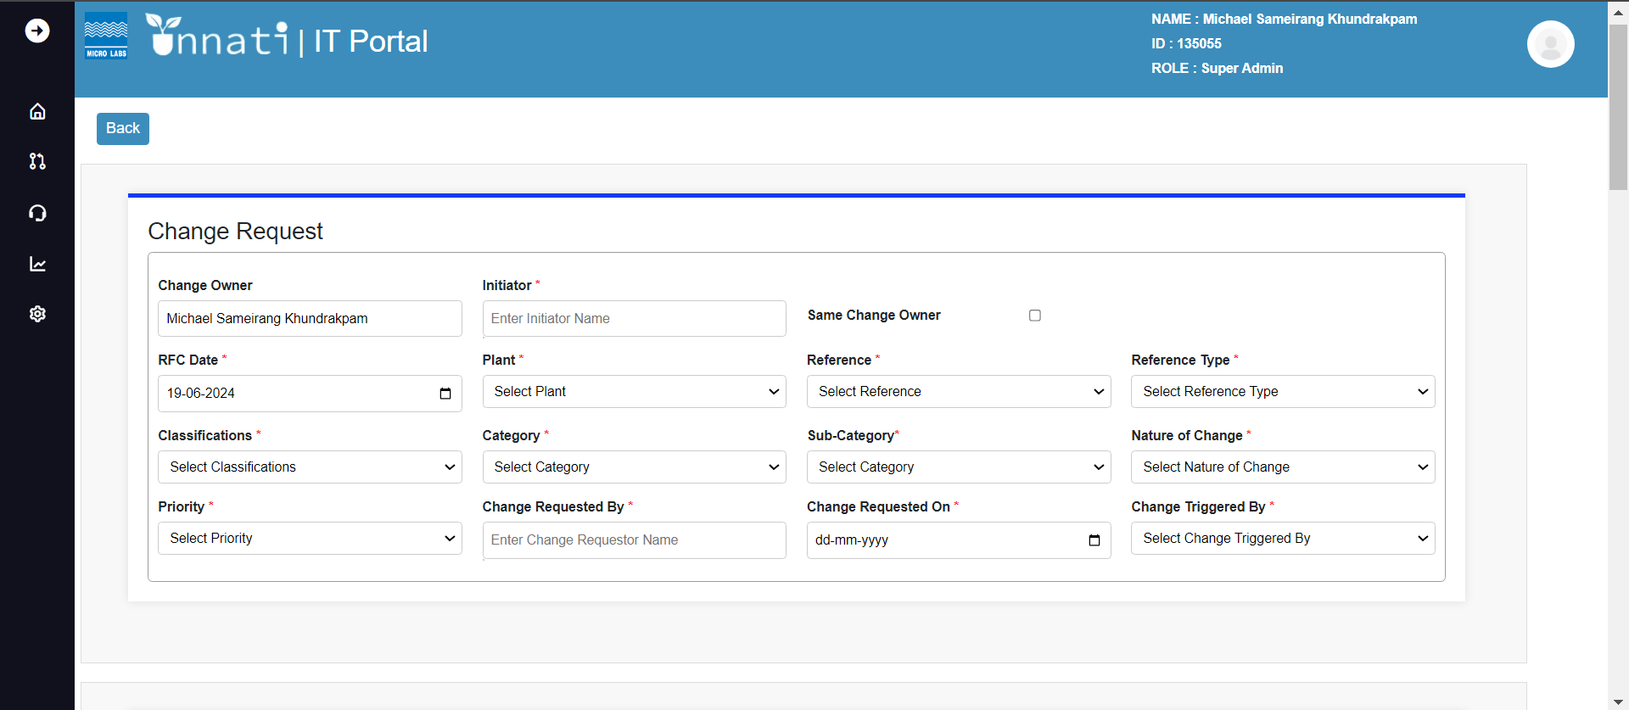

System landscape depends on the classifications and categories.

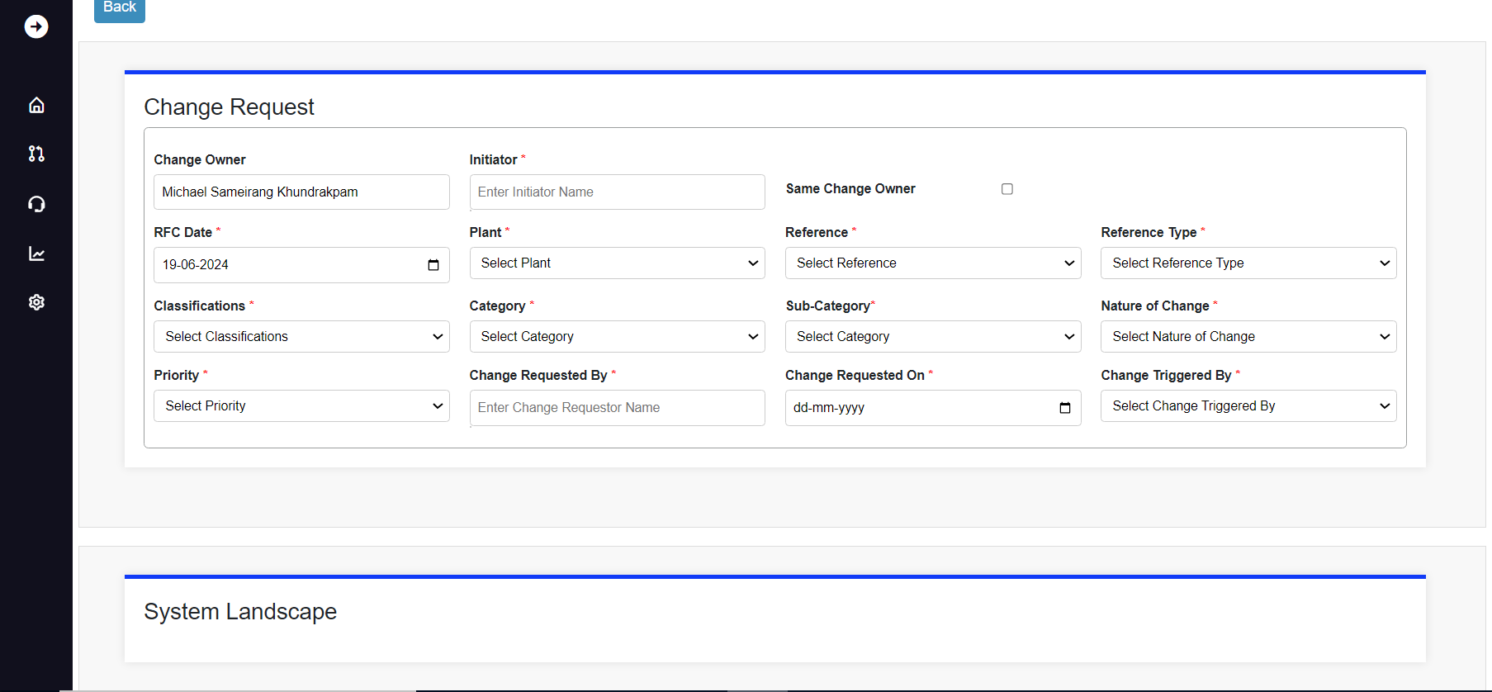

Fill in all the required fields.

Note: Change Description and Reason For Change are mandatory fields.

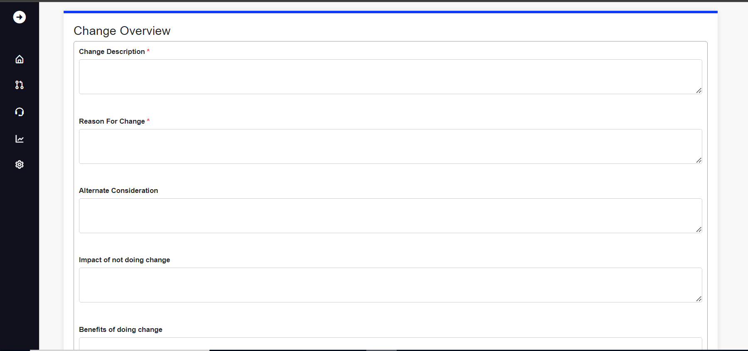

Choose the timeline for the specified task.

(Approximate cost - Currency - Estimated effort - Work days/hours - Expected completion date)

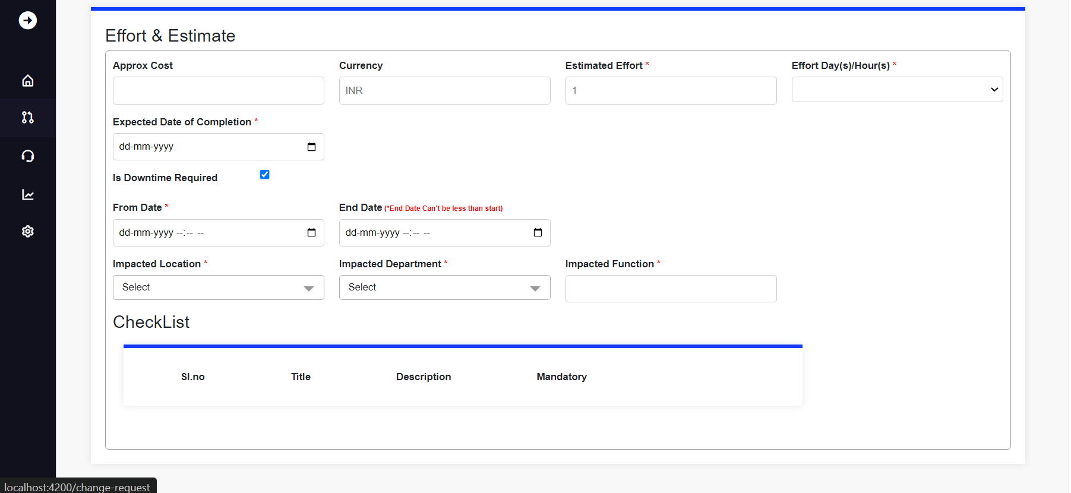

Fill in the Gxp Classifications fields if required and click Save.

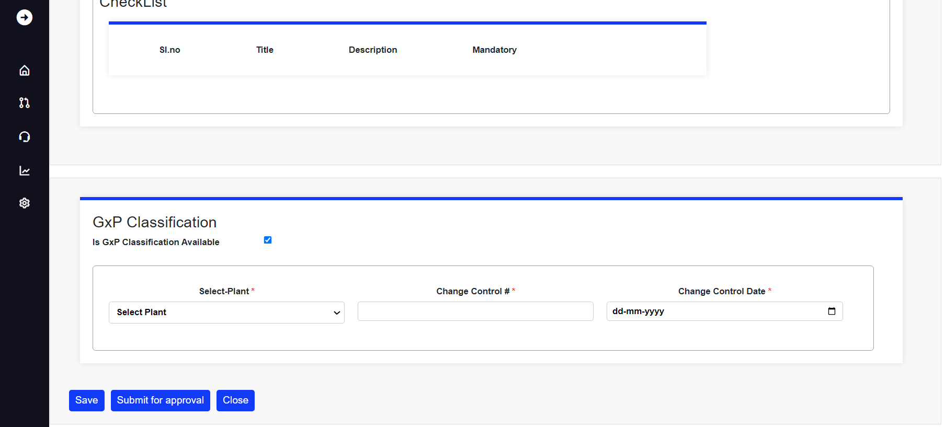

When you click the save button, you will see a popup message that says "Saved successfully."

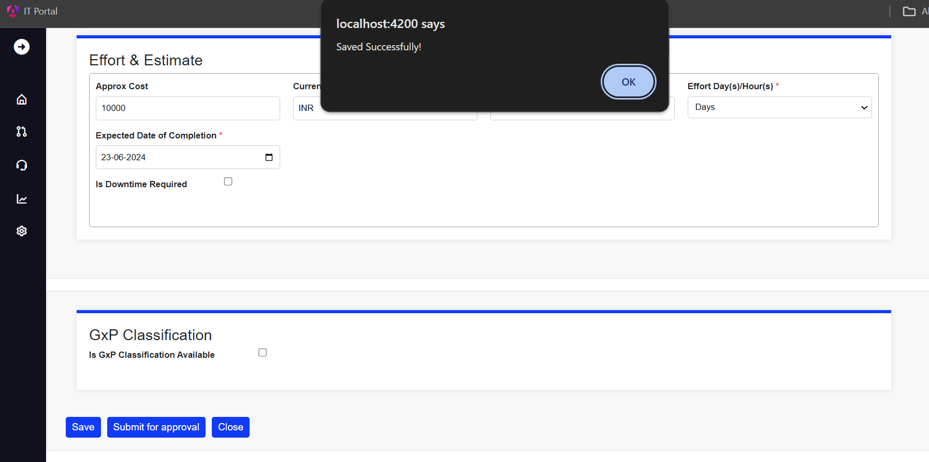

When it is successfully saved, you will see that a draft has been created.

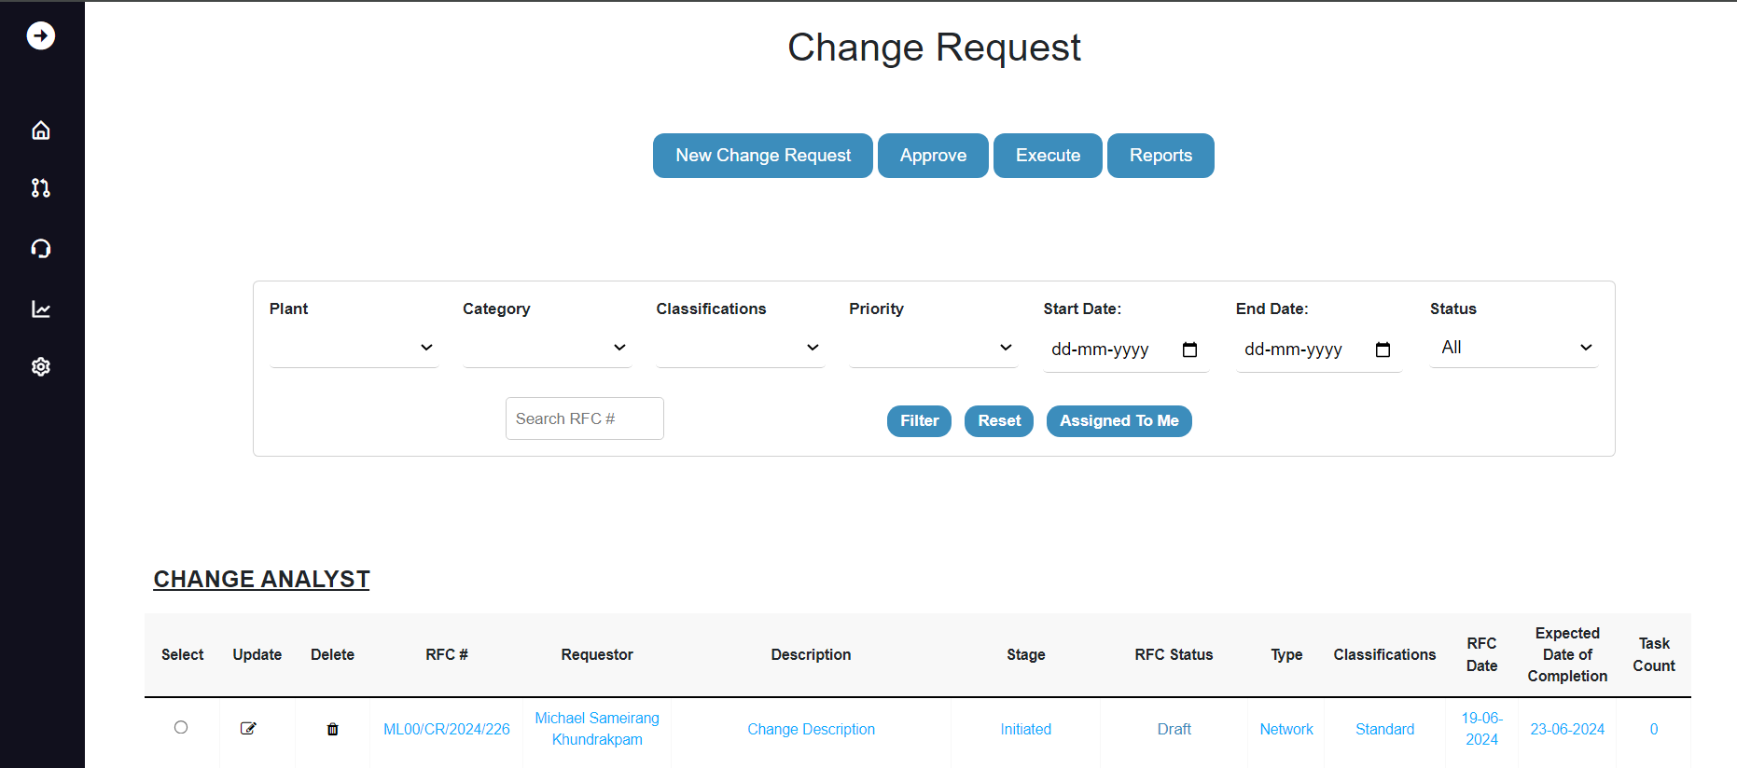

If modifications are required, Click on the radio button for the specific CR, then hit the Update button to begin the modification. Once completed, click the Submit button.

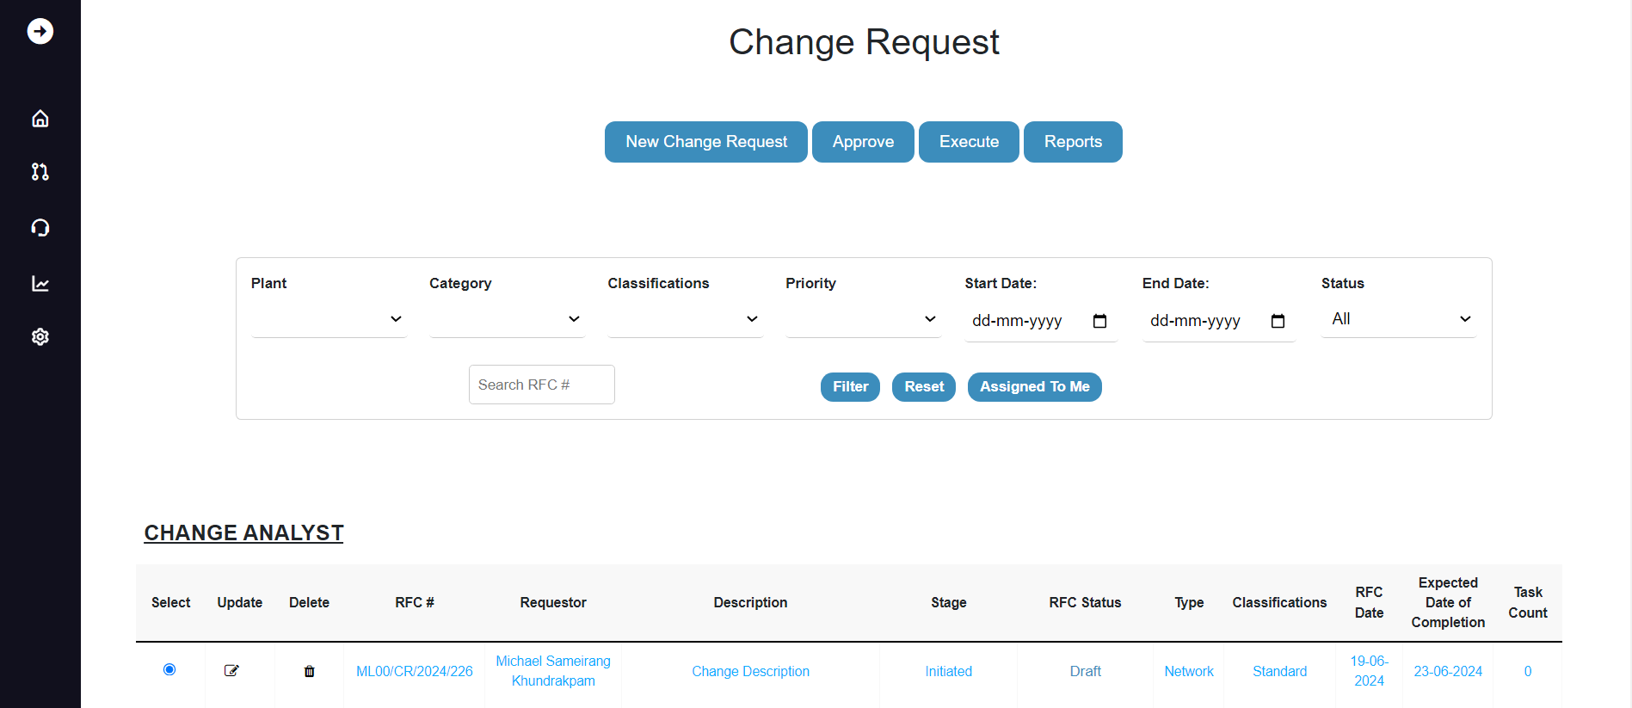After updating the CR, click the Submit for Approval button.

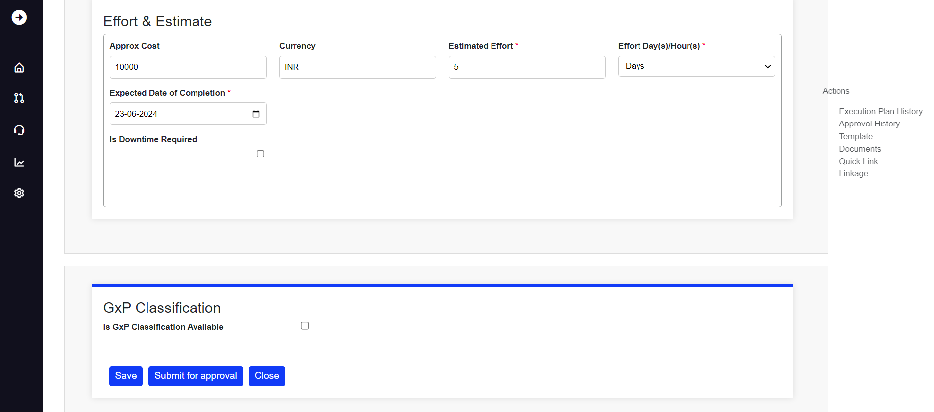When you click the submit button, you will see a pop-up notification that says " Change ID 226 RFC is successfully submitted for approval."

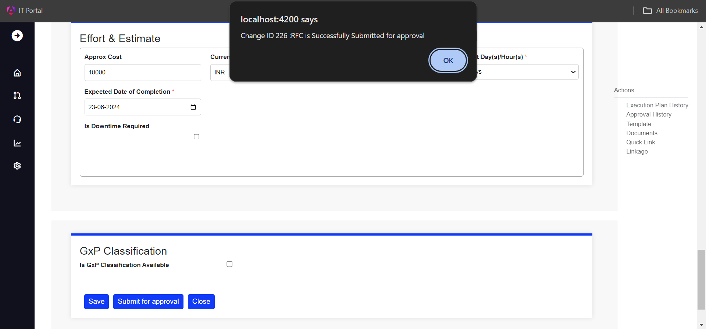

Once the submission is completed, the CR will be updated as pending for approval, and emails are get triggered, one to CR Requestor and to the Approvers who are in the Queue as shown below.

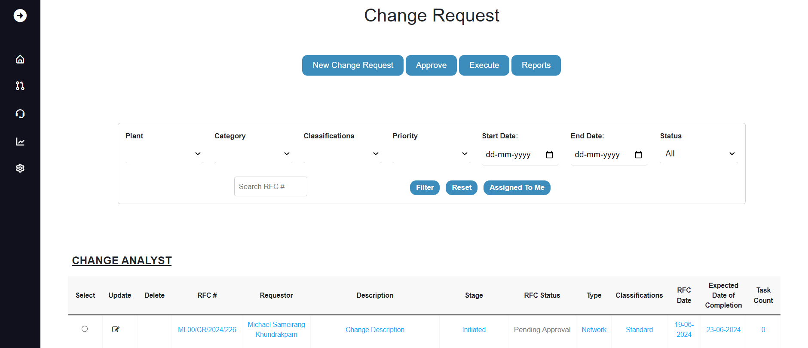

Email to the CR Requestor.

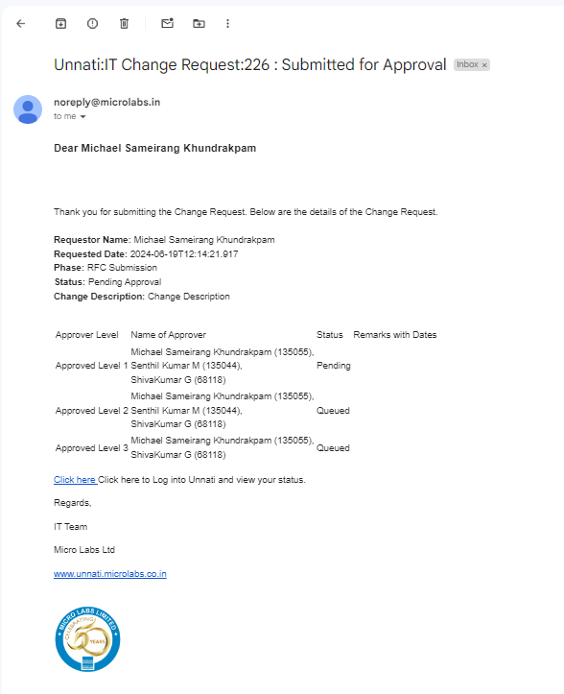

Email to the Approvers who are in the Queue.

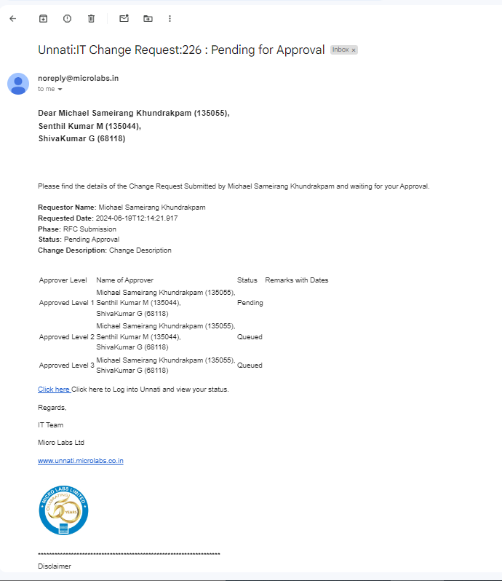

As a Change analyst, you will only see two buttons:

• New change request button

• Reports button

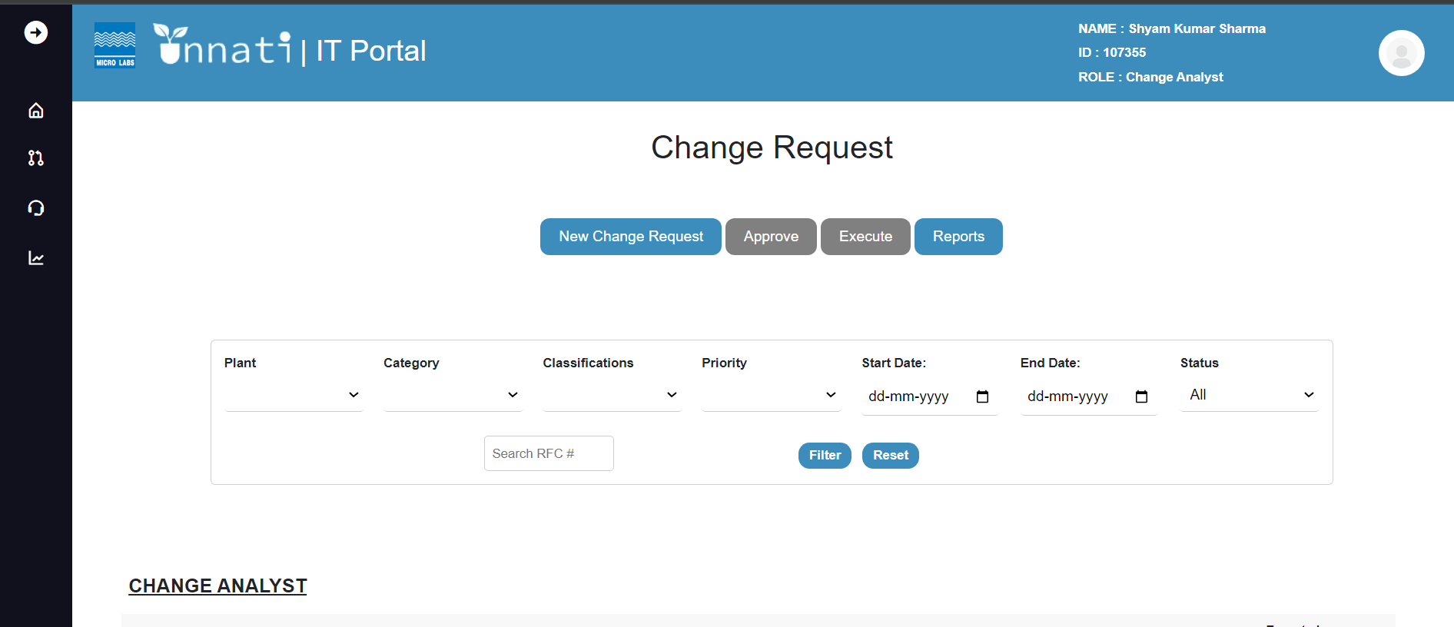

Approver:

As an approver, you can read the CR but cannot alter it. You will only see the Approve and Report buttons. As an approver, you will be able to see the CR in awaiting approval, as well as the specific CR assigned to you depending on the classification and category for the specific user.

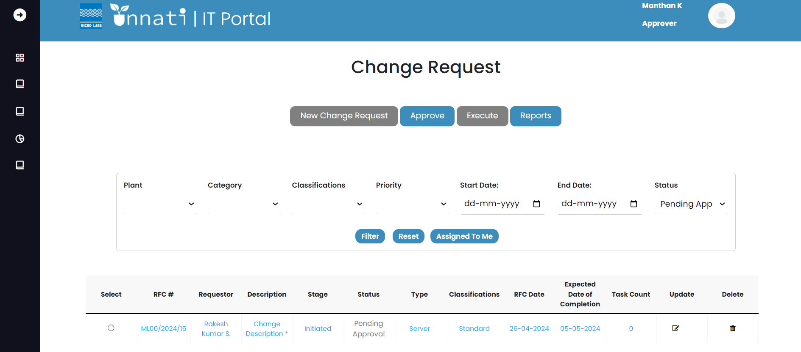

To approve the CR, pick it by clicking on its radio button and then click the Approve button.

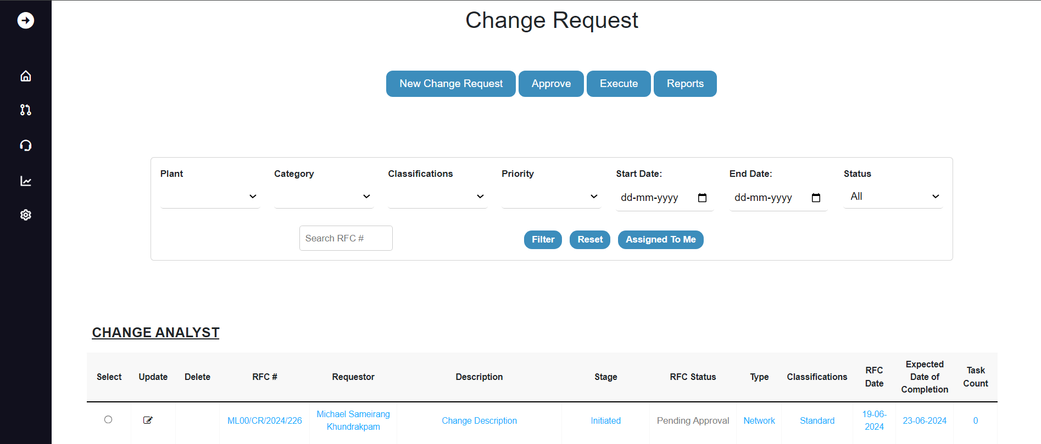

When you open a CR, you will see the RFC number, creation date, and status bar. If the CR is not yet authorized, the status will be highlighted in orange, indicating that the current status has not been updated.   
By clicking on the RFC button, the user may read the CR details but cannot alter them. The Blue button for approver indicates that you are in approver phase level 1, and the History button allows you to view the history of the specific CR. It also provides the name of the particular approver.

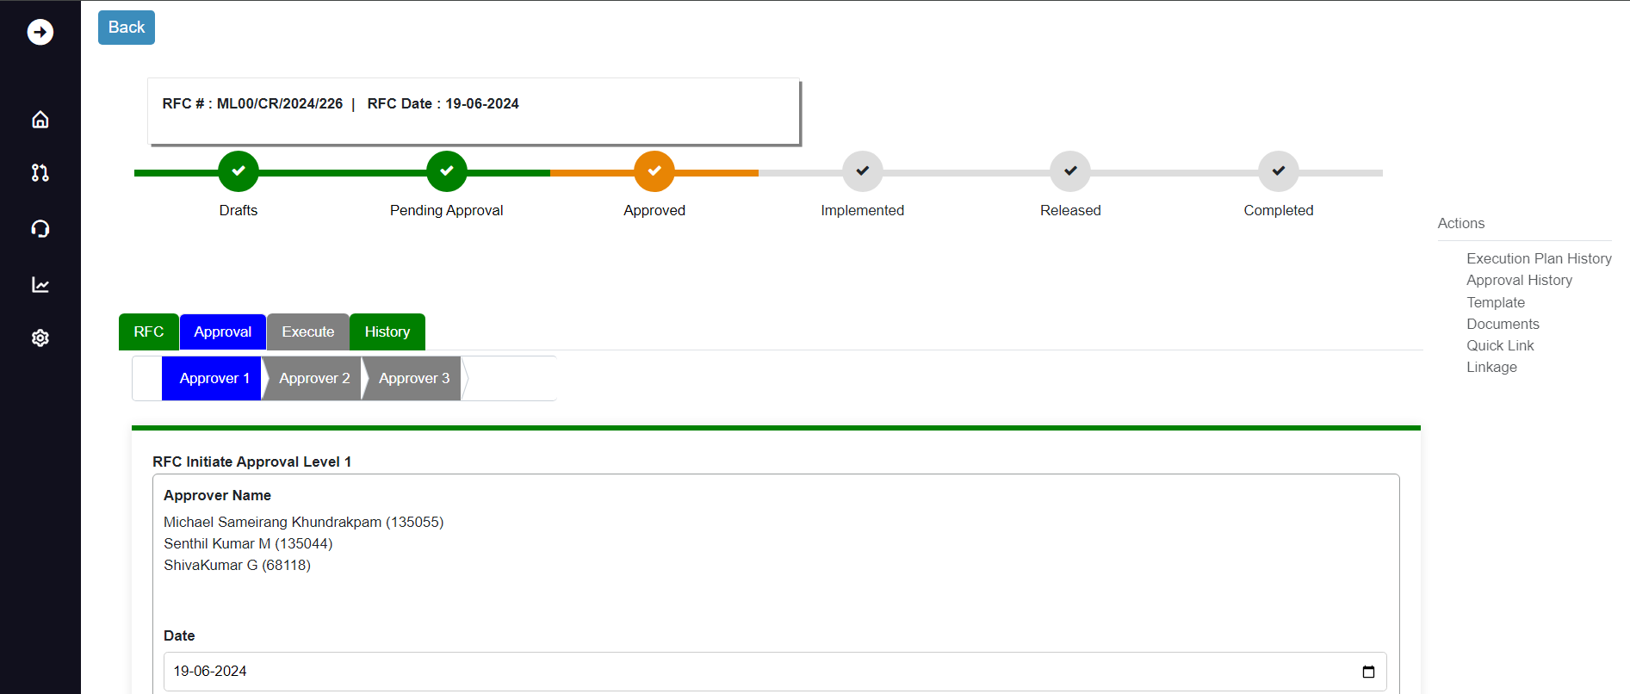

In this part, the user can record notes and attach documents in the attach document section before clicking on approve. By doing so, you are approving the level 1, and the user can reject the CR for any valid cause or click on seek clarification for further explanation/update.

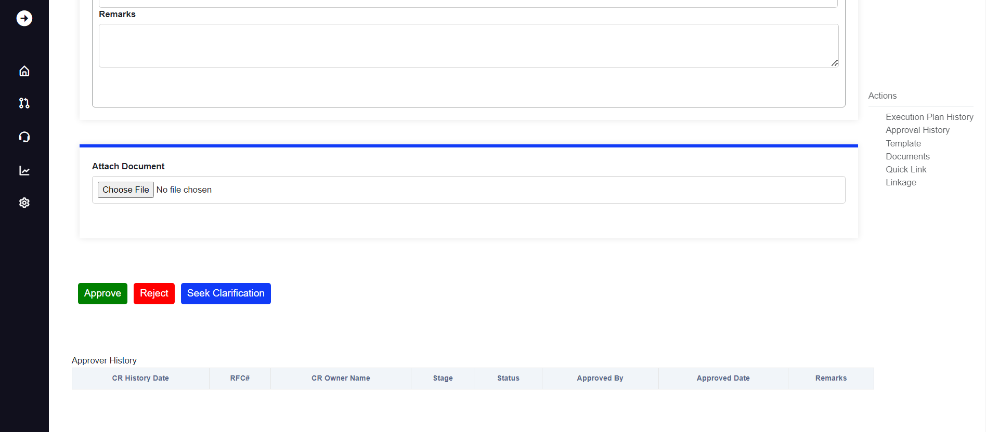

Rejecting the current CR, once clicked on the Reject button it gives you a pop message saying “Change ID 227: RFC Is Rejected at Pending Approval”.

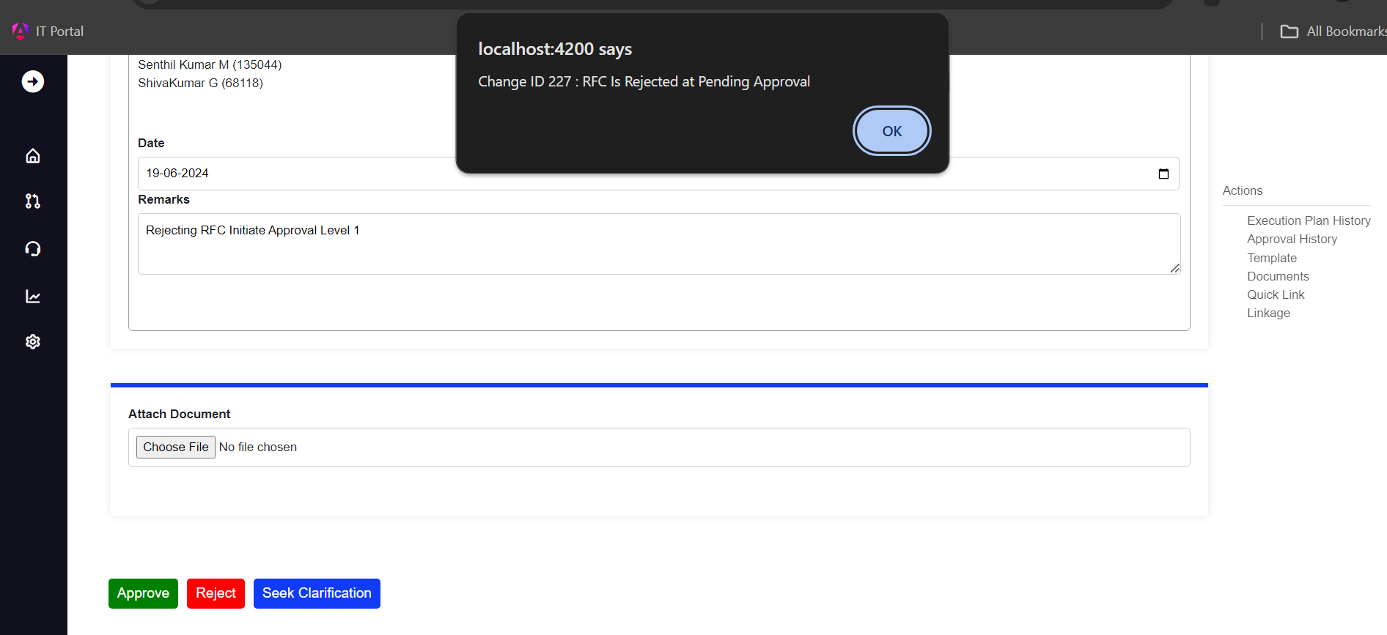

Once clicked on ok the Email with the Reject Status will be triggered to the requestor and to the approver who has rejected it and the status will change to Rejected.

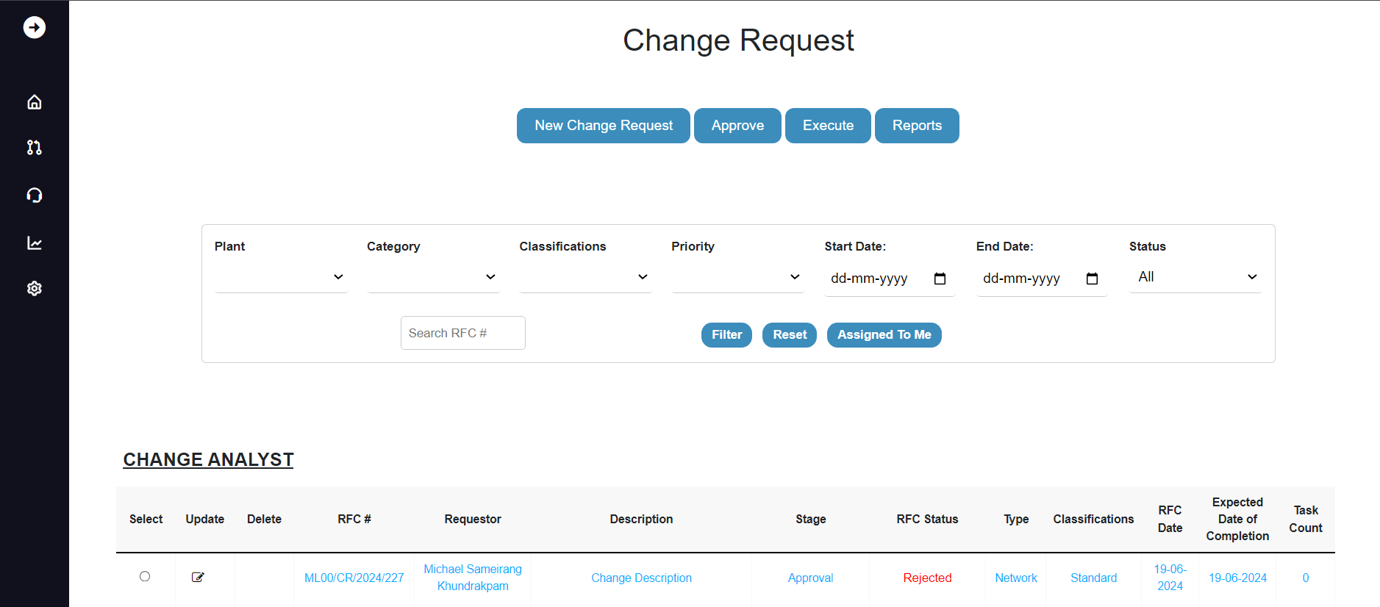

Rejection email triggered to the requestor and approver.

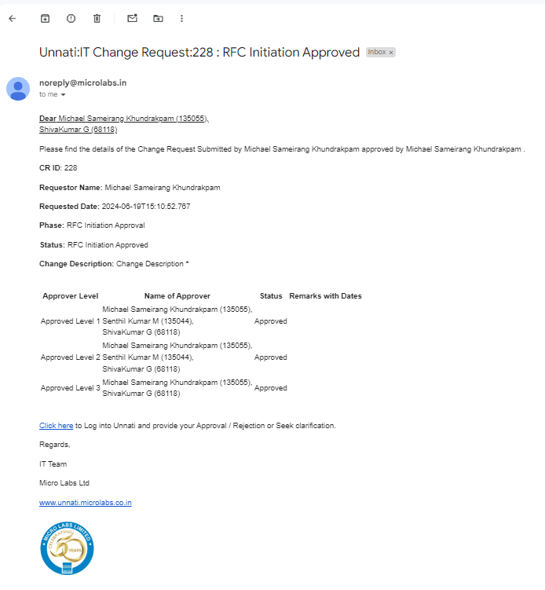

As the current CR is rejected if you click on the update button it will give you message saying Change Request was rejected. Please check History for details, once clicked on OK it will take you the rejected CR.

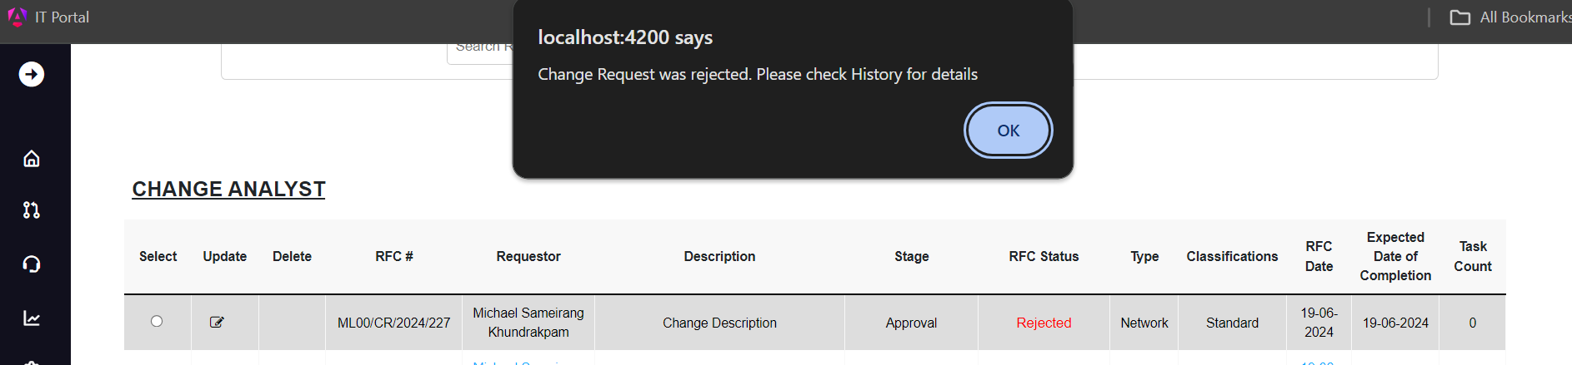

Where you can see the status bar of the particular CR is rejected and the Requestor or the Approver can read the history of the particular CR but cannot modify or rewrite it.

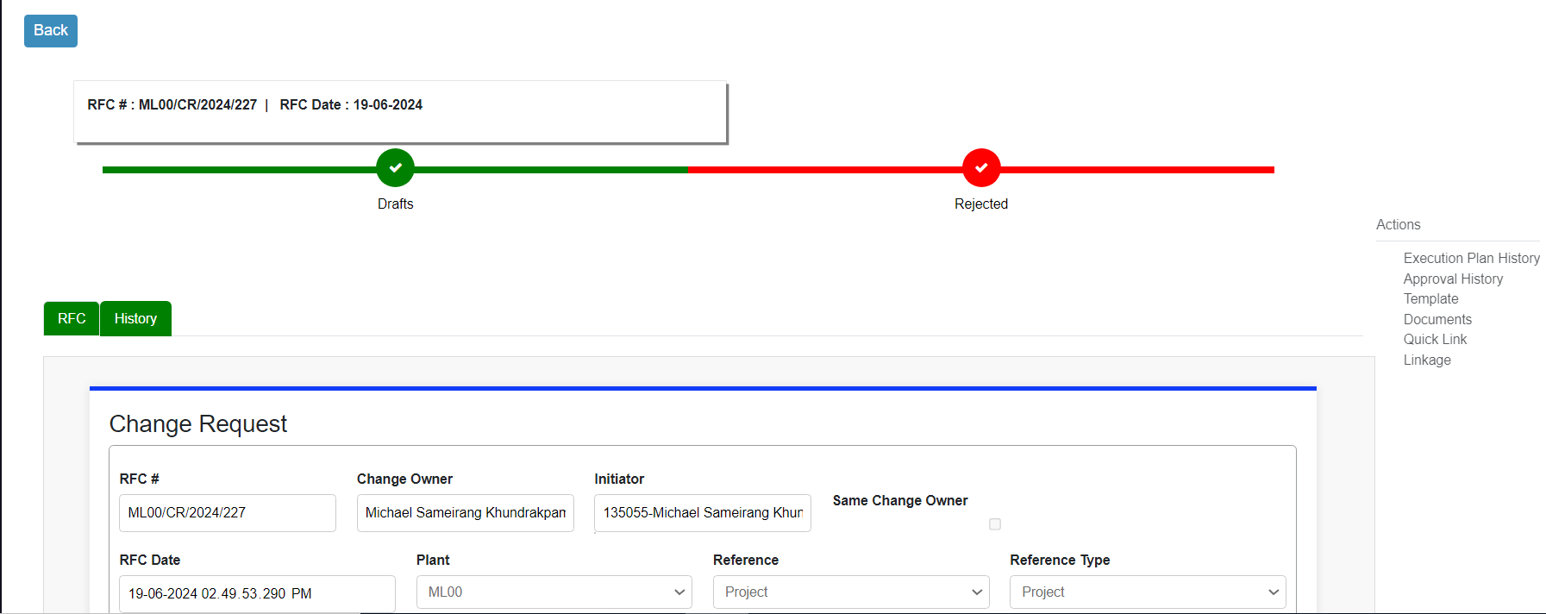

Clicking on the Seek clarification,



once clicked on the Seek clarification button it gives you a pop message saying “Change ID 224: Needs Clarification at Pending Approval”.

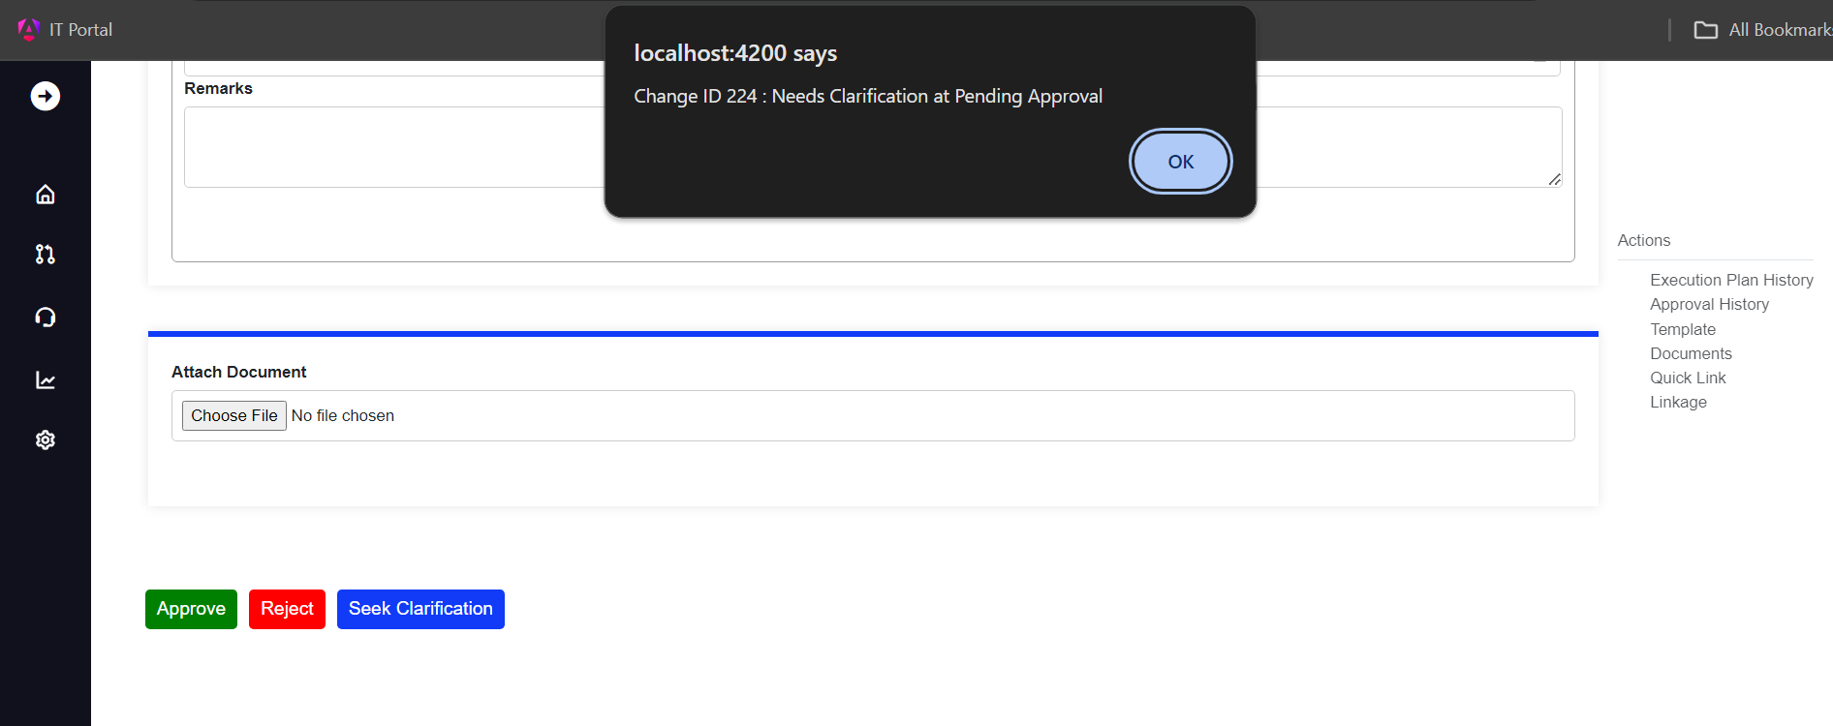

Once clicked on ok the Email with the Seek Clarification Status will be triggered to the requestor and to the approver who has clicked on Seek Clarification button and the status will change to Draft.

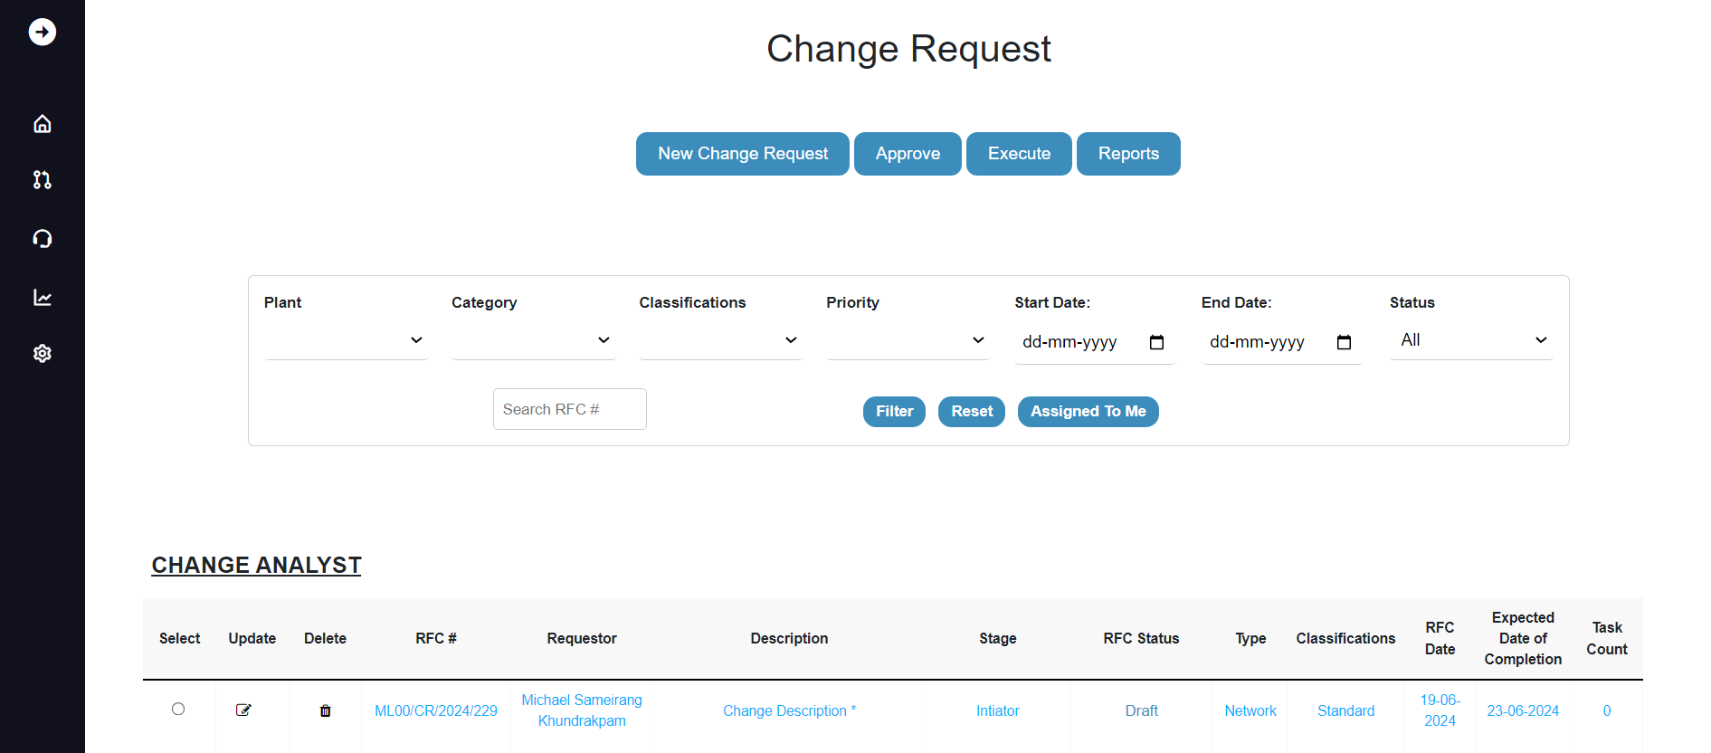

Seek Clarification email triggered to the requestor and approver.

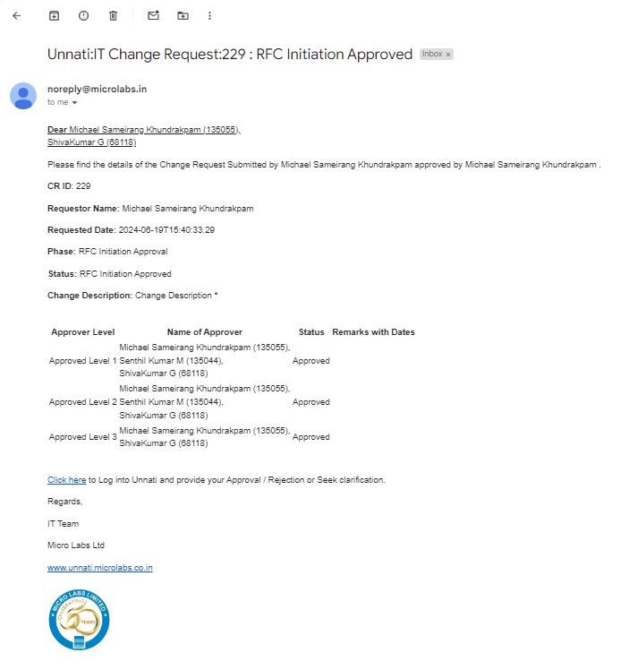

**RFC Initiate Approval**

Here we are in RFC Initiate approval level1 and here we can see all the approvers assign for the particular CR based on the Classification and category.

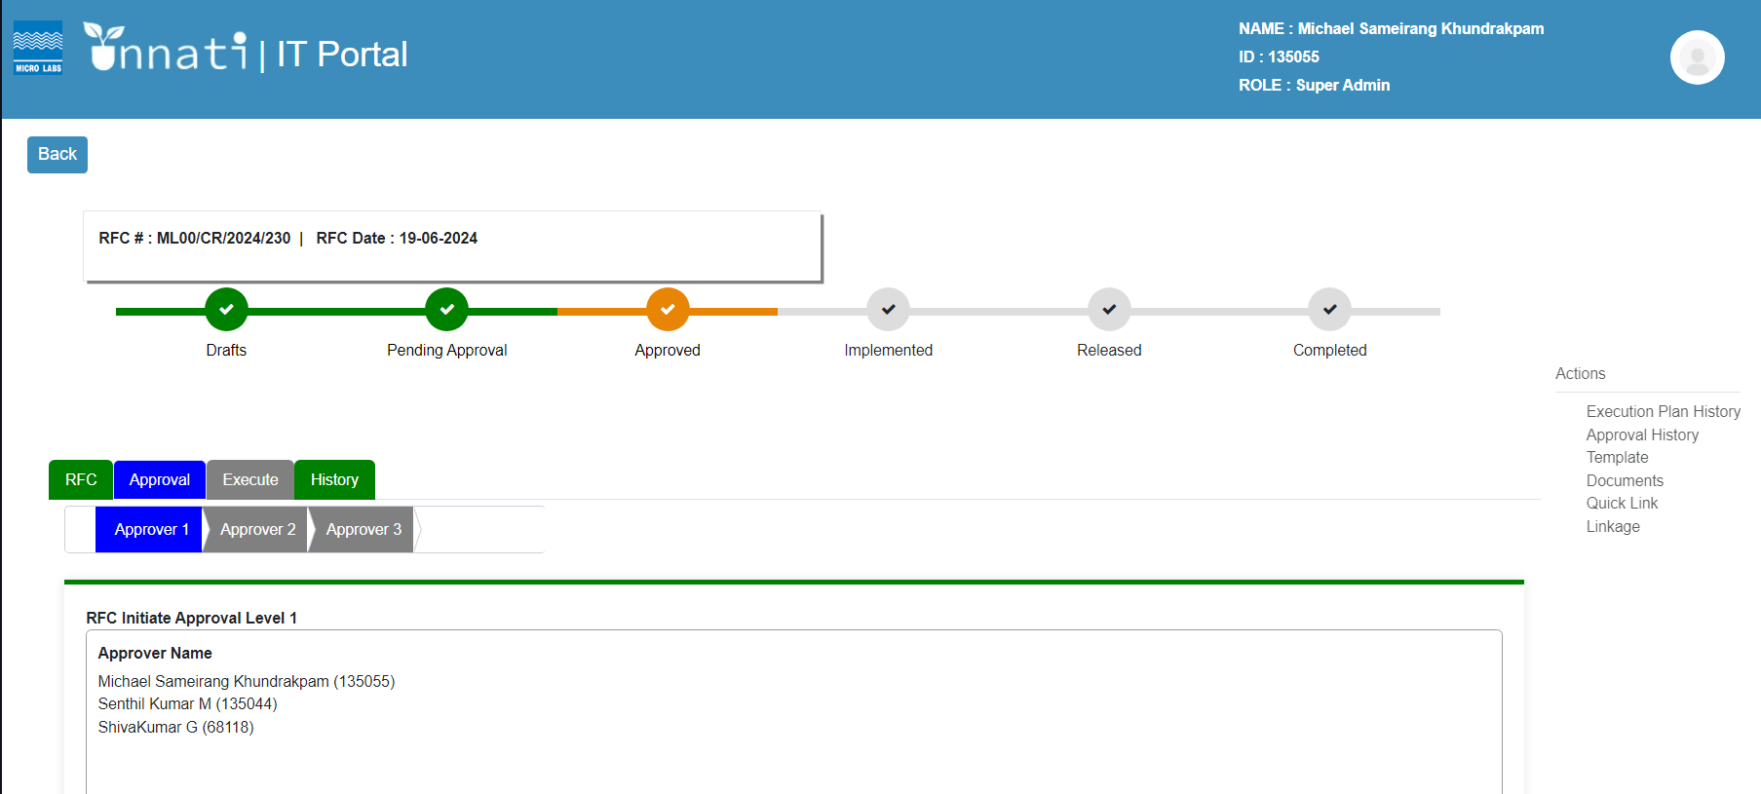

Here the approver can capture the remarks and can attach the attachments if required and once click on the approve button.

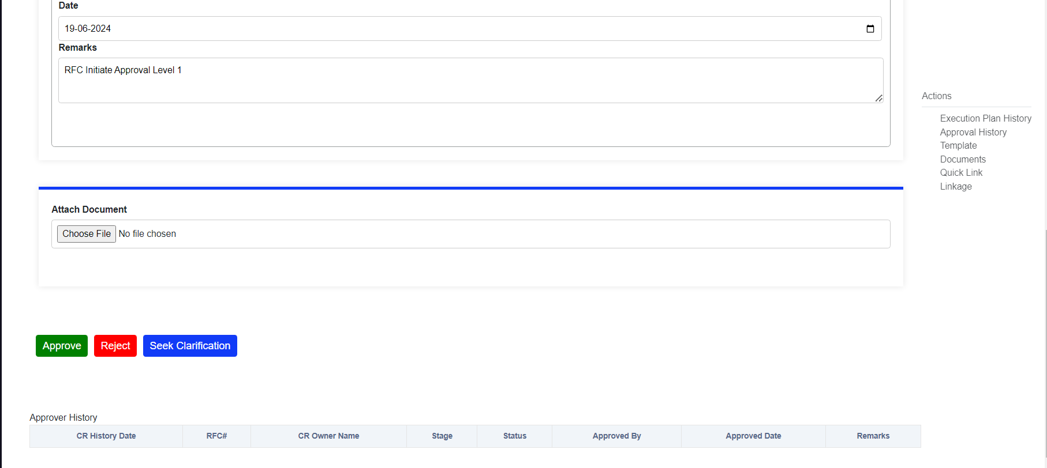

Once clicked on the approve button it will give a pop up message saying “Change ID 230: RFC Is Successfully Approved Level1”.

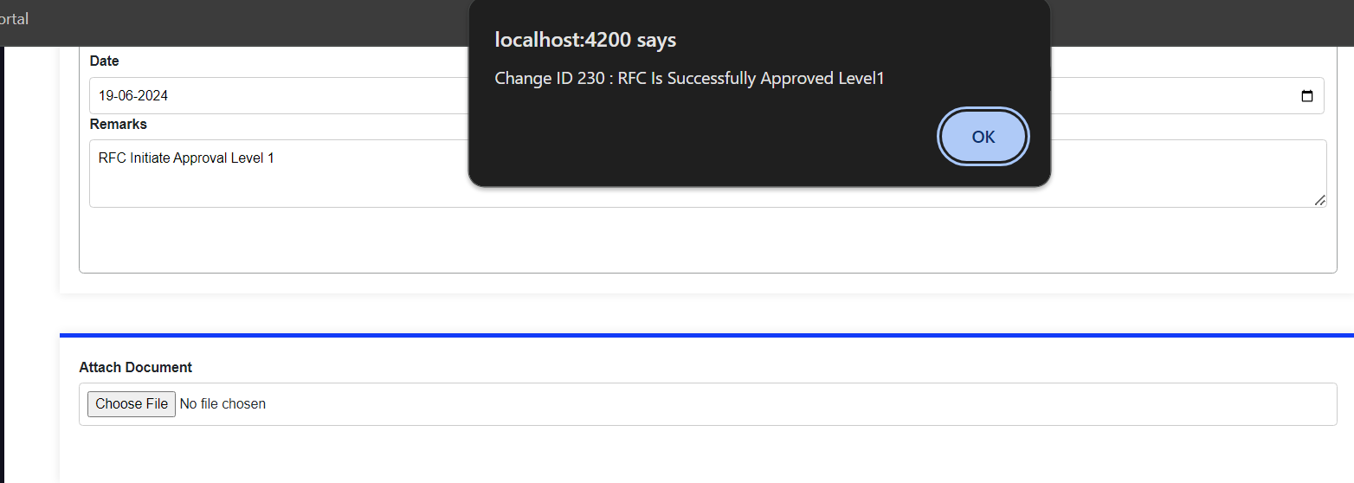

Once clicked on okay the emails will get triggered to the CR Owner and the Approvers and the status will change to approved level 1.

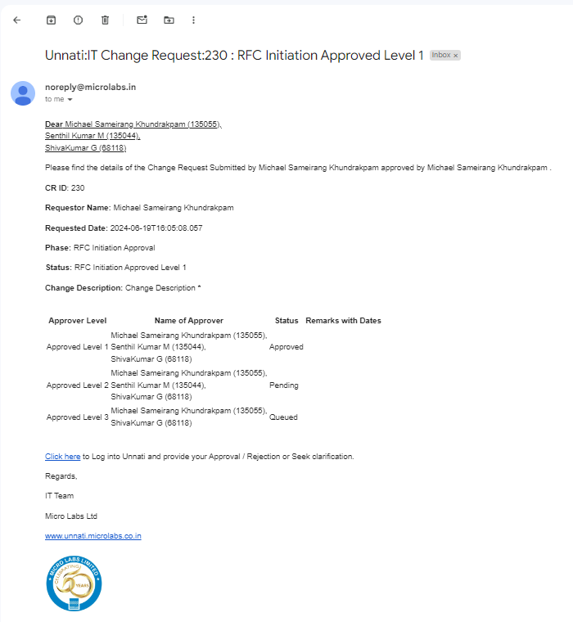

The status has been updated to approved level 1 because you approved it.

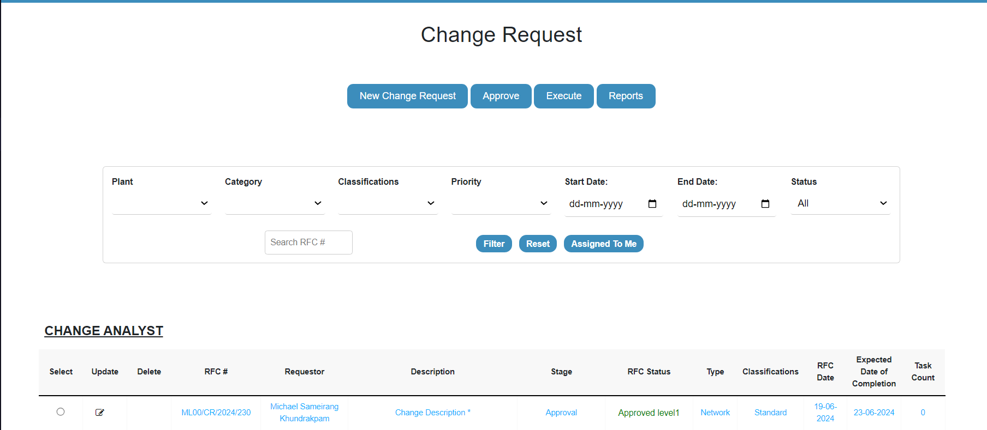

Now that we are in the level 2 phase, you can see that the approver level 1 colour has changed from blue to green. As the level 1 approver, you will not be able to approve the level 2, and you will not be able to see the level 1 approver's name or the following buttons- Approve, Reject, and Seek clarification. So, the following CR must be approved by level 2 approvers.

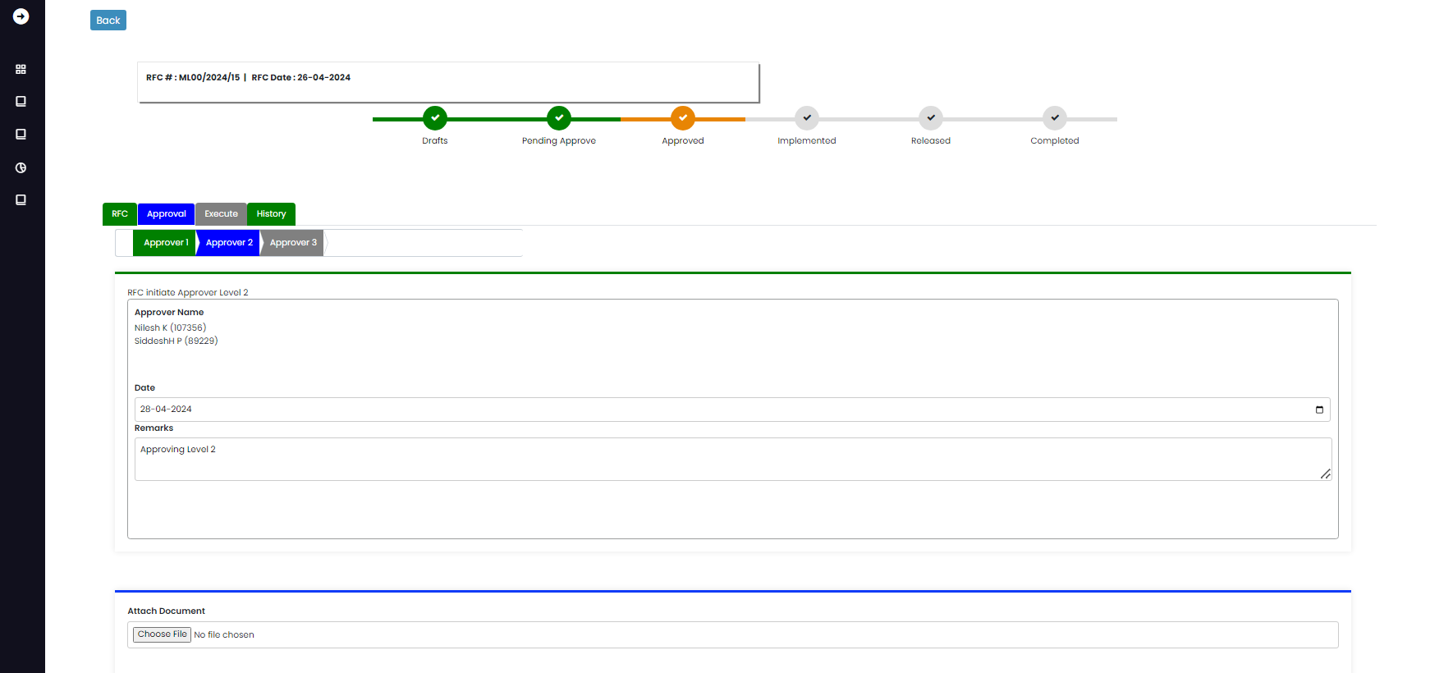

Level 2 Approver:

As a level 2 approver, you can see that approver2 is blue, indicating that you are in the approval level 2 phase.

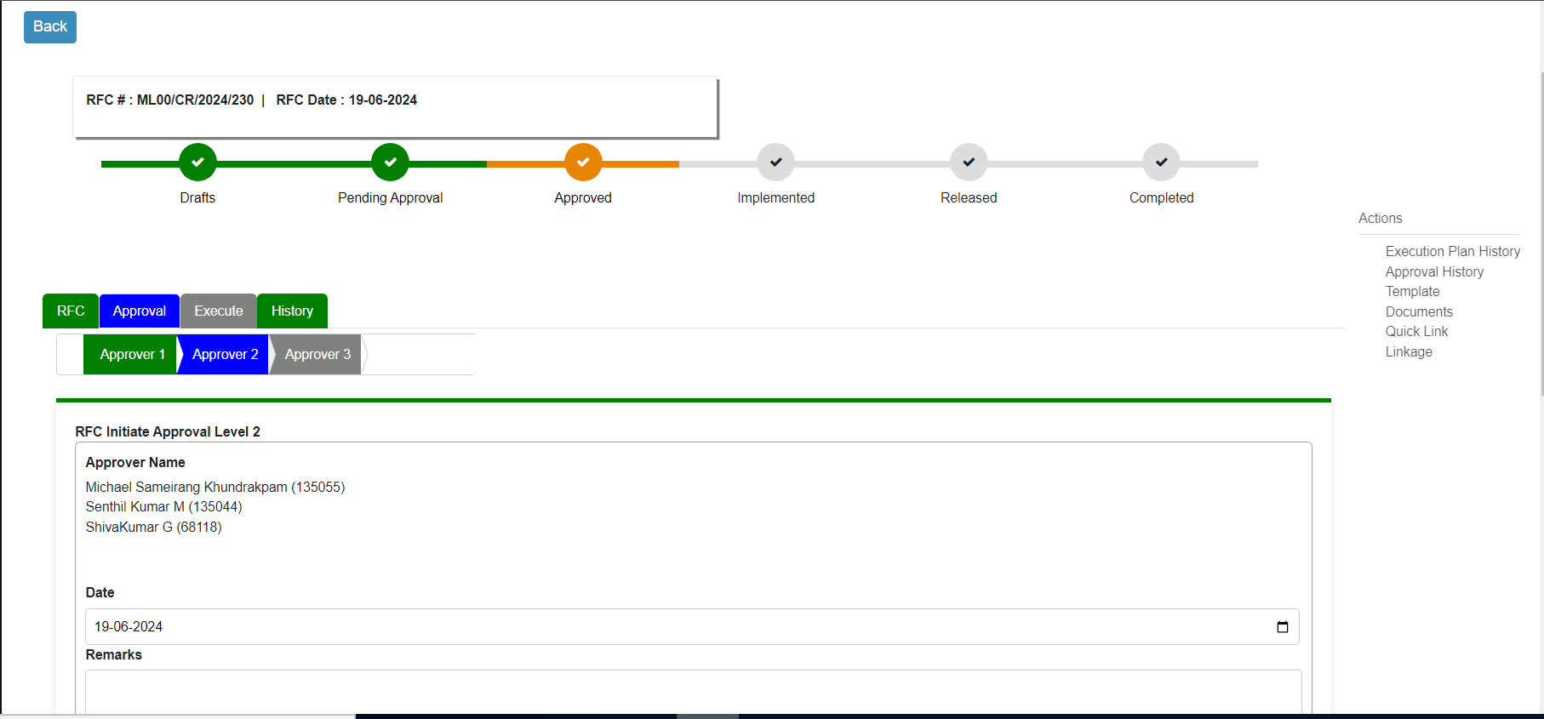

You can update your notes here, as well as read prior remarks in the approval history area. Once you update your remarks and click the approve button, you will get a pop up message saying Change ID 230: RFC Is Successfully Approved Level2.

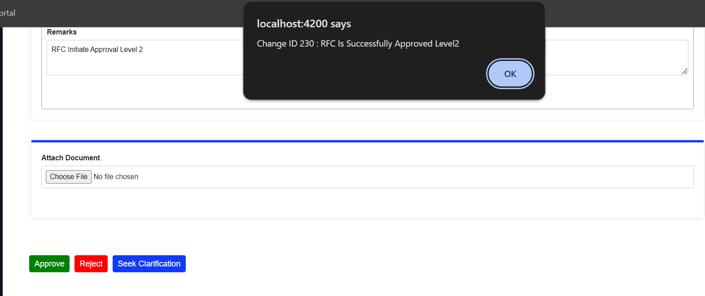

Once clicked on okay button the email will get triggered to the CR owner and to the approvers with the updated status of the CR.

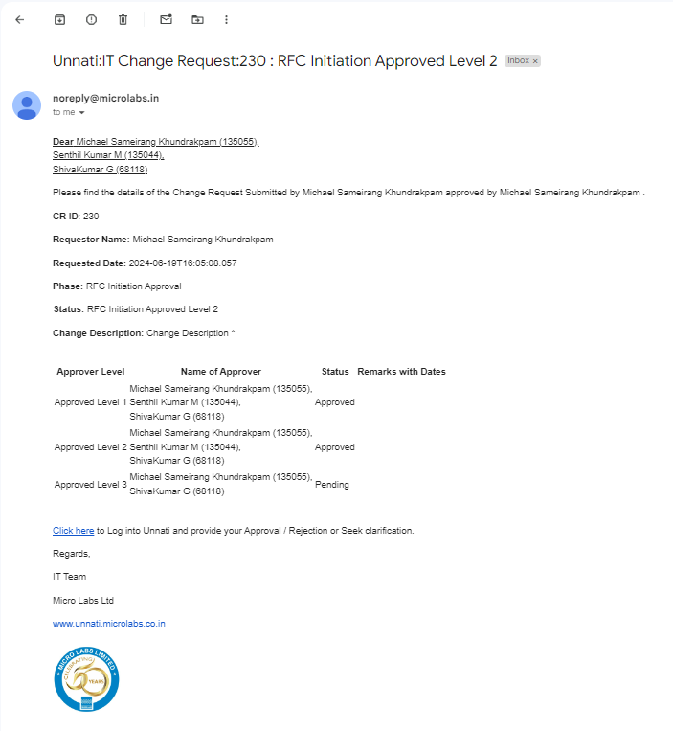

We can also see the remarks got saved in the Approver history table.

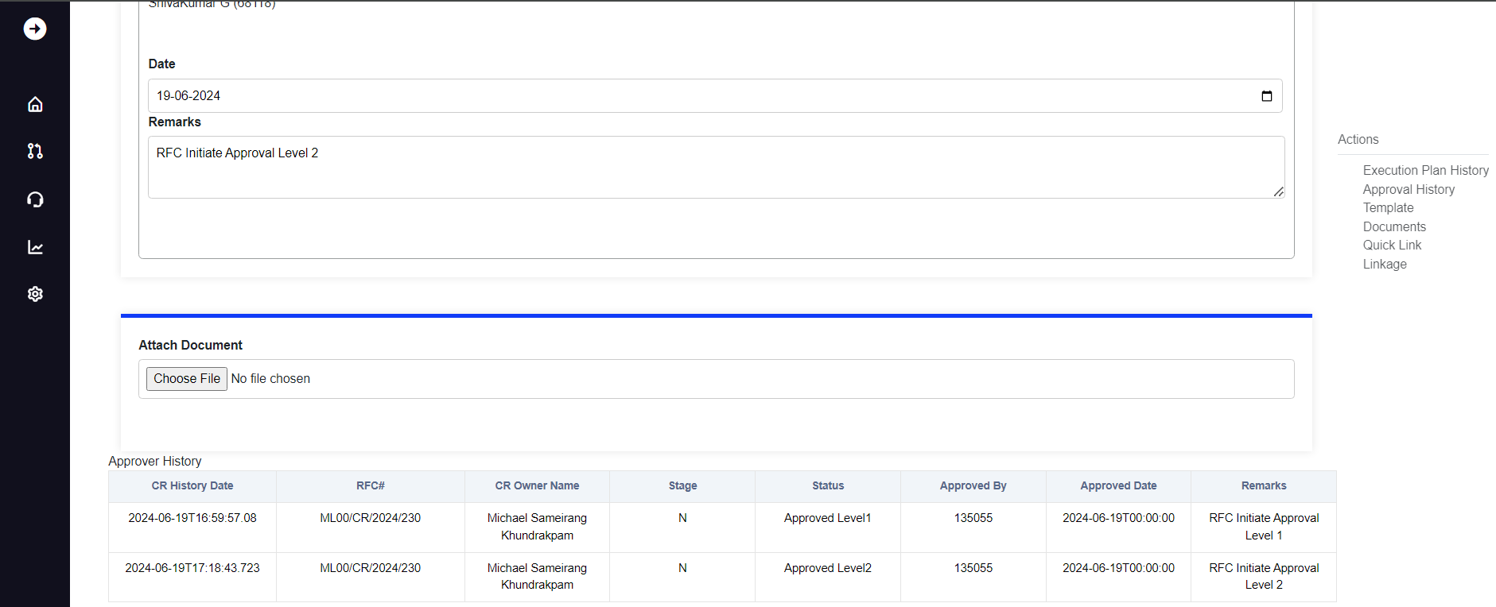

As approval level 2 was approved, the CR status was changed to Approved level 2.

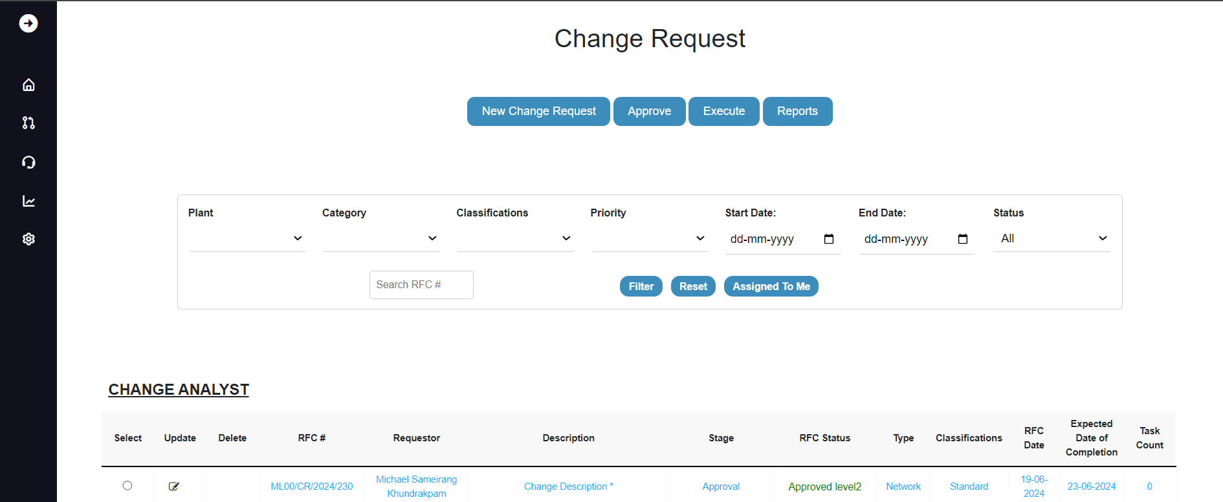

As we enter the Approver level 3 phase, you will notice that the approver level 1 and level 2 colours have changed from blue to green. As a level 2 approver, you will not be able to approve the level 3 and will not be able to see the name of the level 2 approver or the following buttons- Approve, Reject, and Seek clarification. So, the following CR must be approved by level 3 approvers.

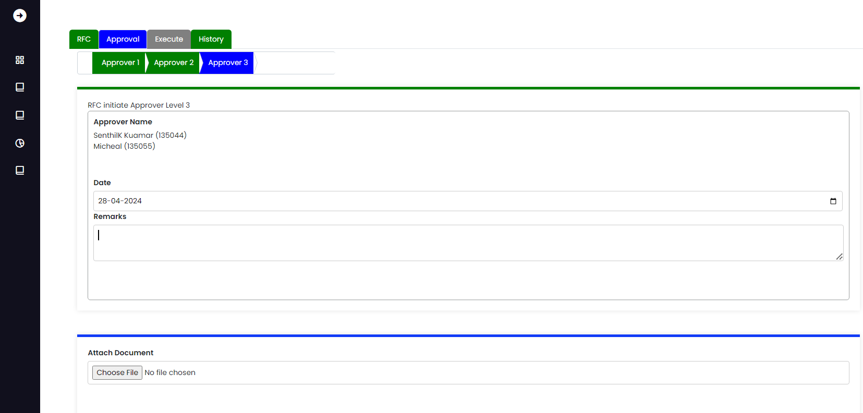

Level 3 Approver:

As a level 3 approver, you can see that approvers 1 and 2 are green and approver 3 is blue. This indicates that you are in the approval level 3 phase and that your name can be found in the Approver list.

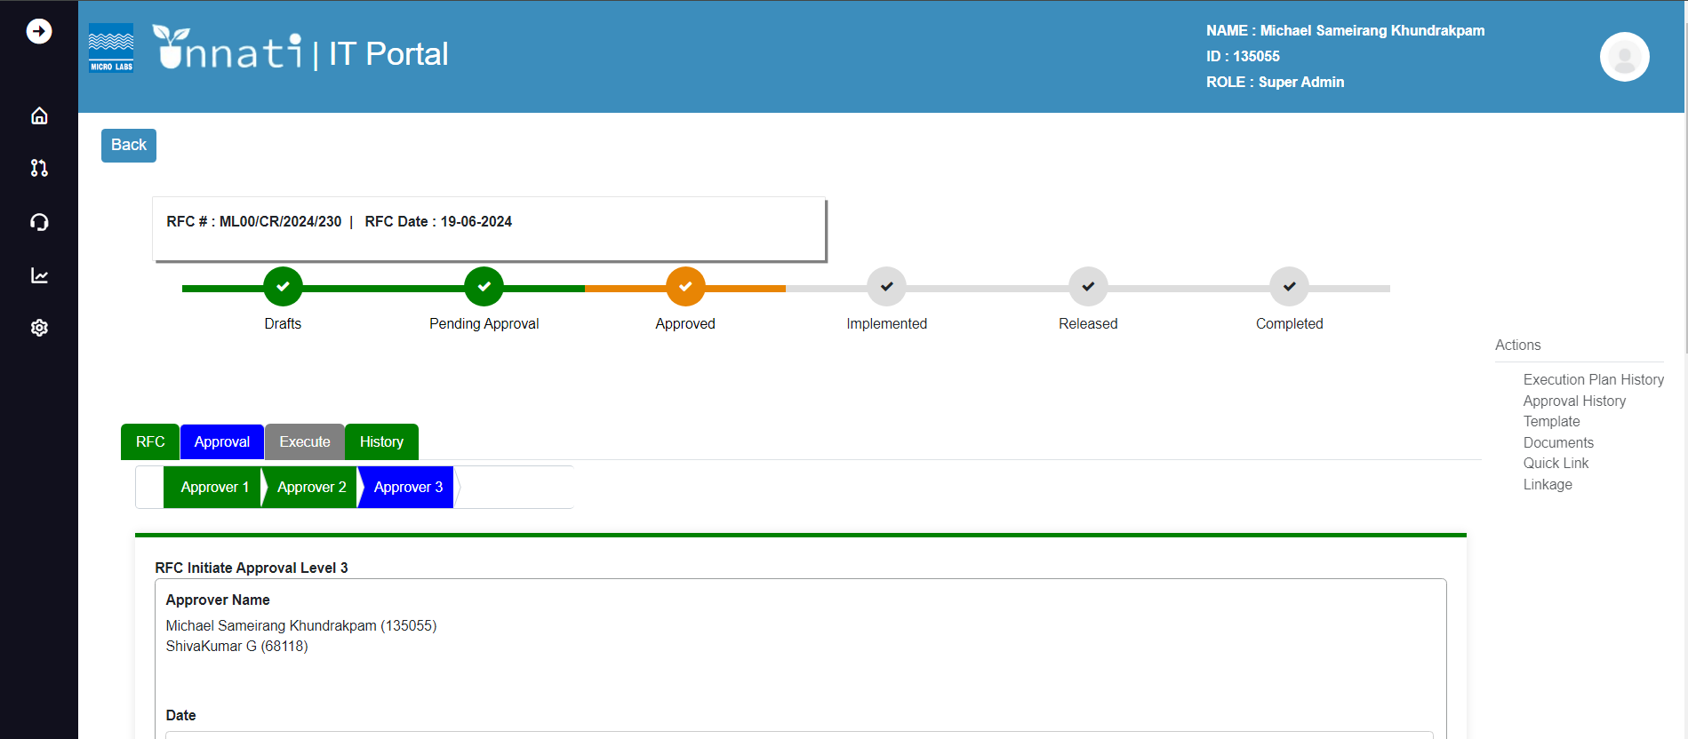

Now updating/writing the remarks and clicking the approve button, click the approve button, you will get a pop up message saying Change ID 230: RFC Is Successfully Approved.

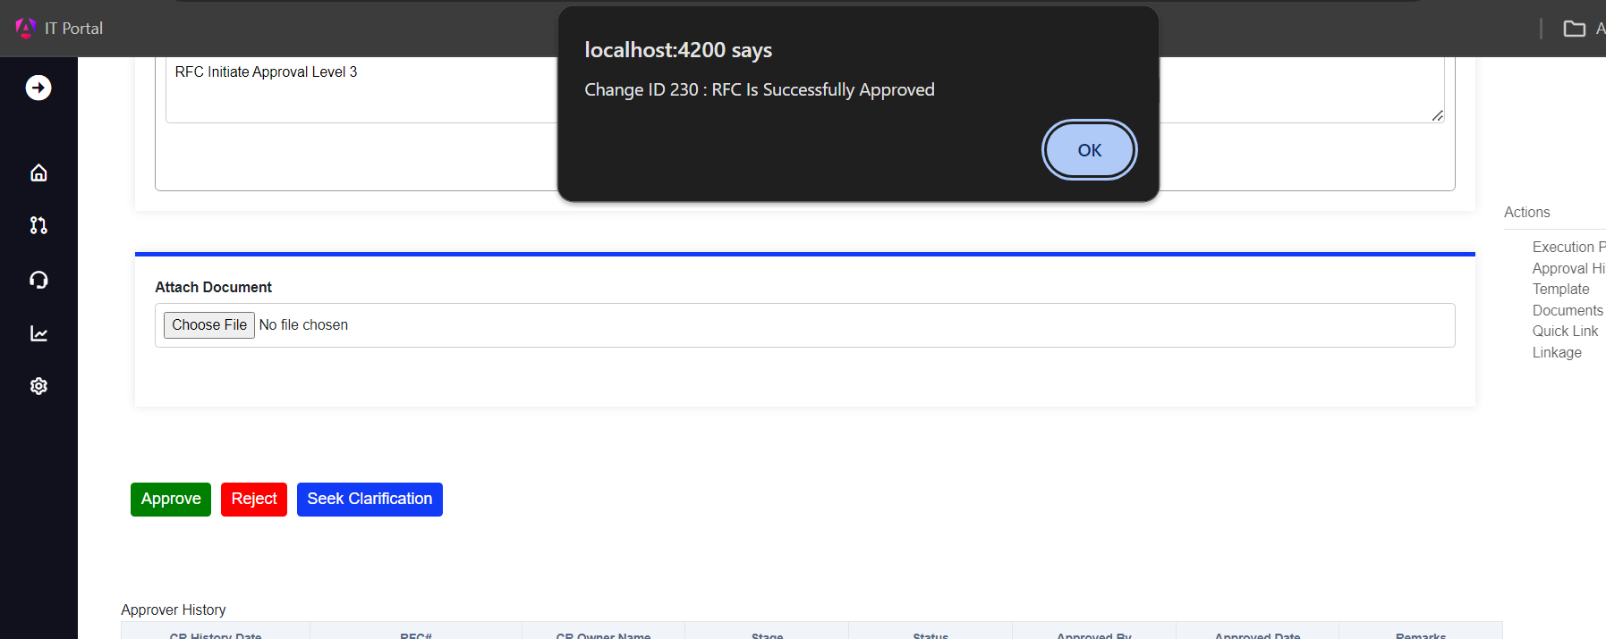

Once clicked on okay button the email will get triggered to the CR owner and to the approvers with the following status of the CR.

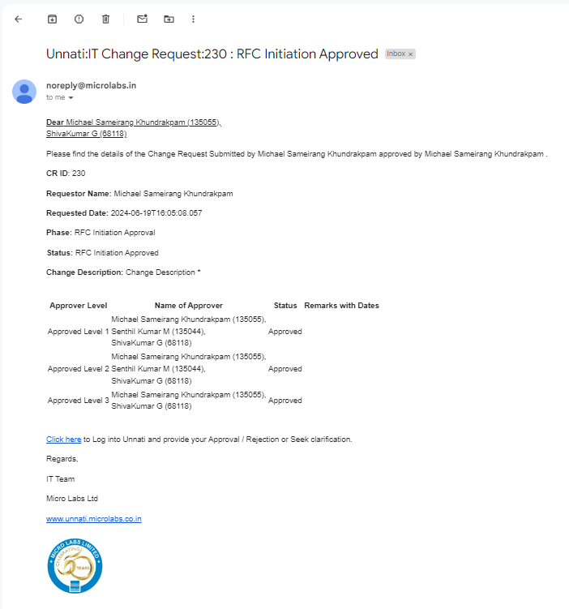

the remarks were updated the status on the status bar changed to Approved, and all approver levels turned green in colour.

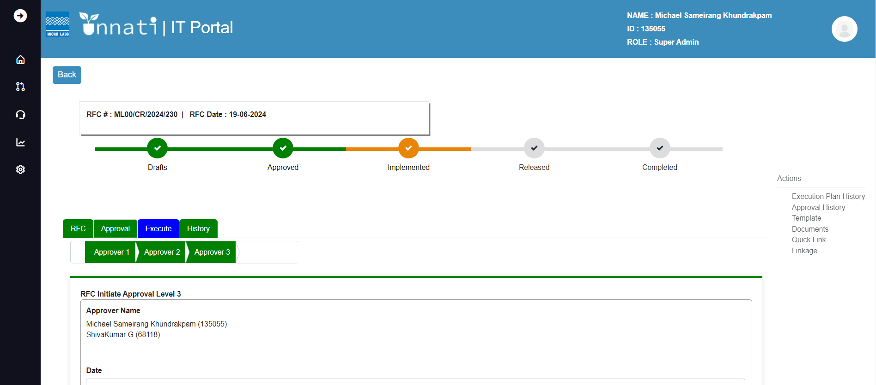

All of the approvers' level data and remarks were updated in the Approver history table.

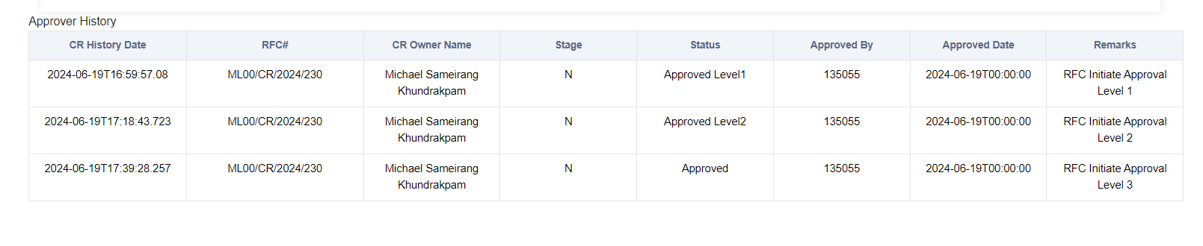

The status of the CR has changed from approved level 2 to approved.

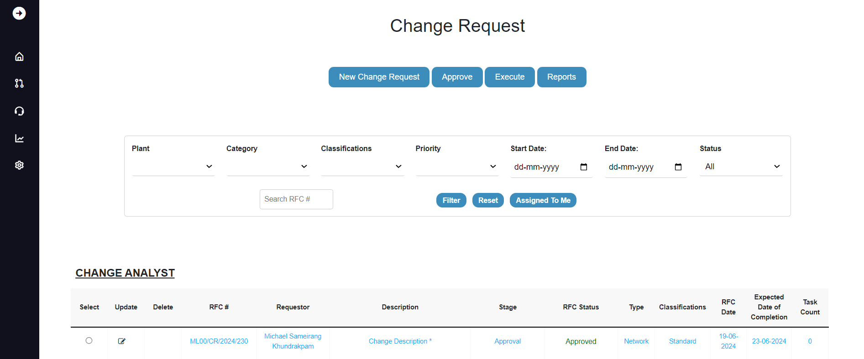

Execute-Implementation:

The change analyst/support engineer is in charge of the task created. Because we are in the implementation phase, the status bar for implemented is orange, all approver labels are green, and the execute tab is blue, indicating that we are in the execution phase of the CR. The system landscape is determined by the classification and category of the CR.

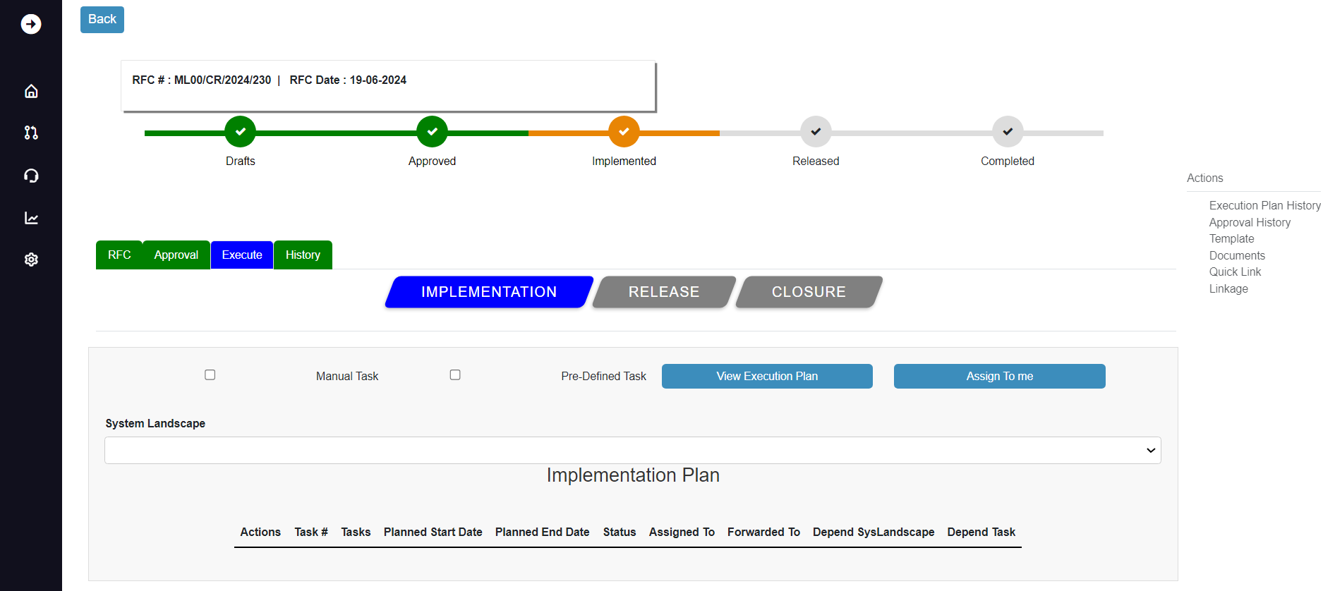

Task creation:

To create a task, we have 2 options i.e., manual task and pre-defined task, manual task is nothing but selecting the system landscape from the dropdown and creating the task, pre-defined task is something that already the task has been created and saved as a template for easy creation of task.

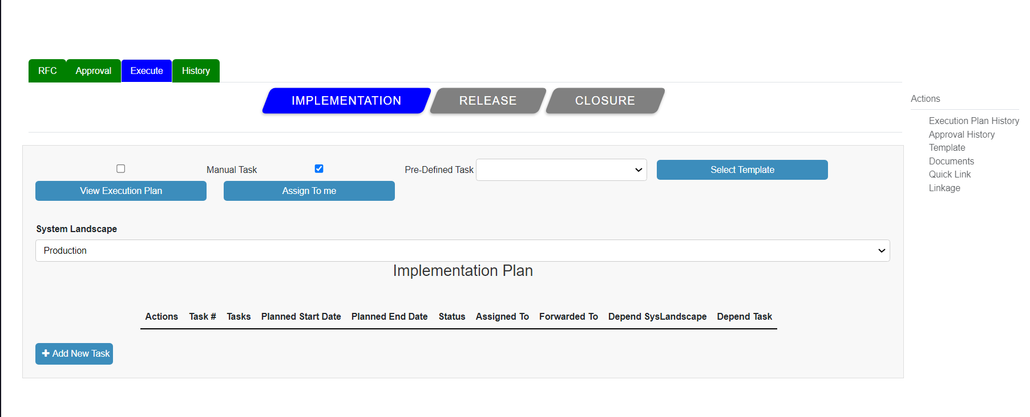

As we have Production in the system landscape, we will build a Production task. To create a task, select planning from the dropdown. Once planning is selected, the add new task button shows on the left side of the bottom. Click on it.

This is how the new task form appears after clicking the Add New Task button.

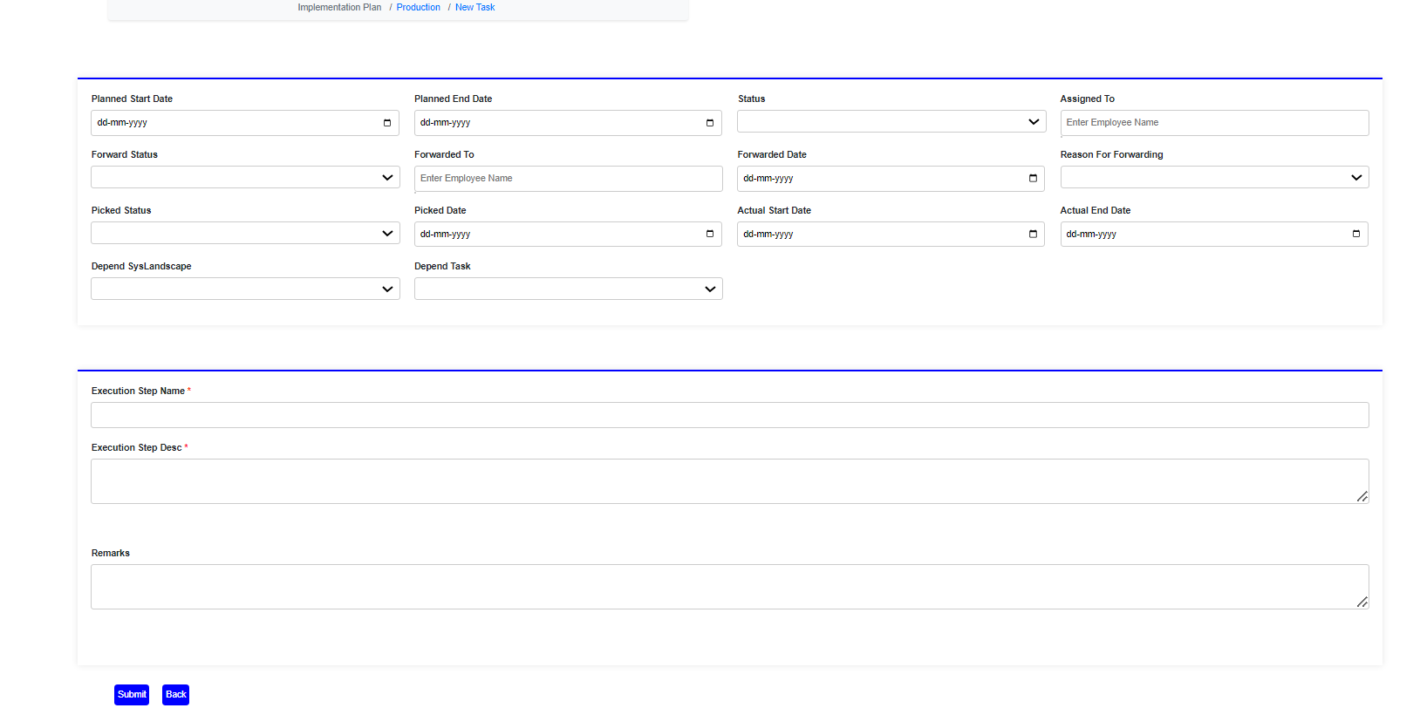

Fill out all of the form's mandatory fields.

Note: Because this is the initial task, it will be independent, which means there will be no dependent tasks. If the status is Unassigned execution step name and execution step description are mandatory fields, once you have entered the appropriate data, click the submit button.

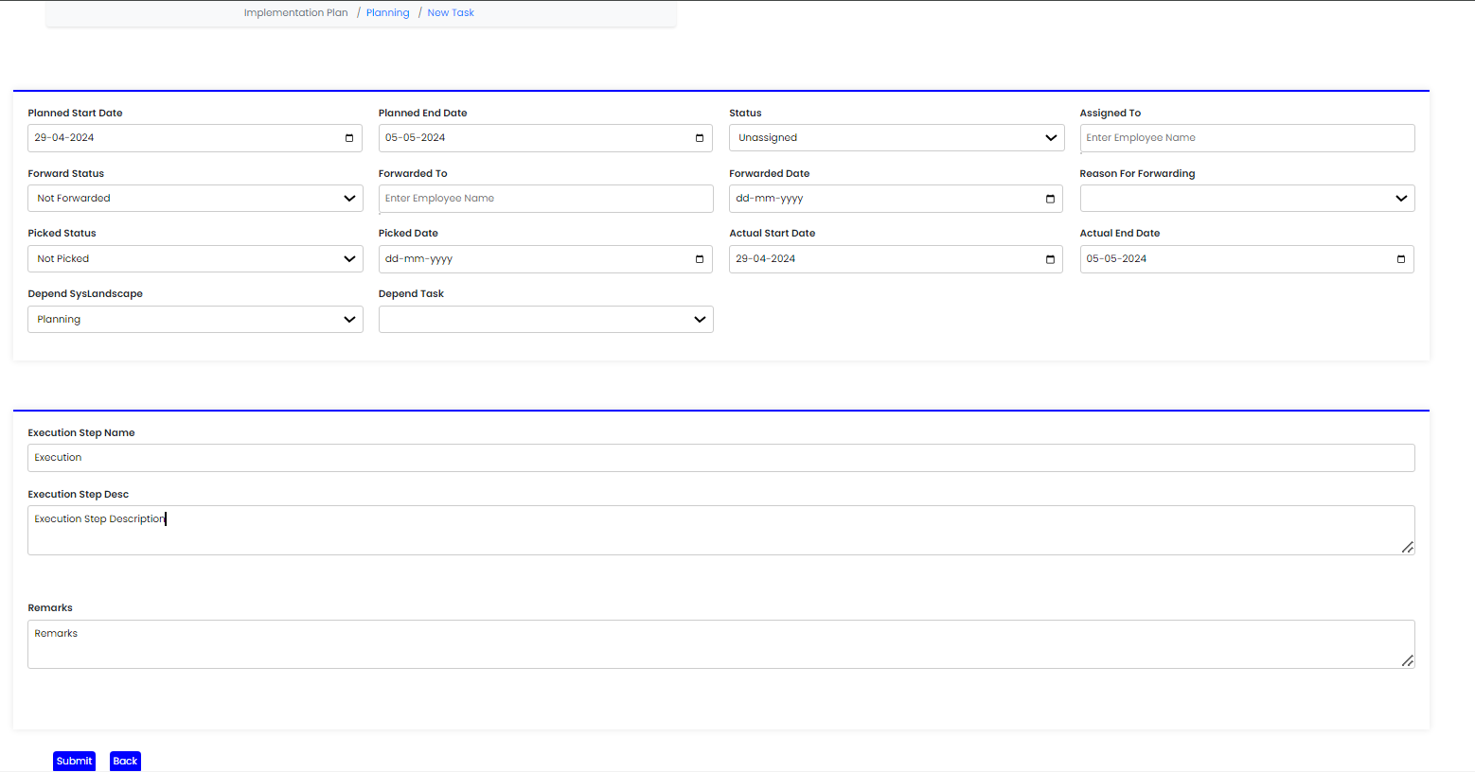

When you submit it, you will see a pop-up notification saying "Change ID 230: Implementation Task ID is successfully Saved."

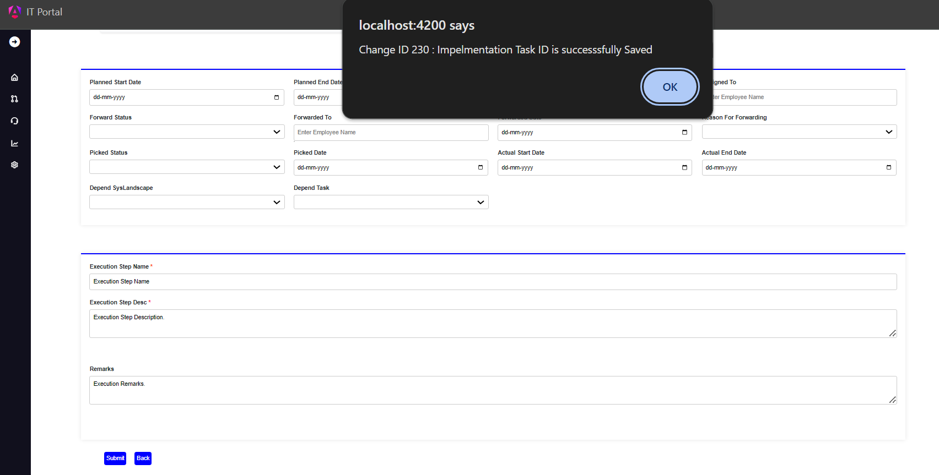

As the task was generated, this is how it appeared. As we have generated one task, it is displayed in the table, which includes the task number, task name, intended start date, finish date status, assigned to, forwarded to Depend system landscape, and depend task. We can add n number of tasks.

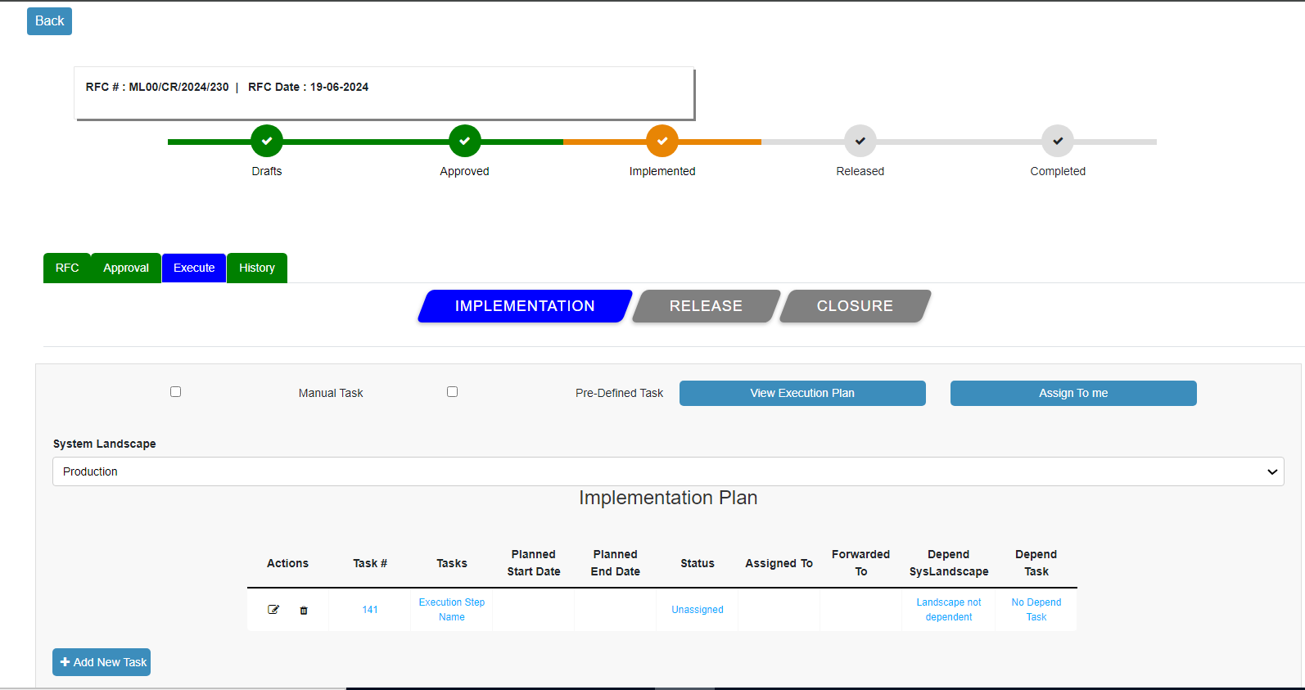

If you want to add another task, click on Add New Task and create a new one as it will be the second task and it can be dependent task click the Add new button.

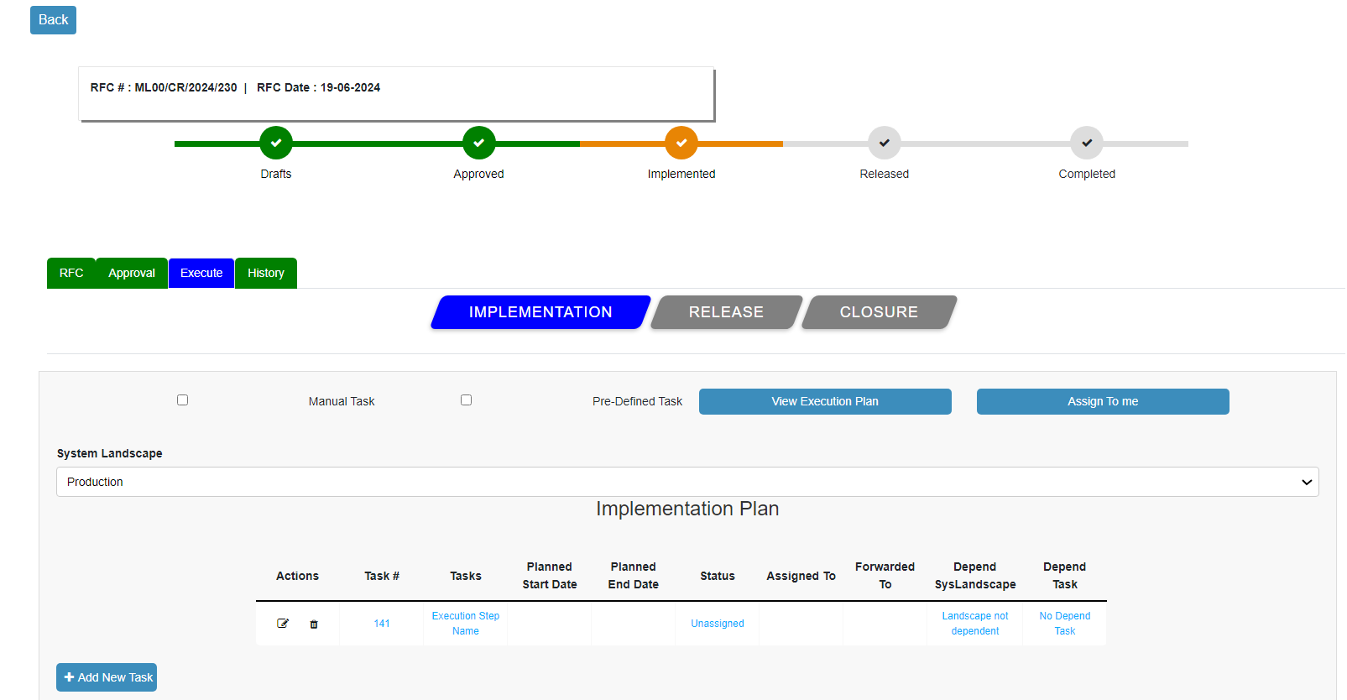

Adding a new task and as it will be the second task and it can be dependent task. If the status is assigned Planned start date, Planned end date, Assigned to, Actual start date, Actual end date, Execution step name and Execution step description are mandatory field.

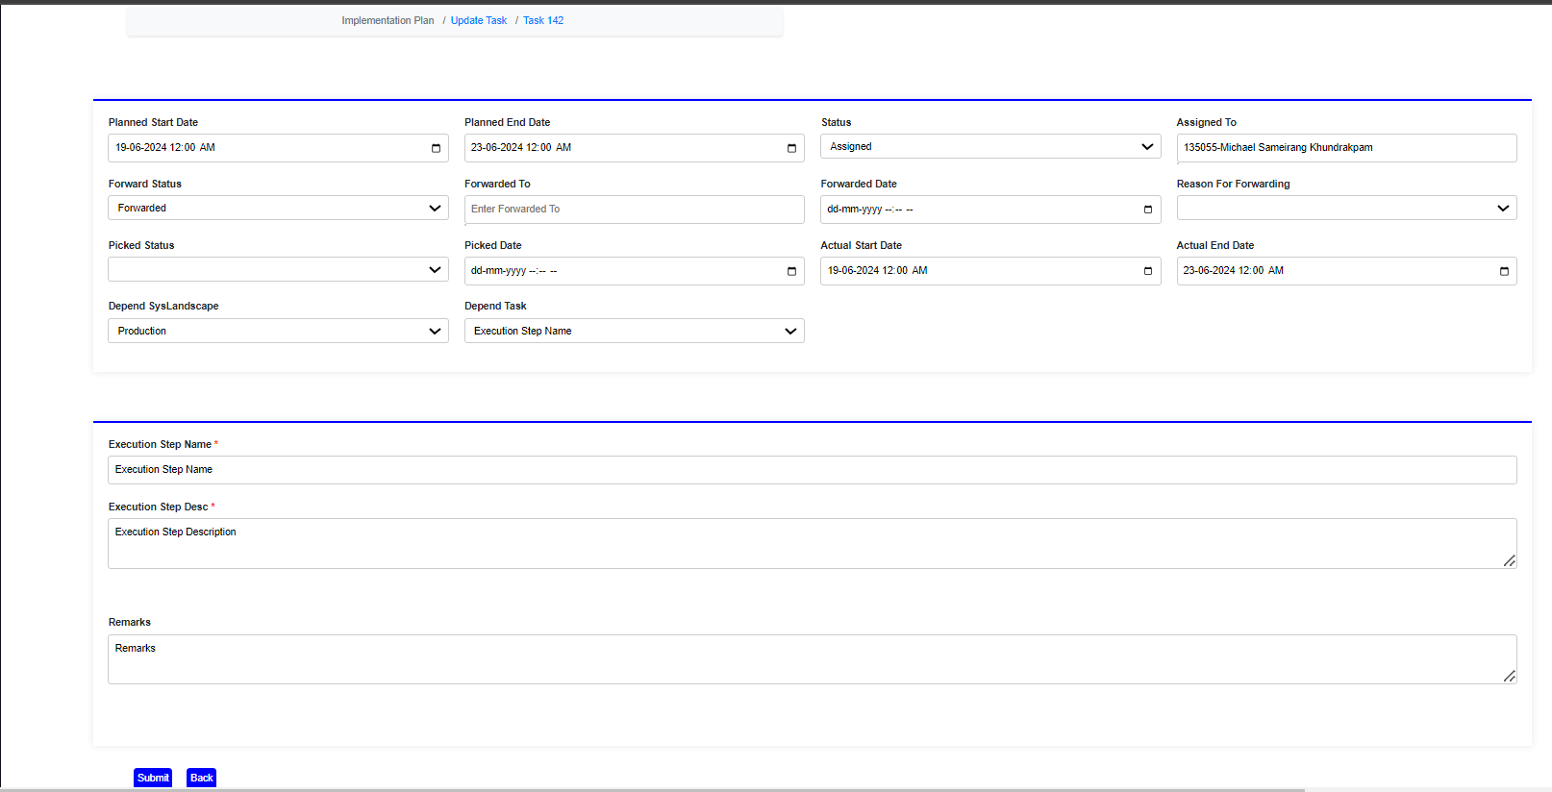

Task added successfully once clicked on submit button it will give you a pop up message saying “Change ID 230: Implementation Task ID is successfully saved”

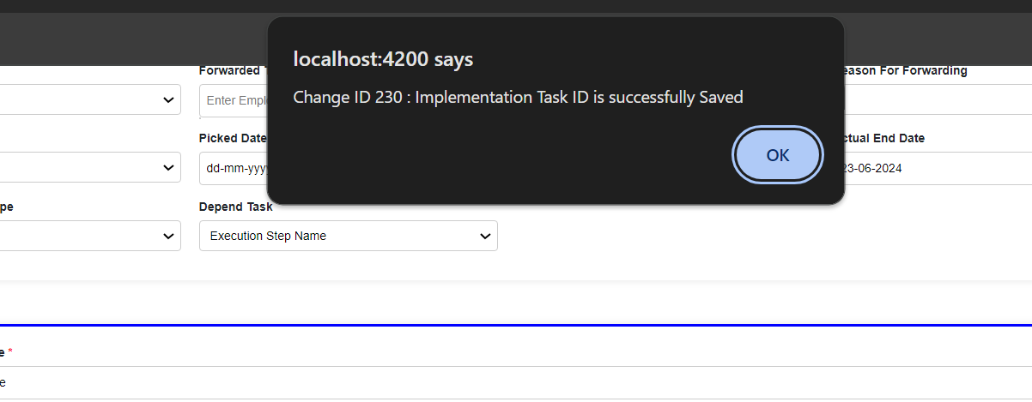

Once clicked on okay emails will trigger to the person who got task assigned and to the requestor with particular task ID.

Email triggered for task ID 142.

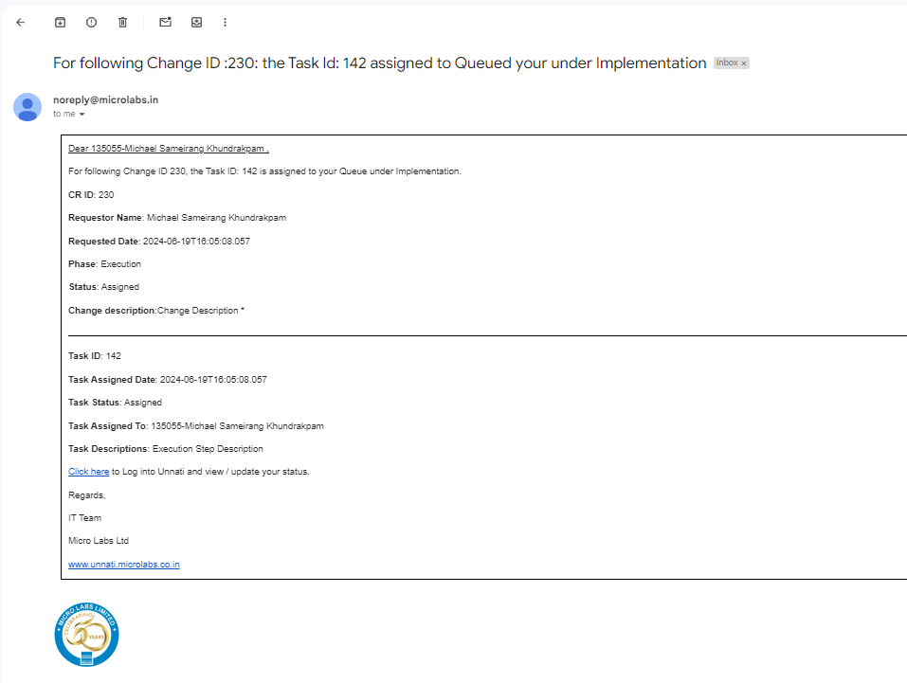

To proceed to the next step of execution, which is release, all created task statuses must be updated to completed; even if one task status is assigned, unassigned, or on hold, the submit for release button will not show. To update the status of a task, select it from the landscape and click the update button, and select the status as completed. To mark the status of task as completed, the Picked Status, Picked Date are mandatory.

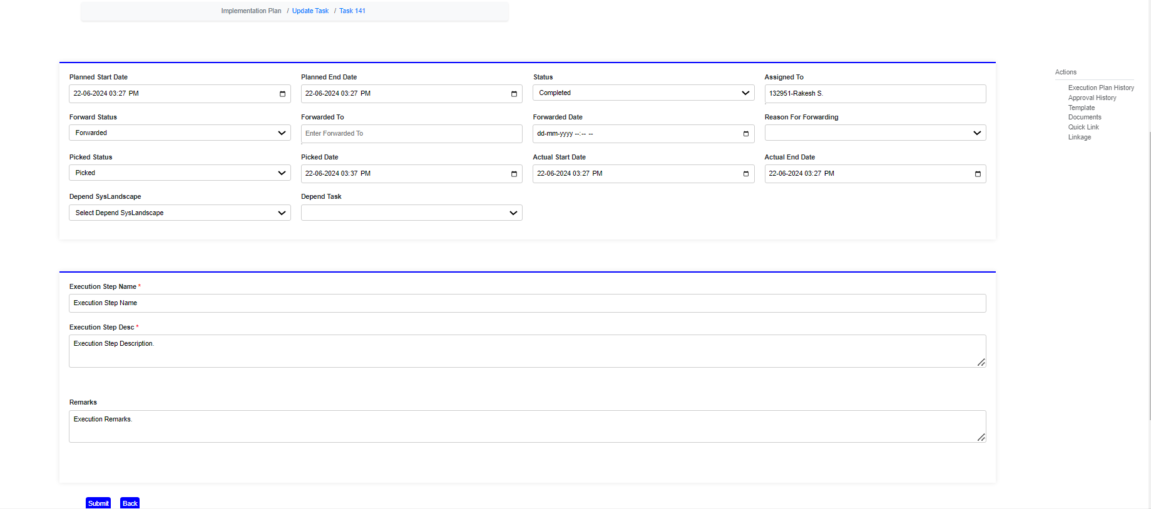

Once clicked on submit button it will give a pop up message saying “Change ID 230: Implementation Task ID is successfully Picked”

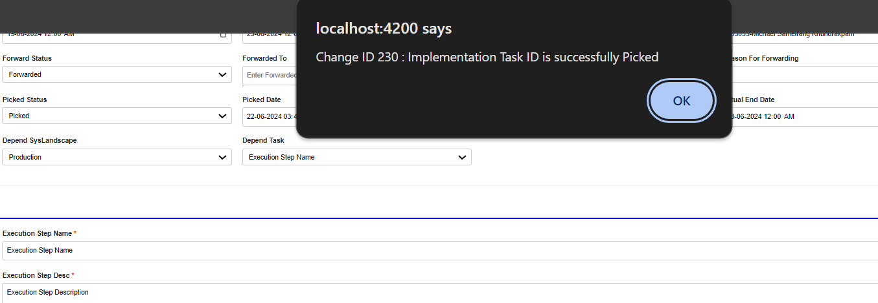

And once clicked on okay emails will get trigger to the requestor and to the person whom the task was with, the task status as completed.

Email triggered for task ID 141 status as completed

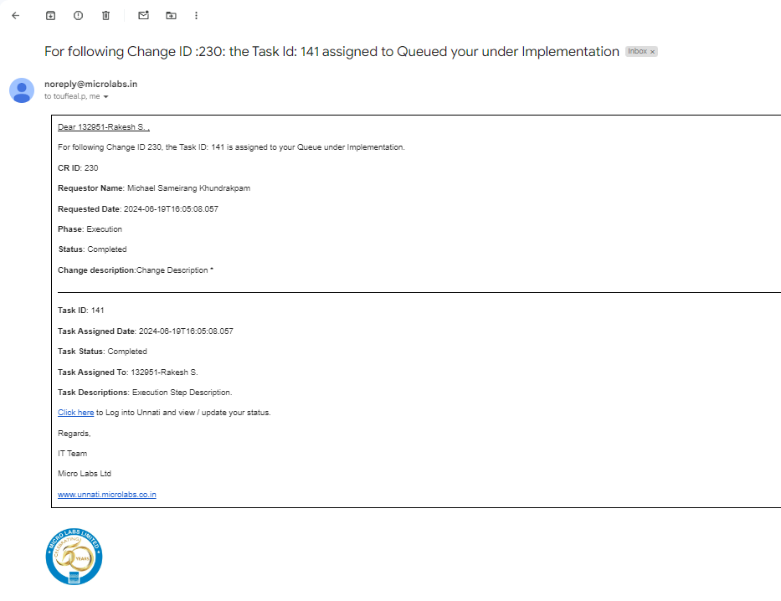

Email triggered for task ID 142 status as completed.

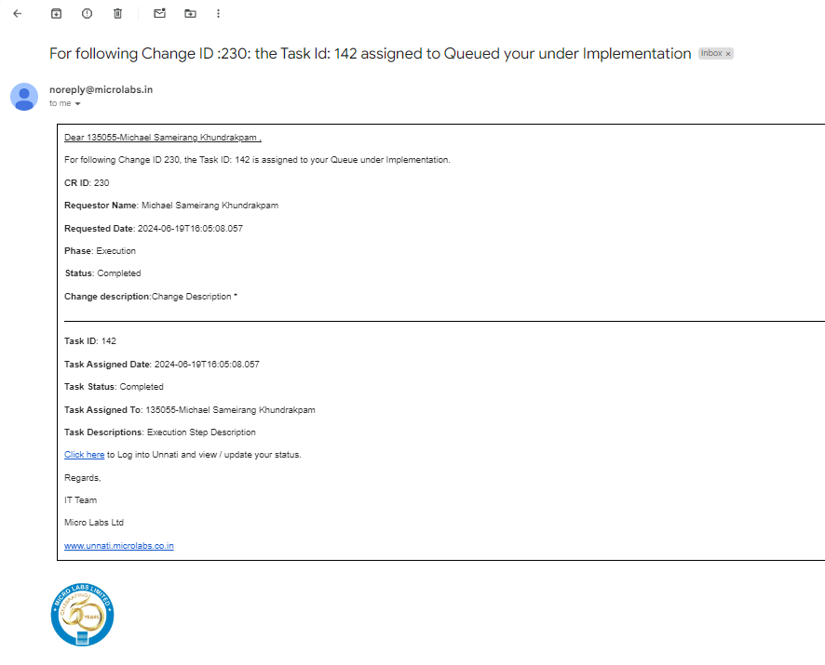

Once all of the task statuses have been updated to complete, the submit for release button will appear.

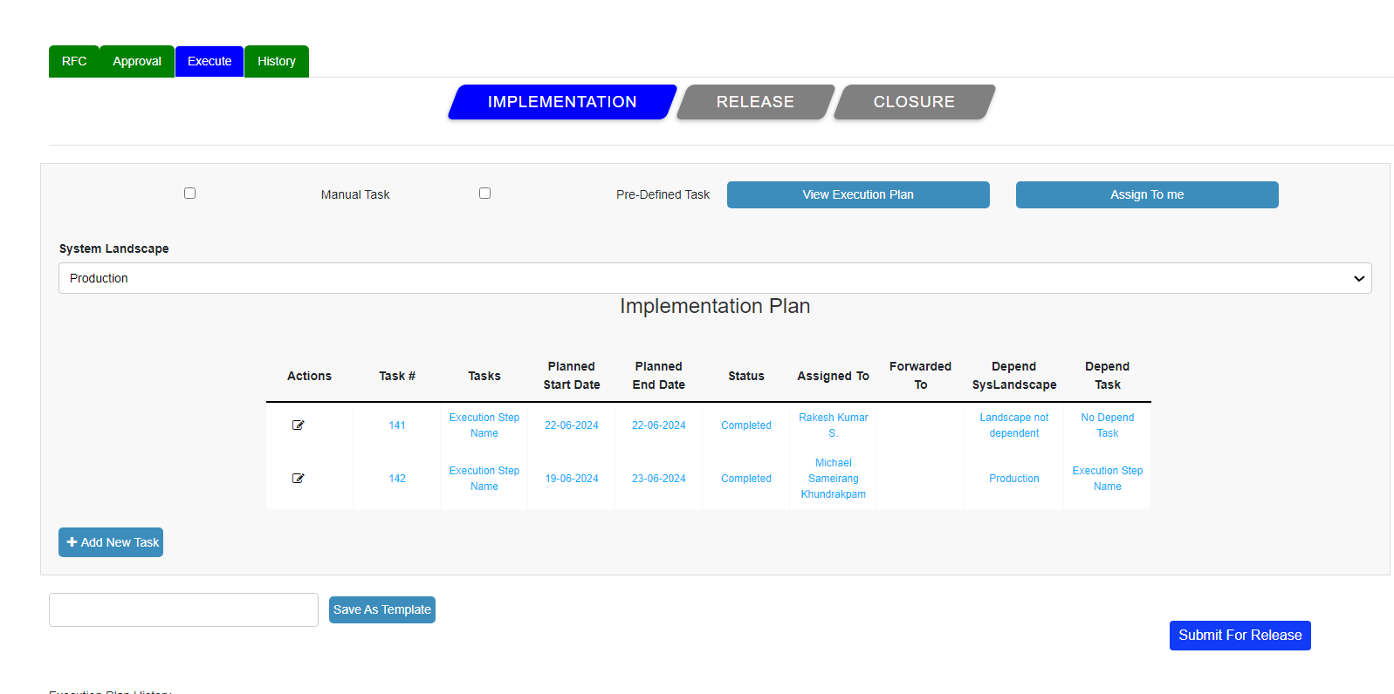

Users can also read the task description and remarks from the below execution plan table.

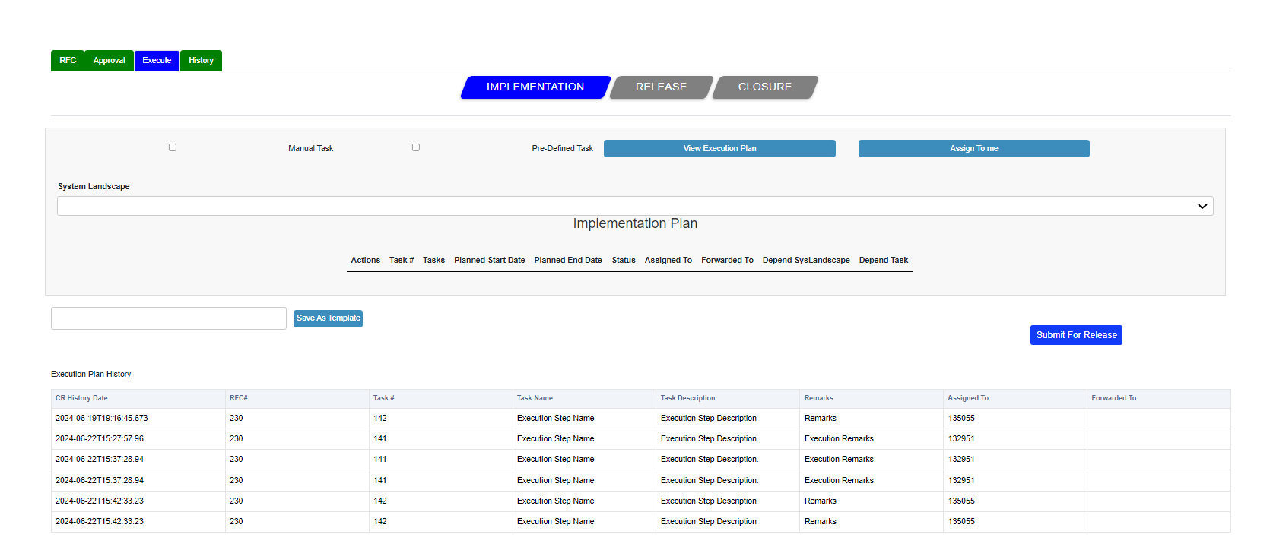

And the stage of the CR got updated to Implementation and the status is updated as Implement.

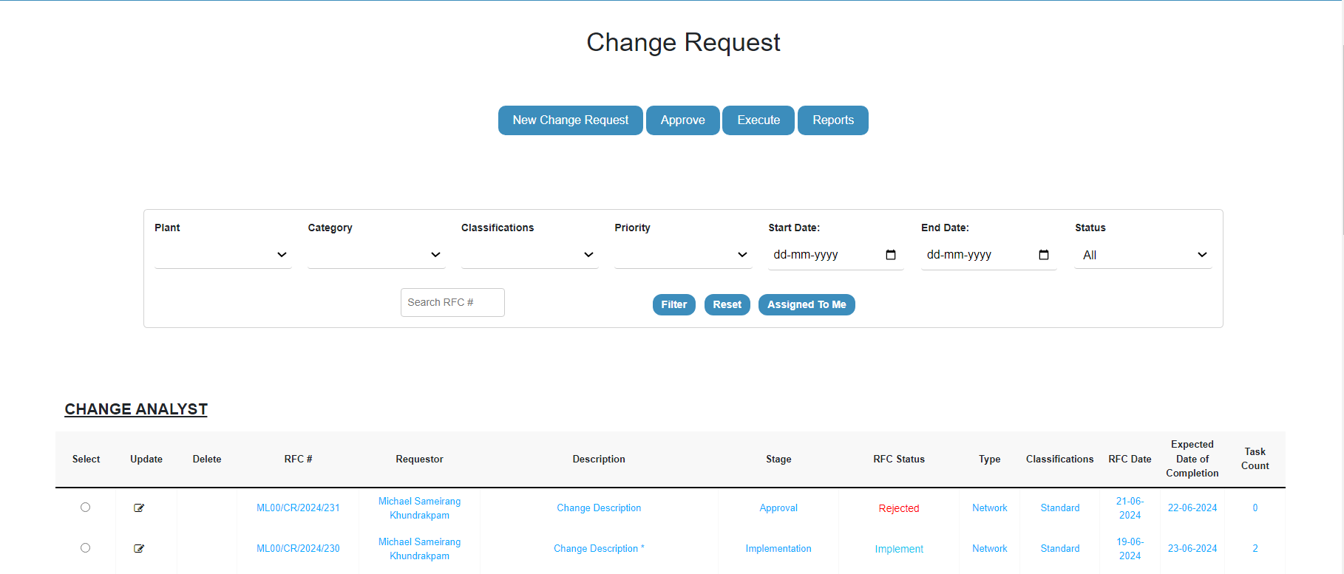

Once clicked on the submit for release button, you will see a pop up message saying “Change ID 230: Release successfully submitted for Approval.

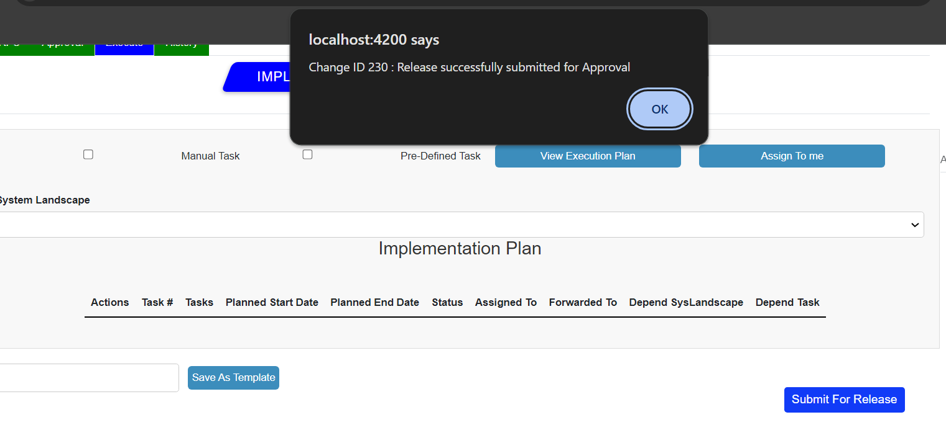

Once the submit for release button is clicked the emails will get triggered to the requestor and the approvers who are assigned.

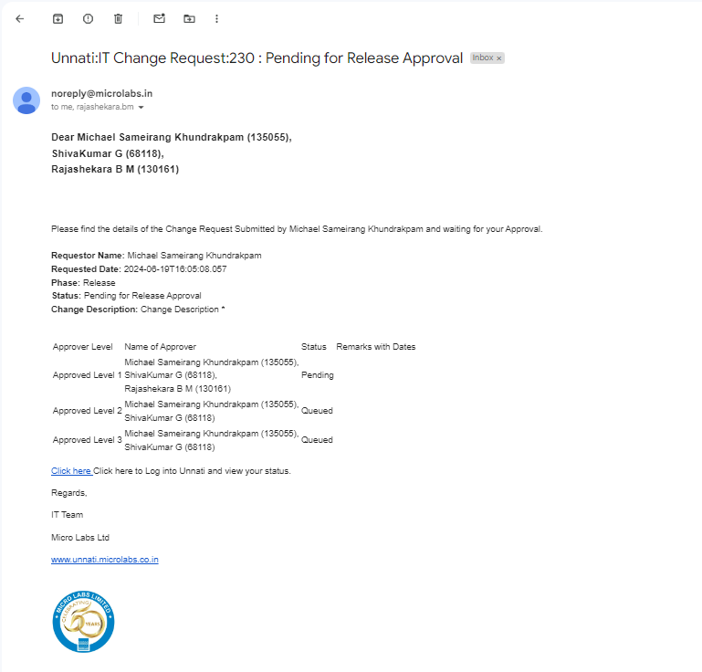

the stage of the CR got updated to Implementation and the status is updated as Implemented.

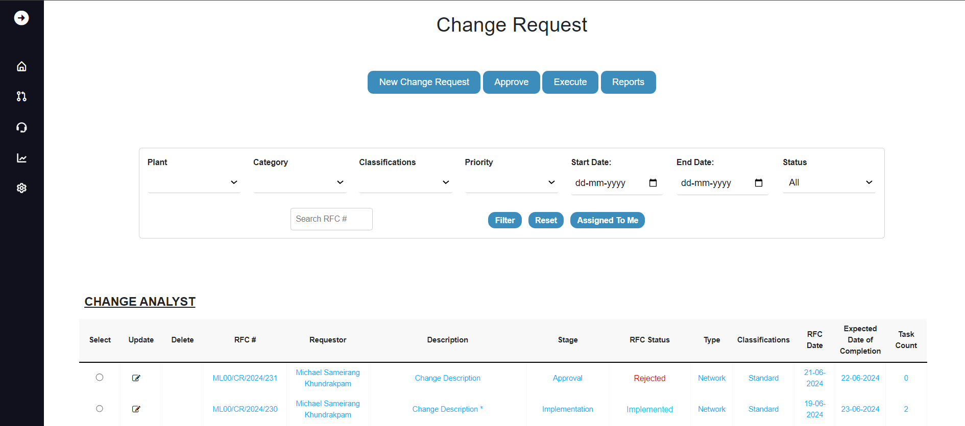

As the implementation is done, the status bar of the specific CR is updated as implemented, and the implementation button colour changes to green, while the release button changes to blue.

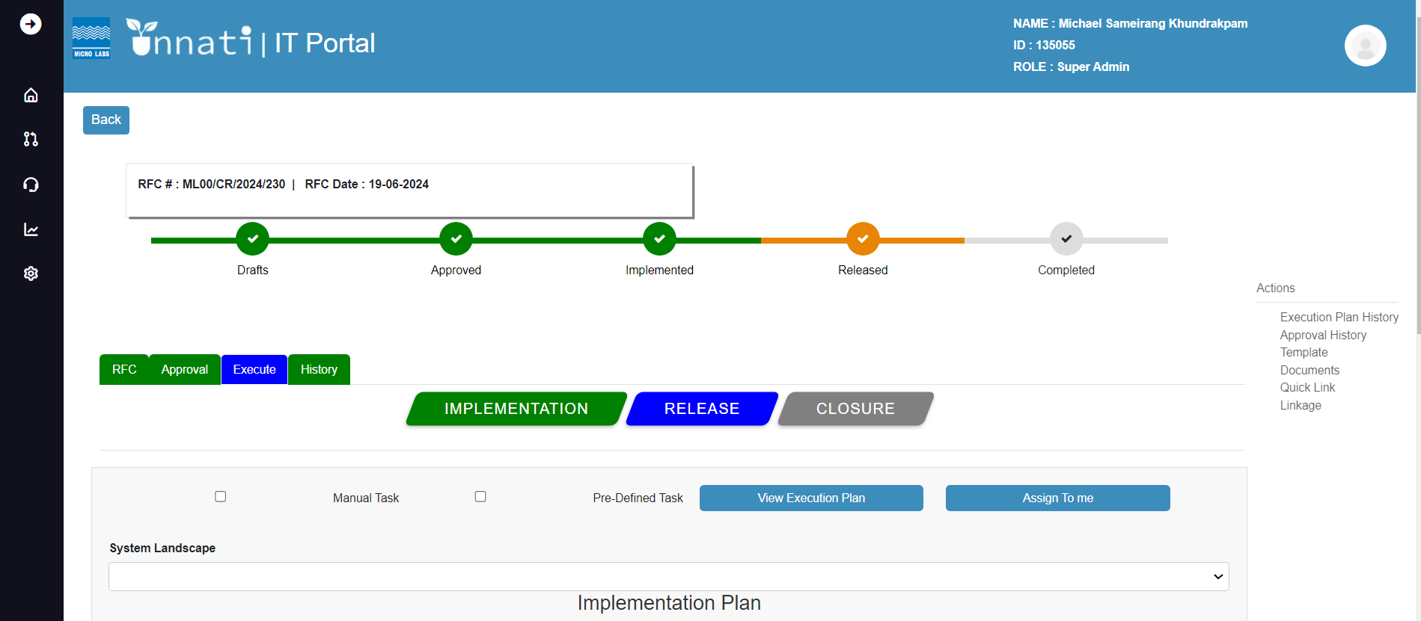

Release Approver:

Select the specific CR and click on approve button, execute button and then click on release. By doing this we will enter the release approver phase 1 Once in the release approver, click on Approve 1, capture the Remarks, and click on the Approve button.

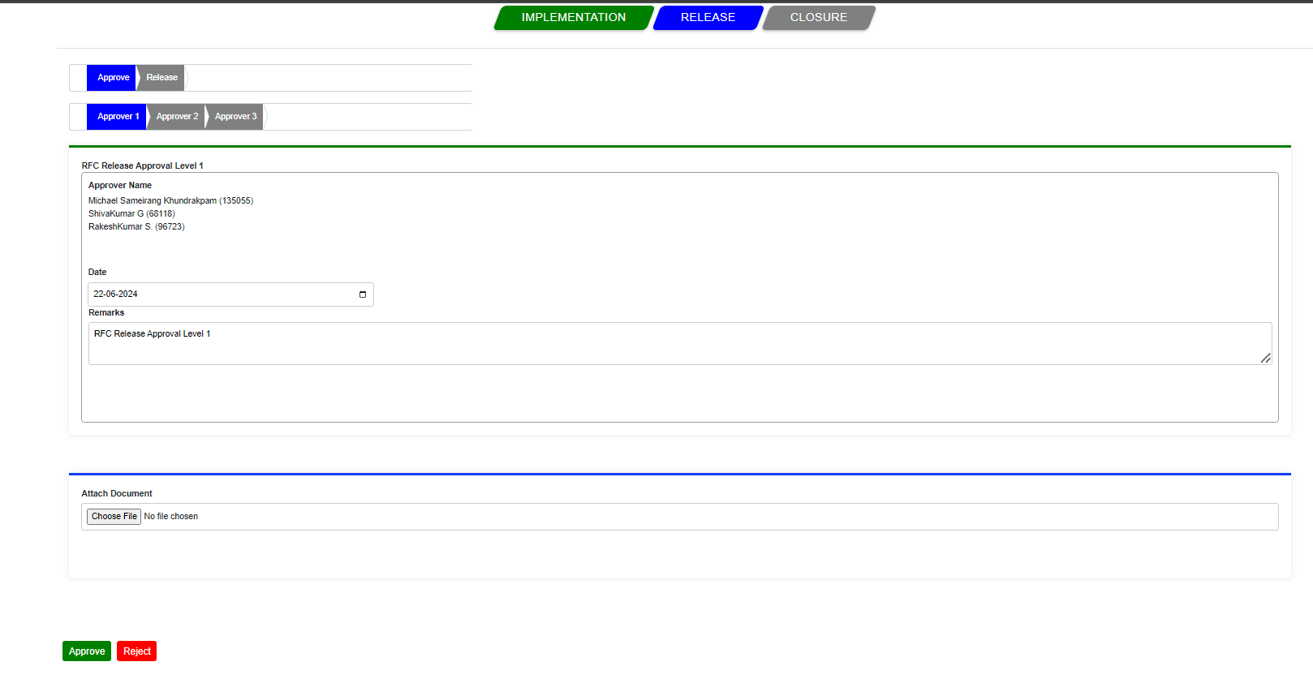

When you click the approve button, a popup message will appear saying that “Change Id:230 Released Approved Level1”

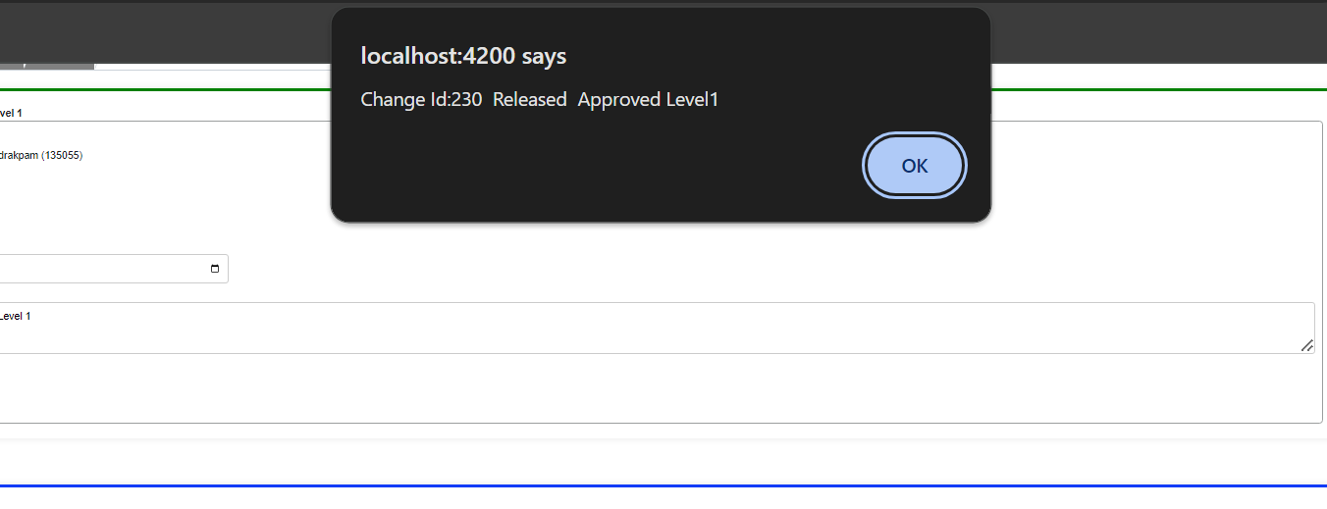

Once clicked on okay emails will get triggered to the Approvers, requestor and to CR owner with the current CR status.

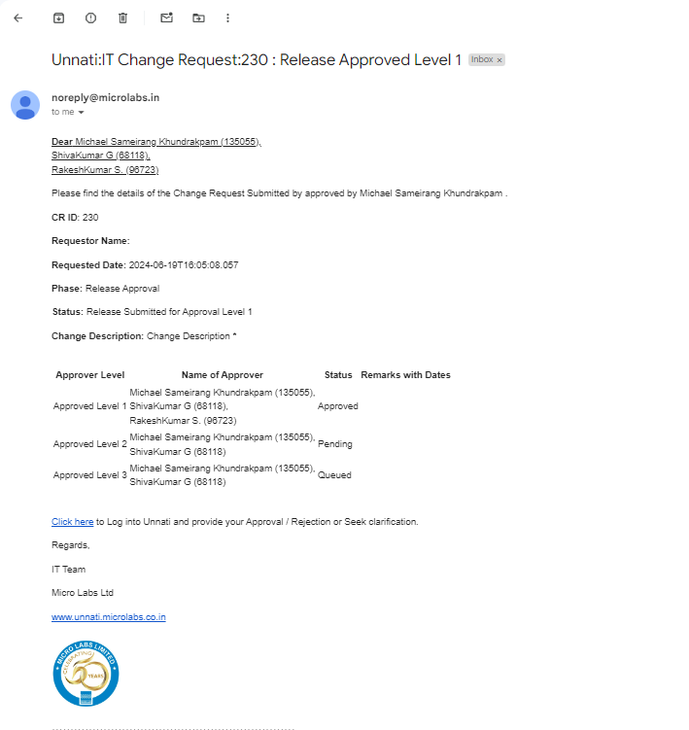

The status of the specific CR has been updated, stage to Release, and the status is Approved level 1.

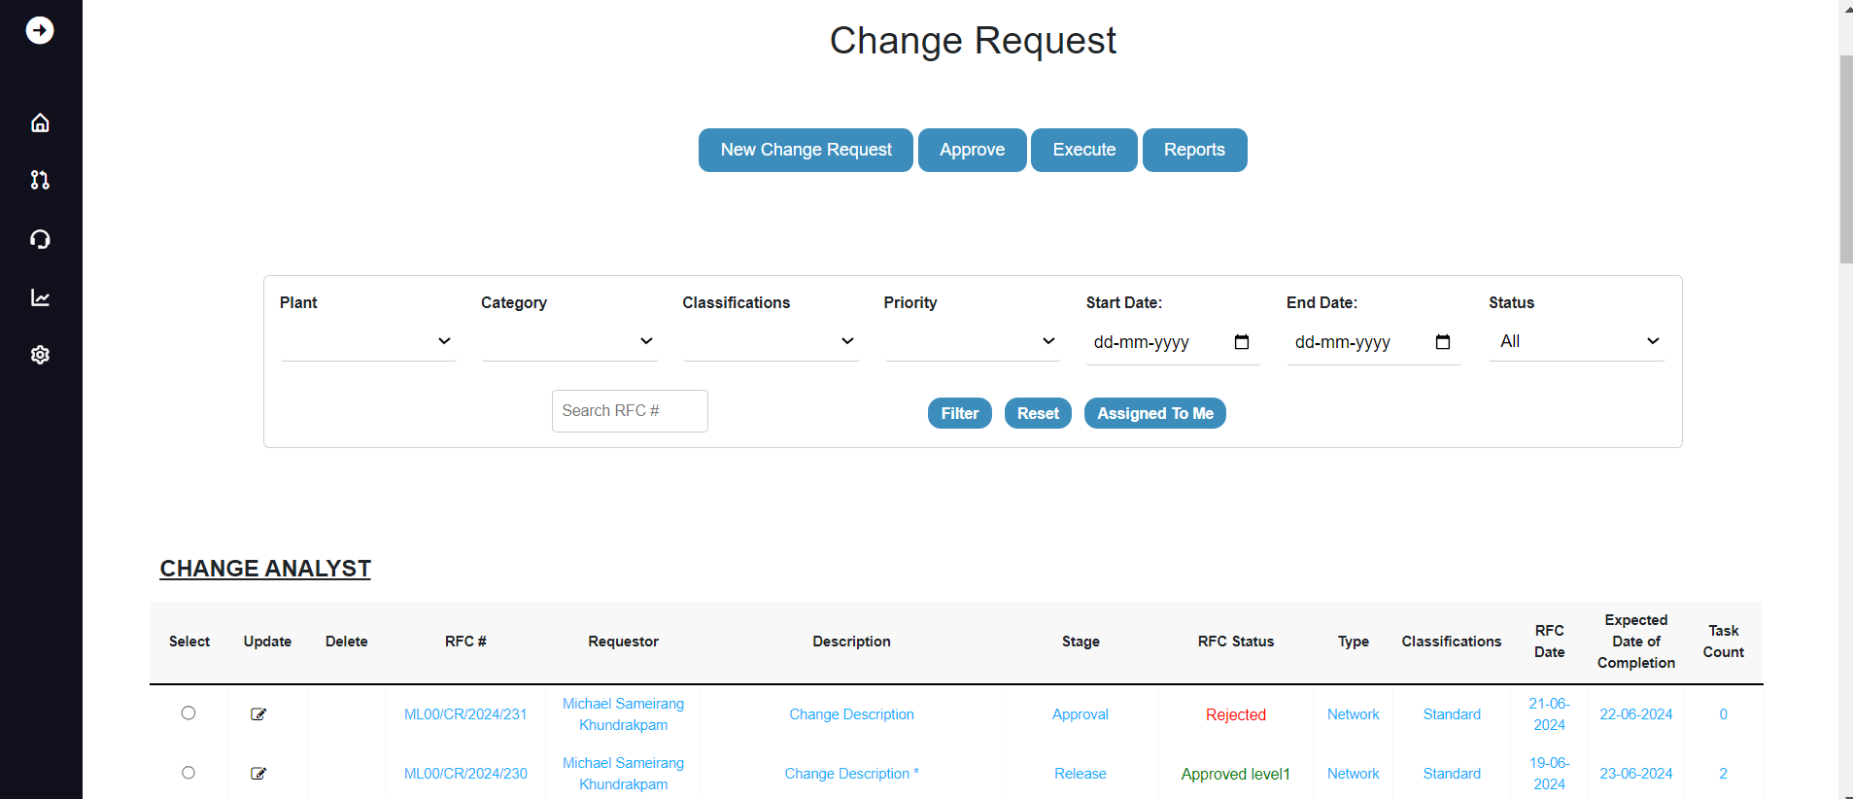

Now that we are in the level 2 phase, you can see that the approver level 1 colour has changed from blue to green. As the level 1 approver, you will not have access to approve the level 2 and will not be able to see the name of the level 1 approver and the following buttons- Approve and Reject. So, the following CR must be approved by level 2 approvers.

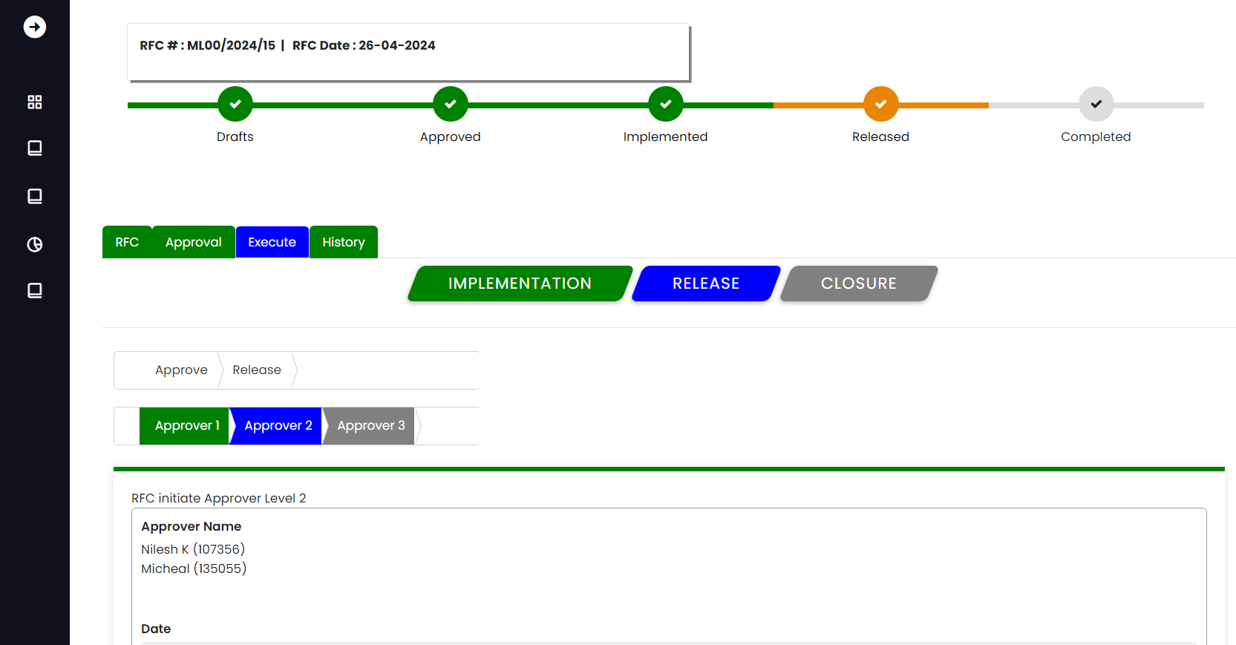

Level 2 Approver:

As a level 2 approver, you can see that approver2 is blue, which indicates that you are in the approval level 2 phase.

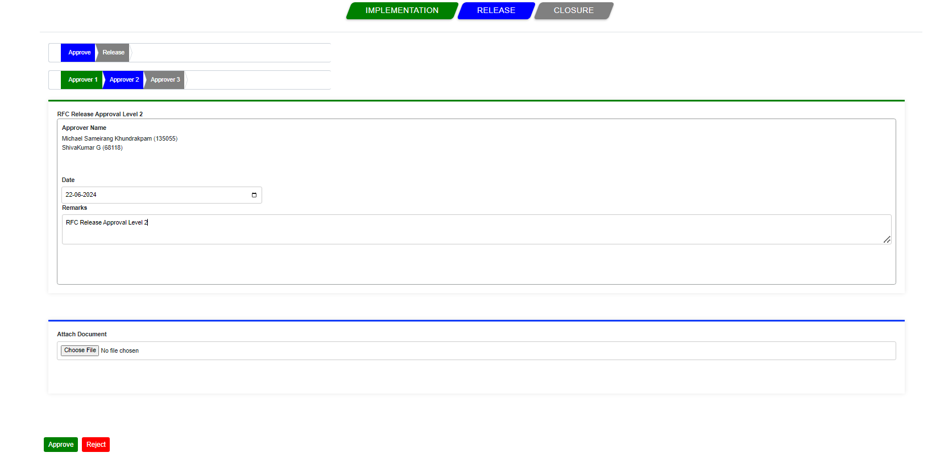

Capture your remarks and click on approve, and the remarks are saved and a popup message appears stating “Change Id:230 Released Approved Level2”.

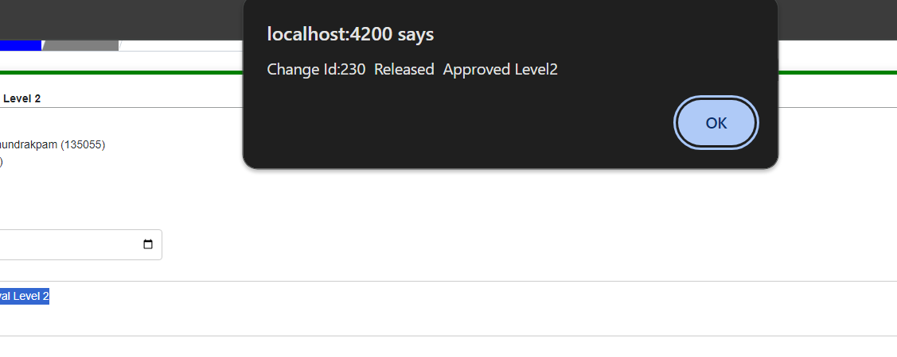

Once clicked on okay emails will get triggered to the Approvers, requestor and to CR owner with the current CR status.

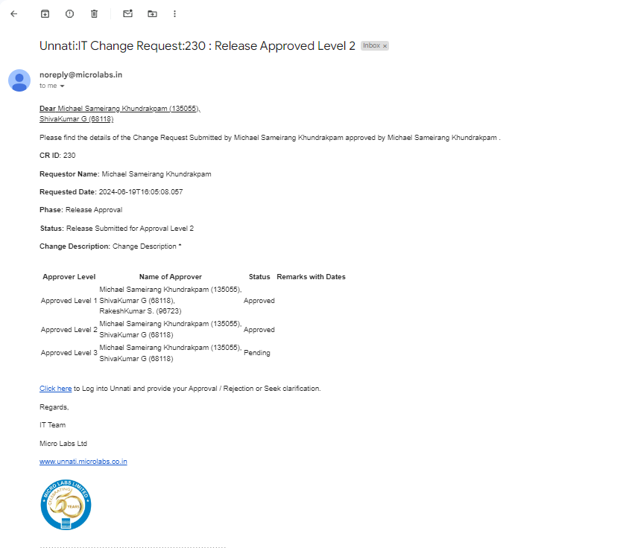

Once the Approver level 2 notes have been successfully Updated, the CR's stage will shift to Release and its status to Approved level2.

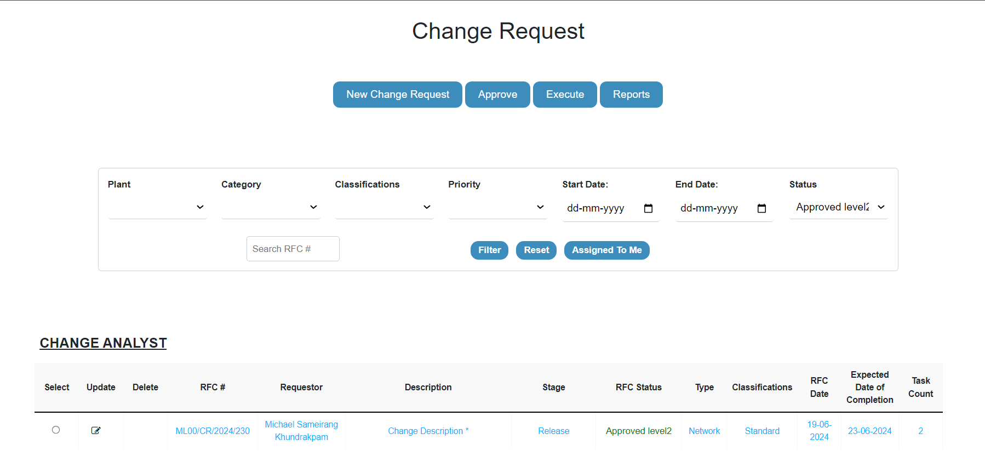

Now that we are in the level 3 phase, you can see that the approver level 1 colour and 2 has changed from blue to green. As the level 2 approver, you will not have access to approve the level 3 and will not be able to see the name of the level 2 approver and the following buttons- Approve and Reject. So, the following CR must be approved by level 3 approvers,

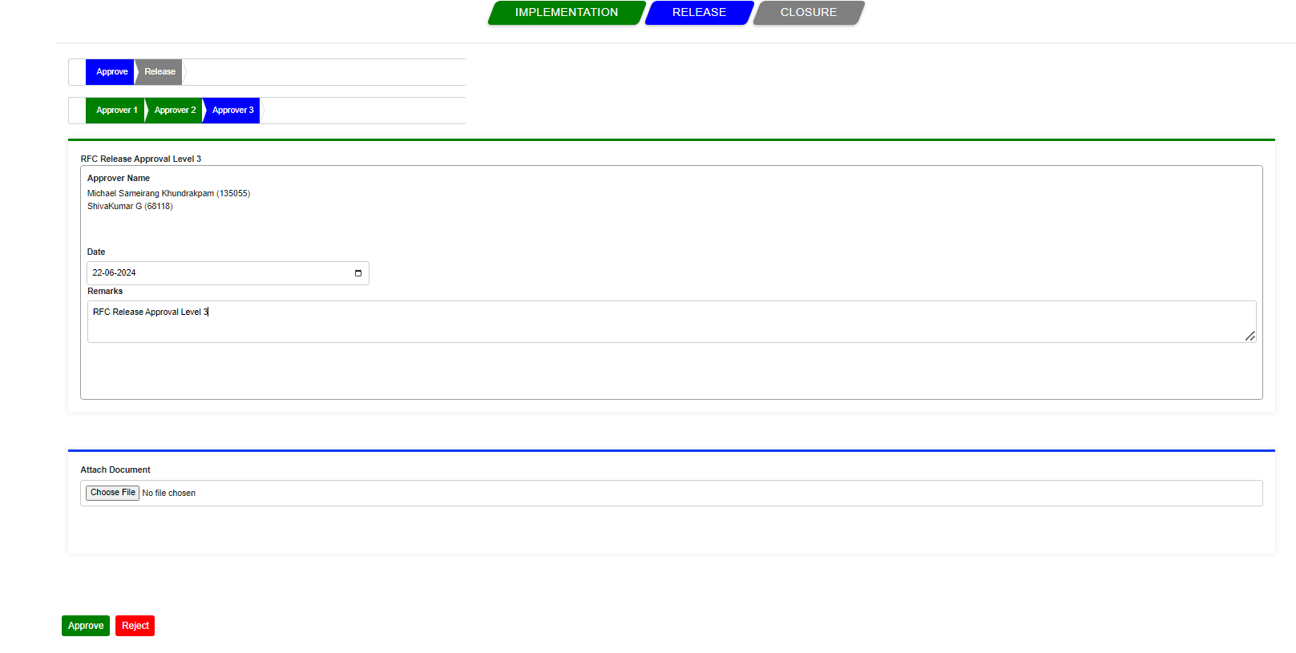

Once the level 3 approver Capture the remarks and click on approve, and the remarks are saved and a popup message appears stating that “Change Id:230 Released Approved”.

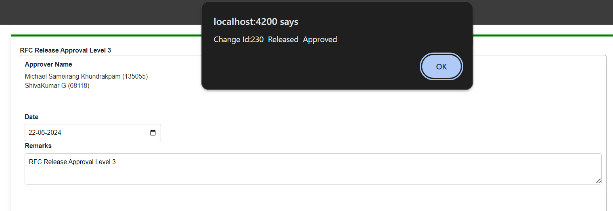

Once clicked on okay emails will get triggered to the Approvers, requestor and to CR owner with the current CR status.

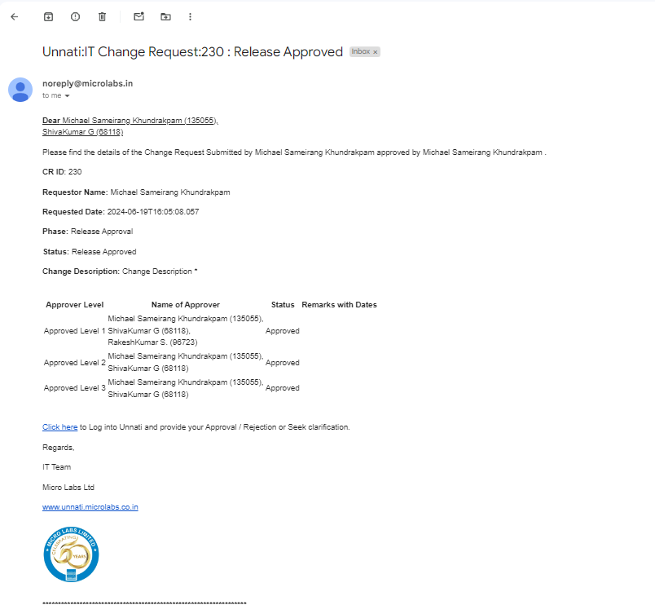

Once the Approver level 3 is completed CR's stage will shift to Release and its status to Approved.

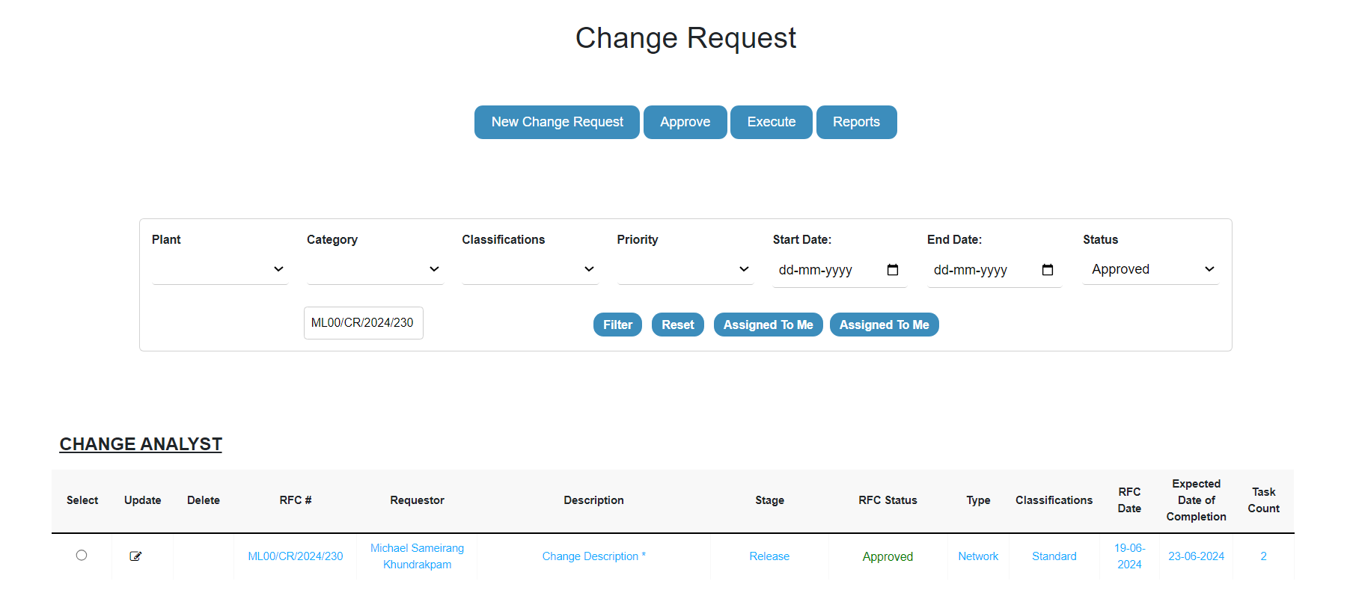

Submit for release:

Once all of the approver levels have been completed, the Status has been updated to released, and the approver will no longer be able to process the CR; instead, it is submitted by the CR owner/initiator for closure, to do so select the particular CR and click on the execute, click on Release button which is blue in colour then again click on release which is next to approver. Then it will give you a screen as given below.

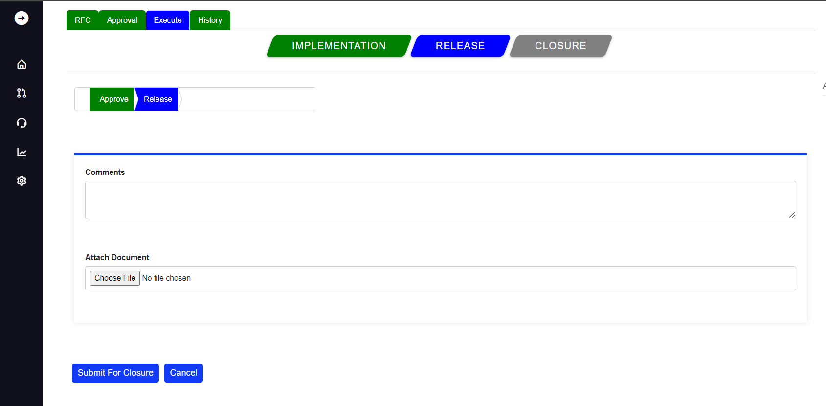

Once you captured your comments and when you select Submit for Closure, a popup message appears stating " Change Id:230 Released for Approval."

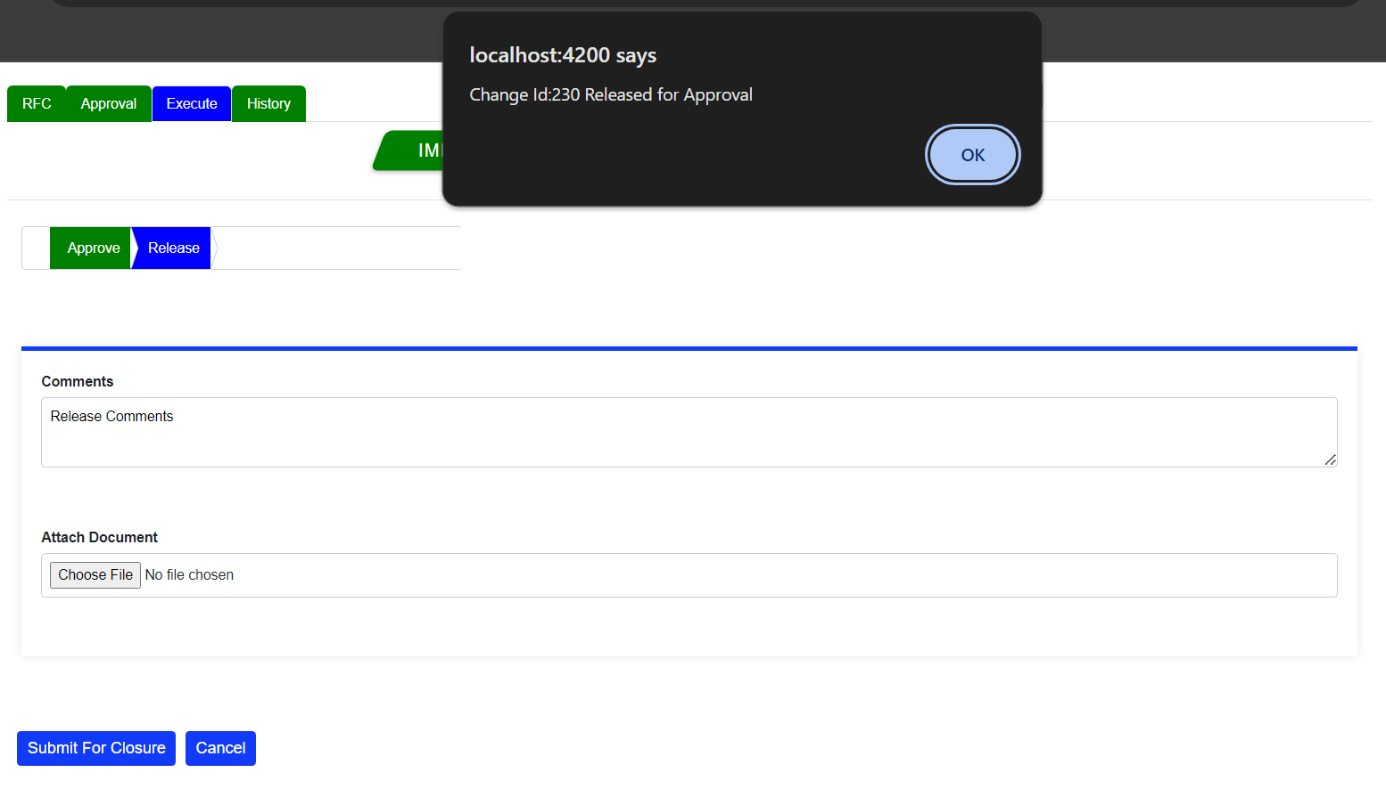

Once clicked on okay emails will get triggered to the Approvers, requestor and to CR owner with the current CR status and the release remarks.

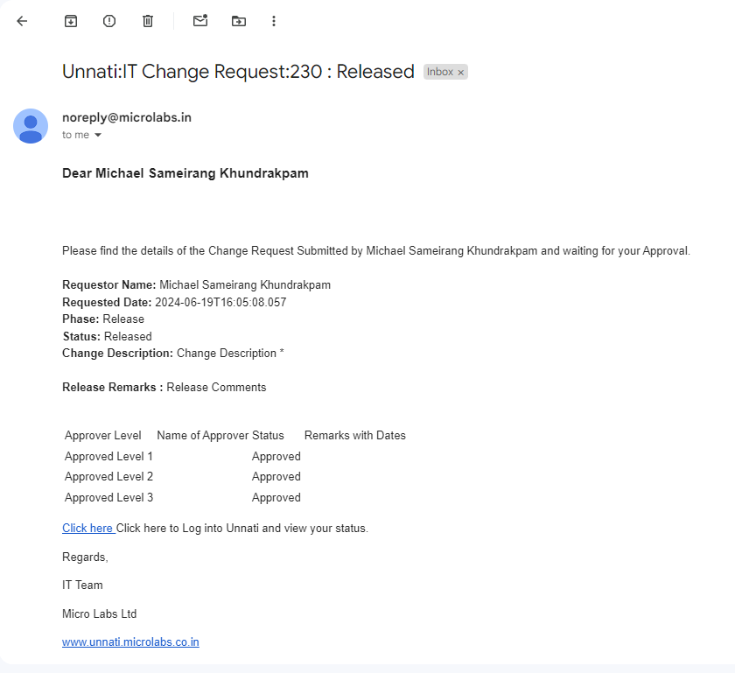

Email for Closure Approvers Queued.

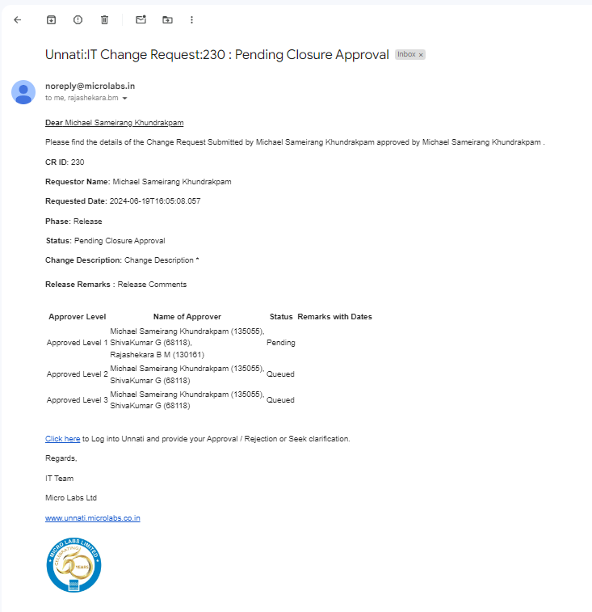

When a submit for closure button is hit, the stage of the specific CR stage is updated to Release, and the CR's status is updated to Released.

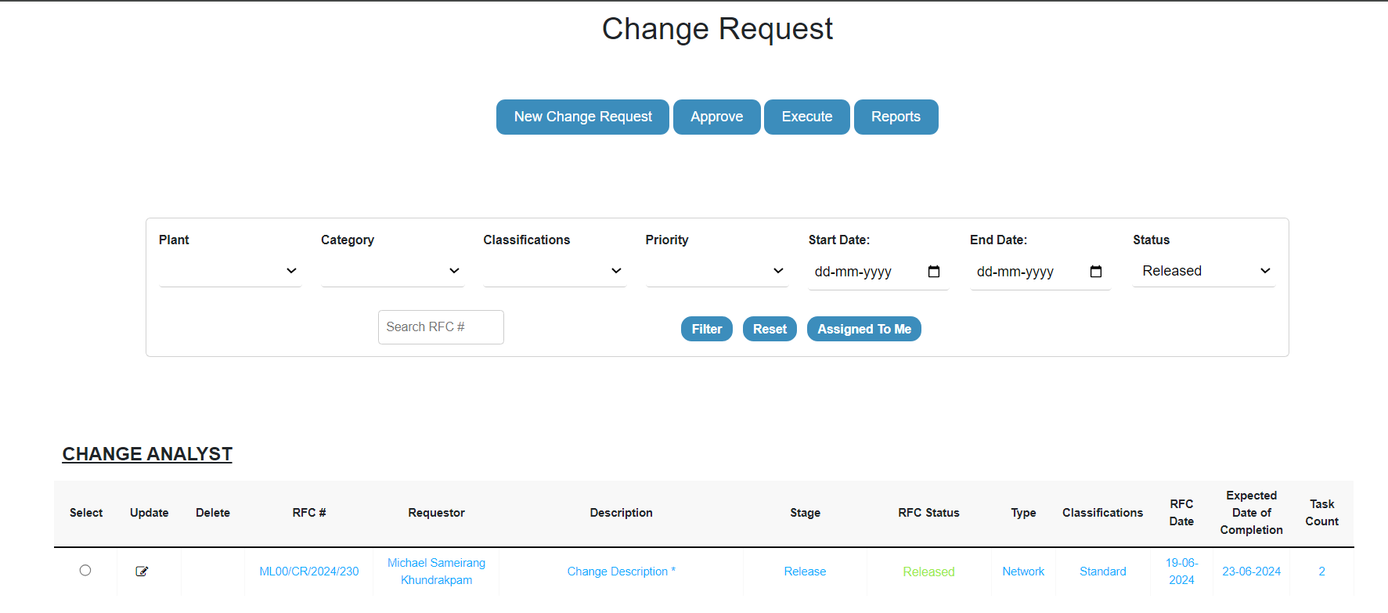

Once the release is done, the status bar for the particular CR will update as released, and the release button will change green in colour and the closure will be in blue, indicating that the release is complete while the status indicator for Complete will be orange in colour.

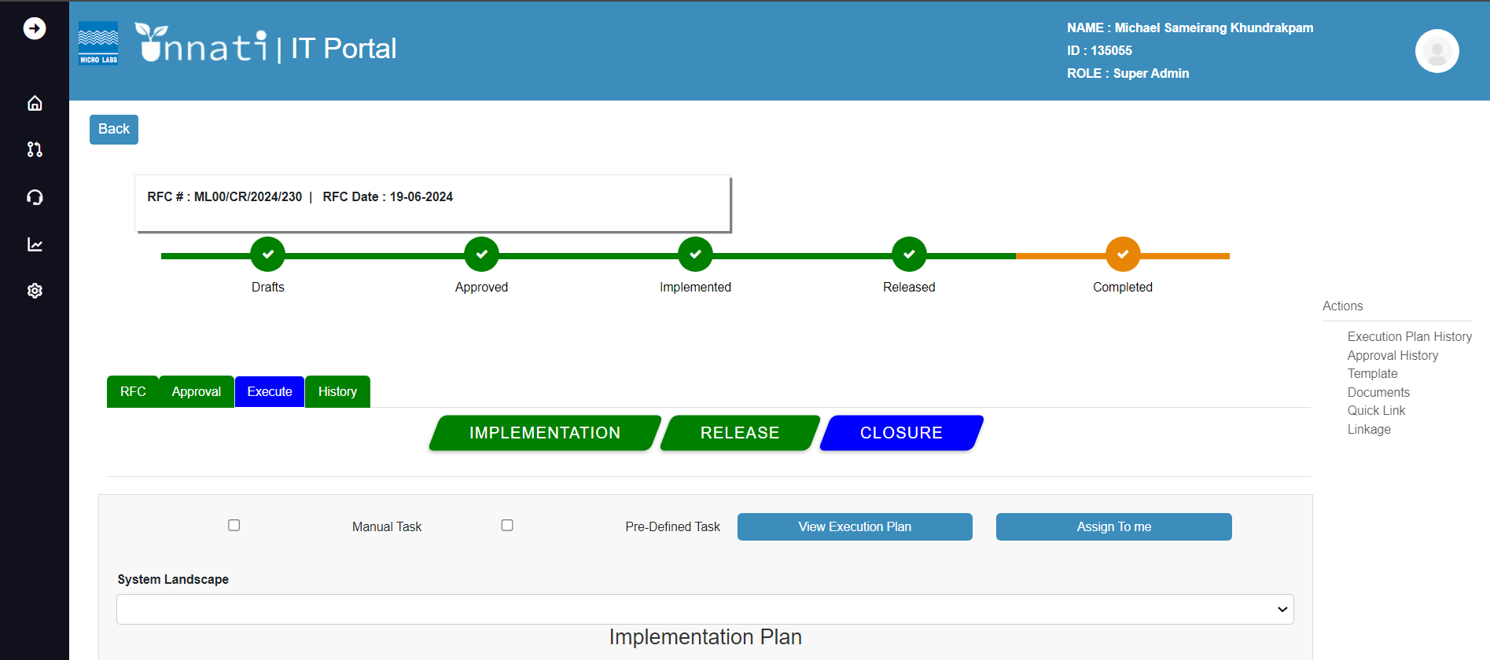

Closure Approver:

After the release is completed, the following step is Closure approver. When you click on closure, a screen will appear with the following details: approver-closure-follow up-lessons learned.

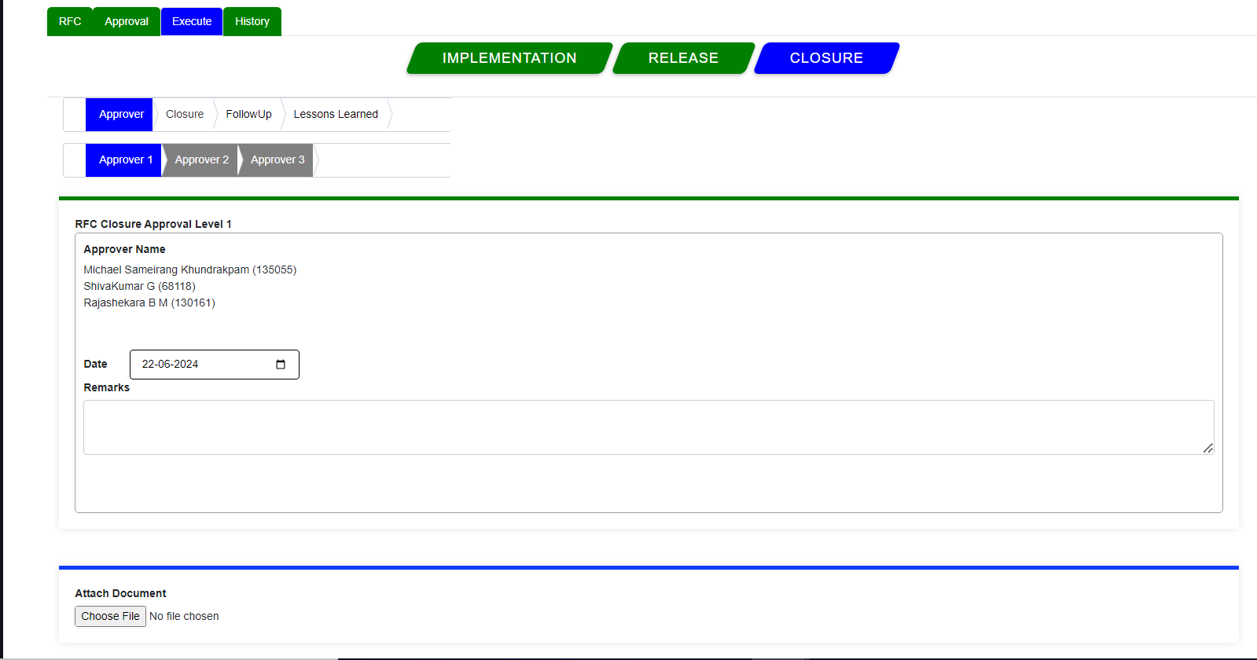

click on Approver, Approver1 by doing this we will enter the Closure approver phase 1,



first capture the Remarks, and click on the Approve button a popup message will appear saying “Change ID 230: RFC Is Successfully Approved Level1”.

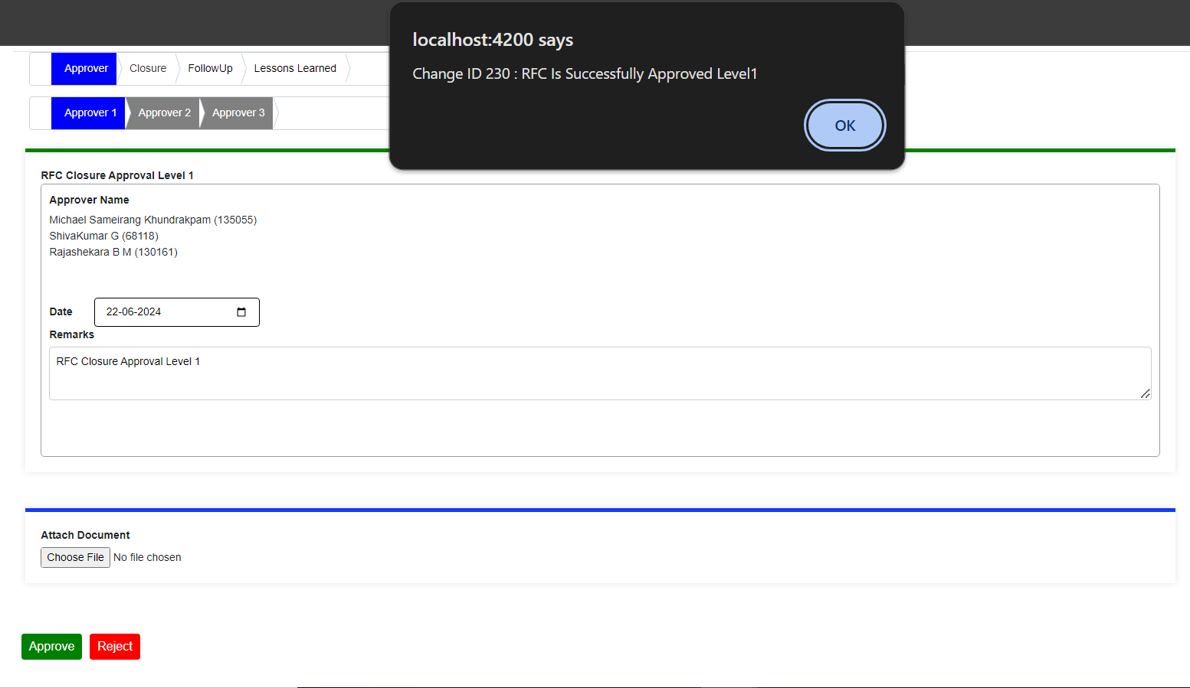

Once clicked on okay emails will get triggered to the Approvers, requestor and to CR owner with the current CR status.

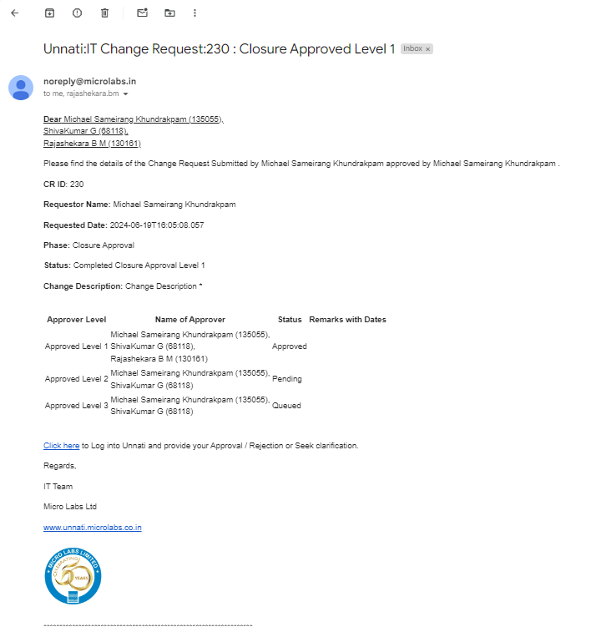

The Stage will be updated to closure and the status is approved level 1

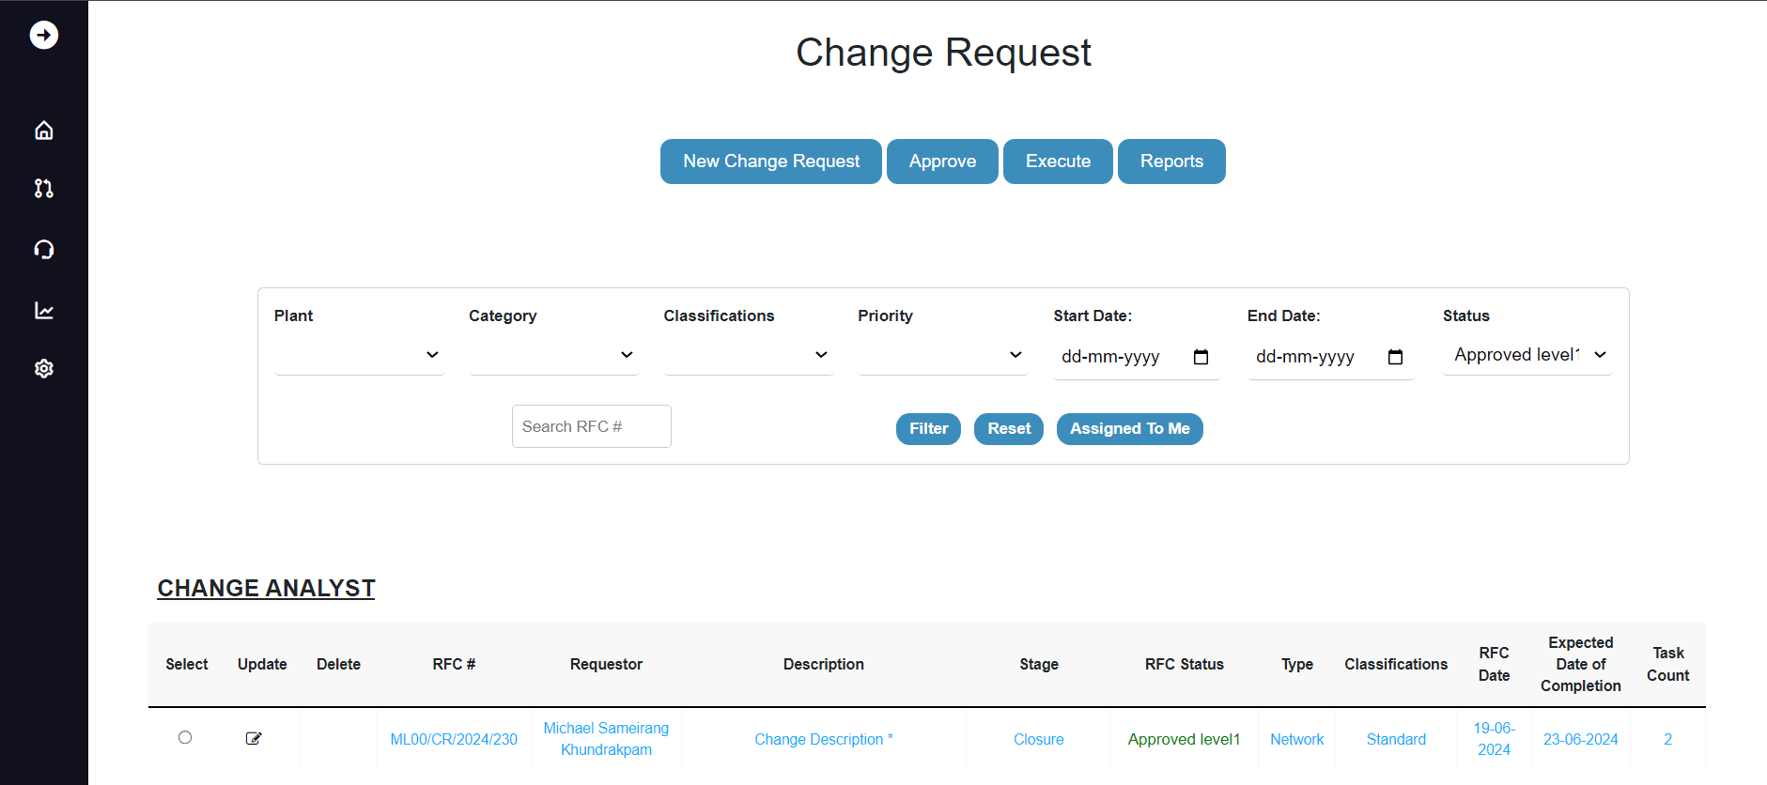

To enter the closure approver level2 phase select the particular CR and click on approve button and click on closure, click on approvers then click on approver2, as a level 2 approver, you can see that approver2 is blue, which indicates that you are in the approval level 2 phase. update the remarks and click on Approve button.

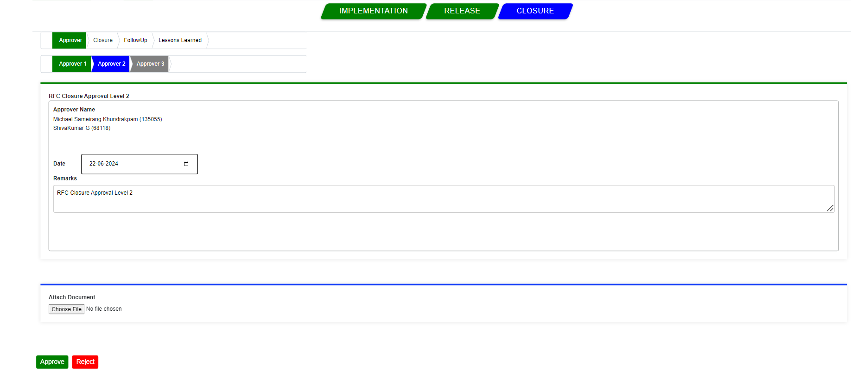

and the remarks are saved and a popup message appears stating “Change ID 230: RFC Is Successfully Approved Level 2”.

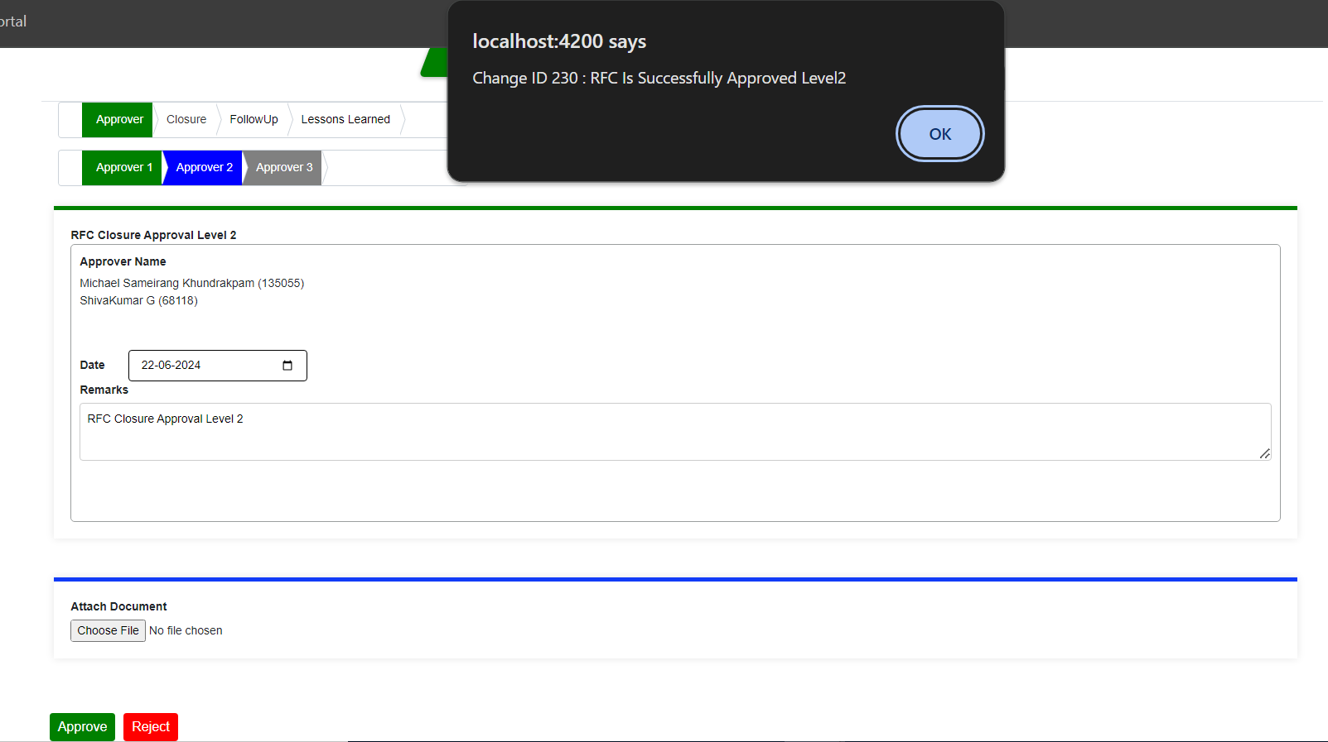

Once clicked on okay emails will get triggered to the Approvers, requestor and to CR owner with the current CR status.

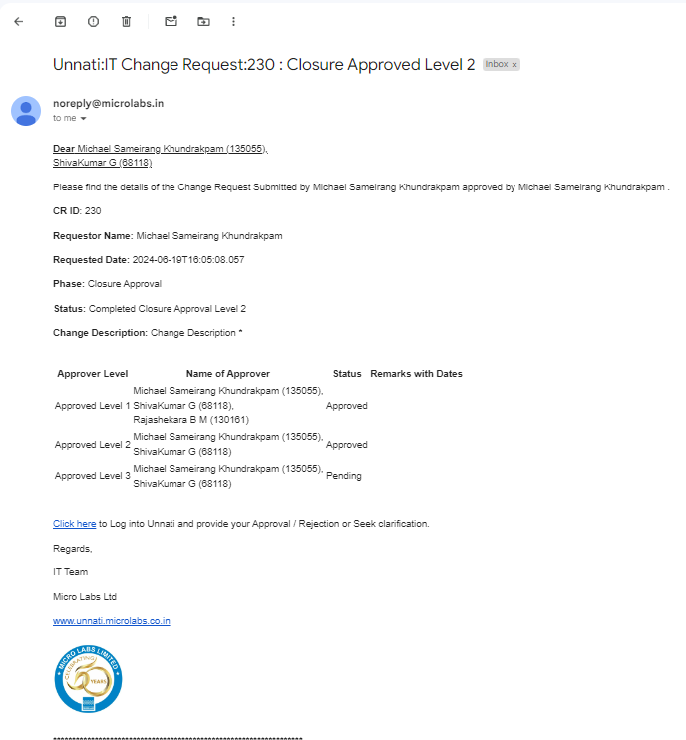

And the Stage will be updated to closure and the status is approved level 2 as shown below.

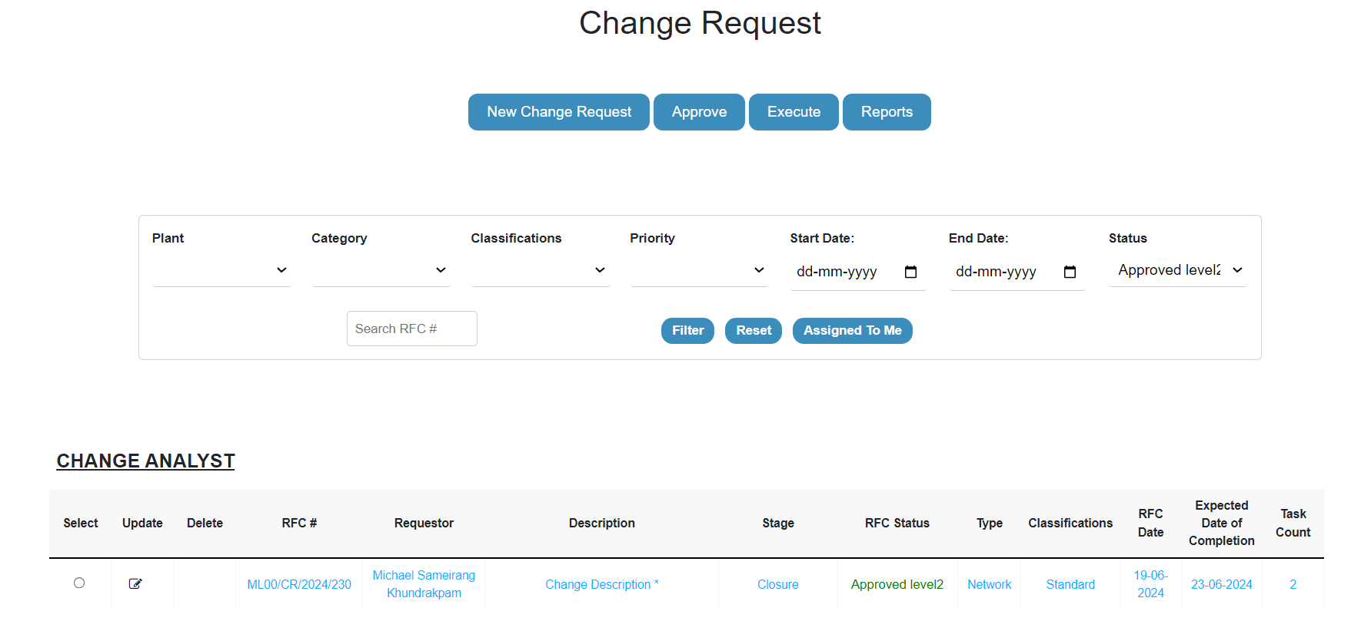

Now we are in the Closure approver level 3 phase, you can see that the approver level 1 colour and 2 has changed from blue to green. As the level 2 approver, you will not have access to approve the level 3 and will not be able to see the following buttons- Approve and Reject. So, the following CR must be approved by level 3 approvers.

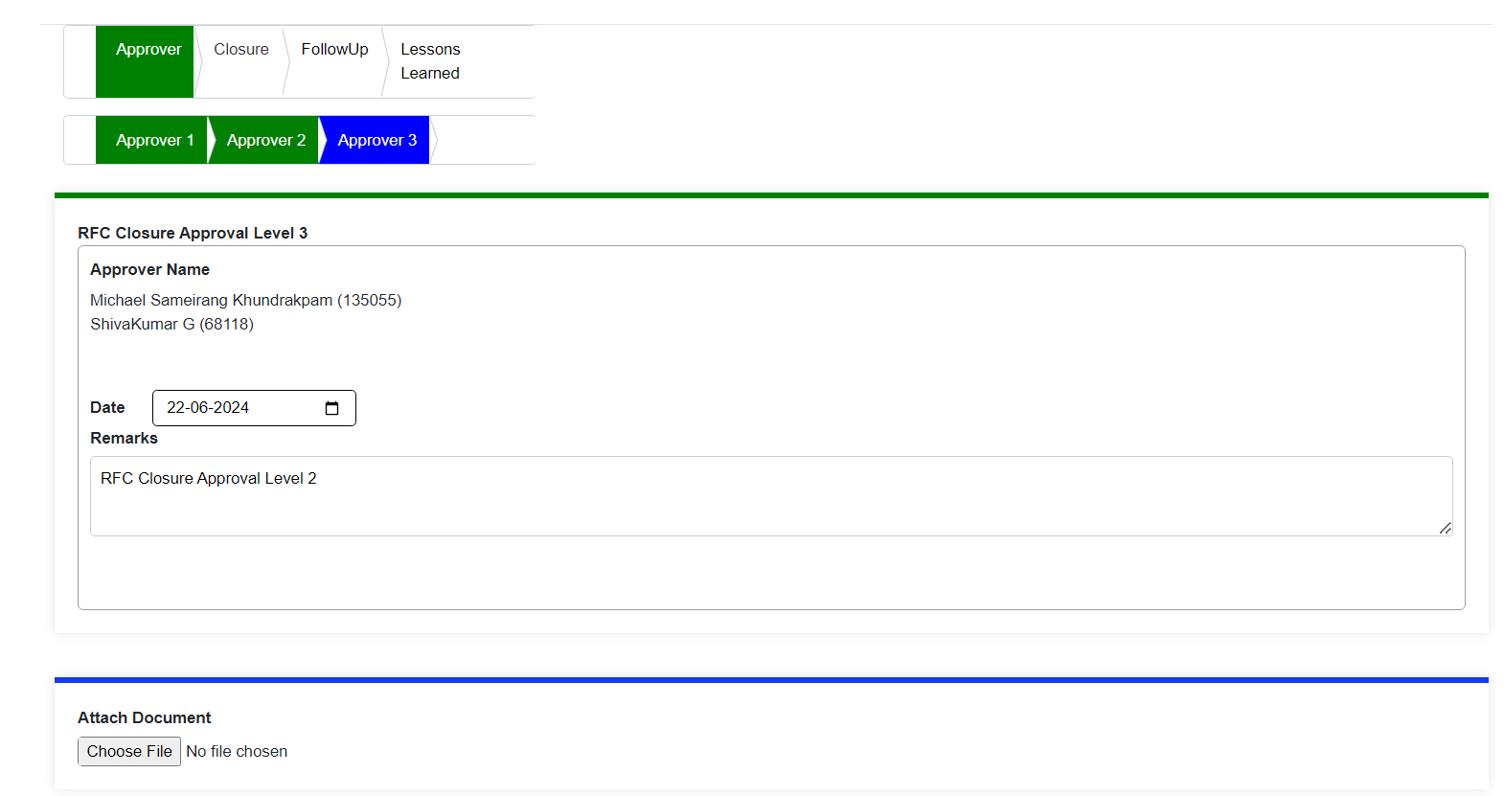

Once the level 3 approver Capture the remarks and if required can also attach the documents then click on approve, and the remarks are saved and a popup message appears stating “Change ID 230: RFC Is Successfully Approved”.

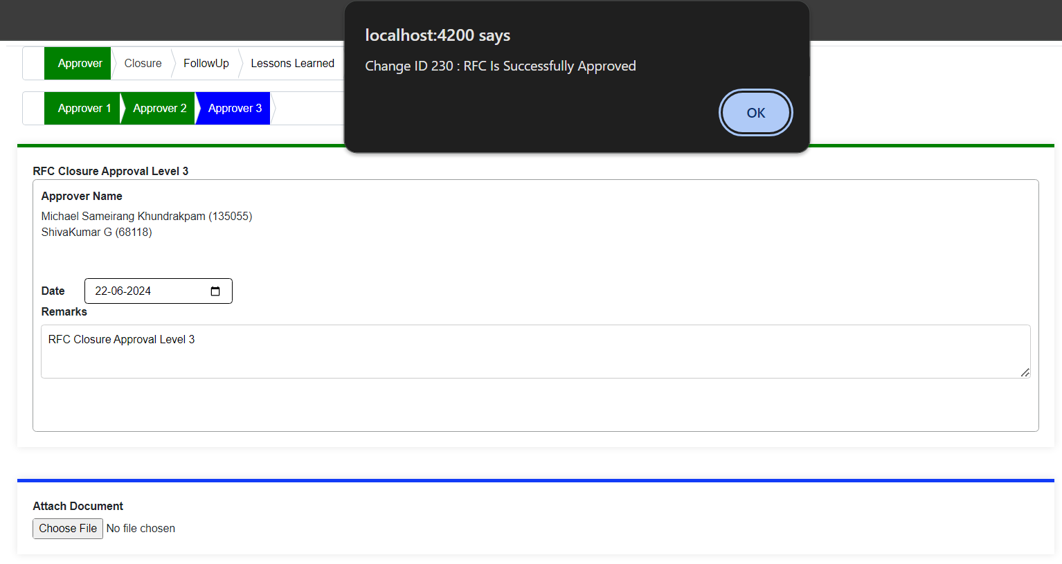

Once clicked on okay emails will get triggered to the Approvers, requestor and to CR owner with the current CR status.

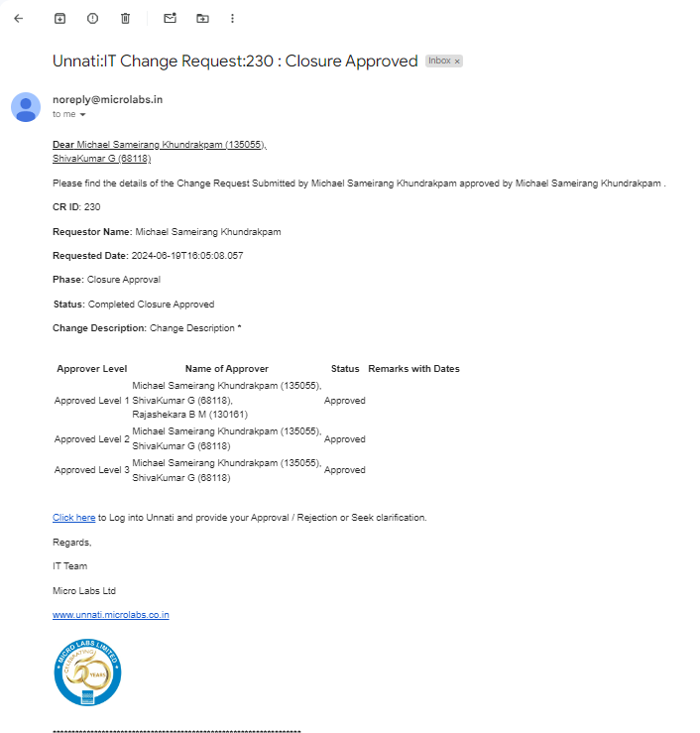

The CR's stage will shift to Closure and its status to Approved.

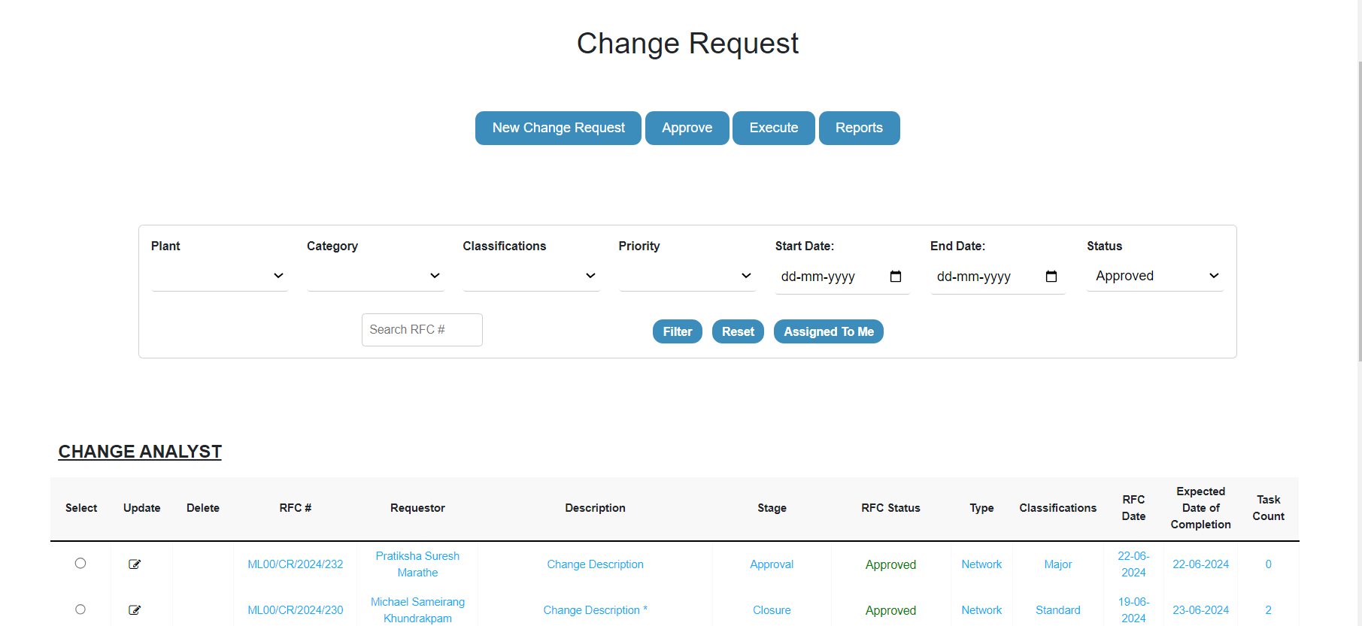

As the Closure Approver is done all the levels approver buttons has turned green in color which means that the closure approver level 3 is completed. we will move towards the closure functionality.

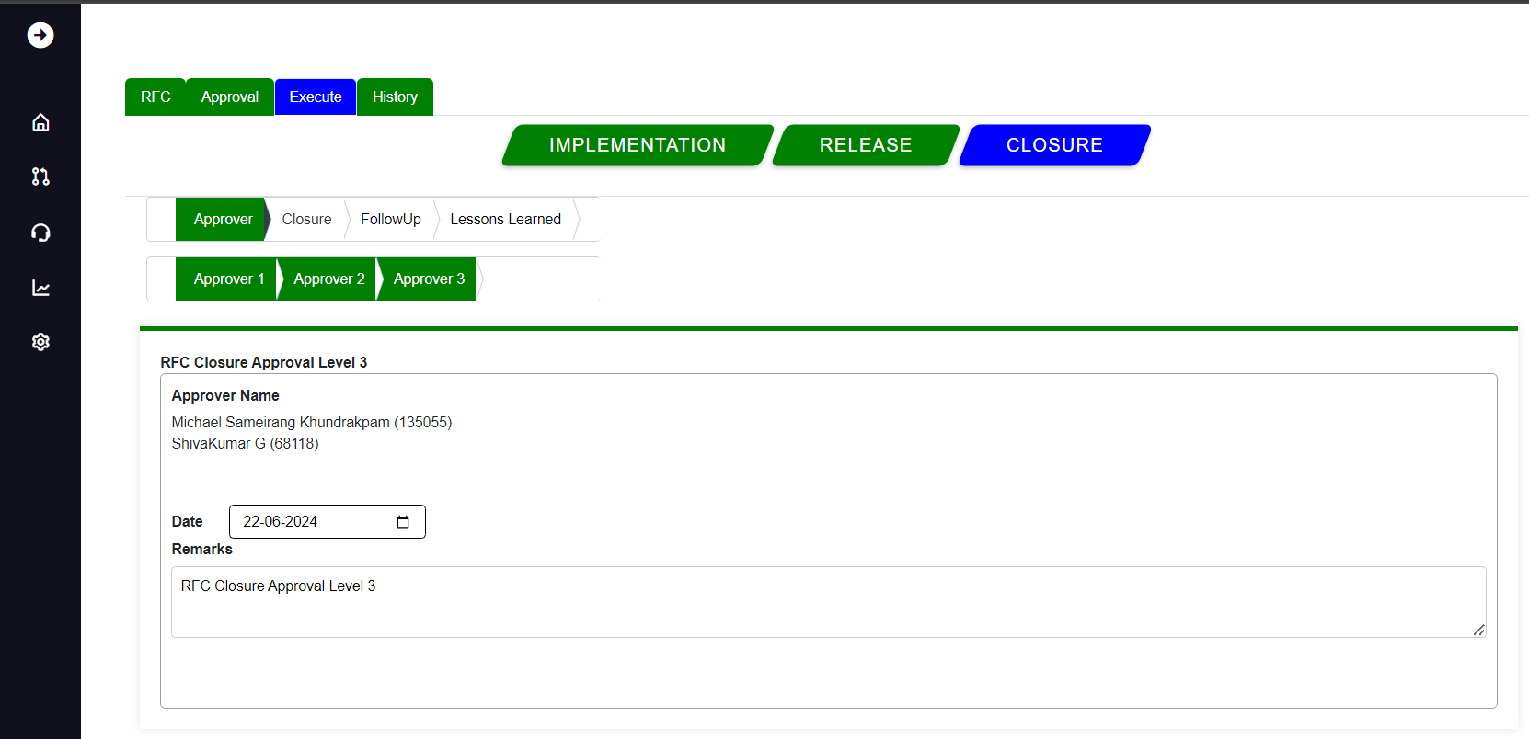

Once all of the approver levels have been completed, the Status has been updated to Closure, and the approver will no longer be able to process the CR; instead, it is submitted by the CR Owner/Initiator for closure, to do so select the particular CR and click on the execute, click on Closure button which is blue in colour then again click on Closure which is next to approver. Then it will give you a screen as given below.

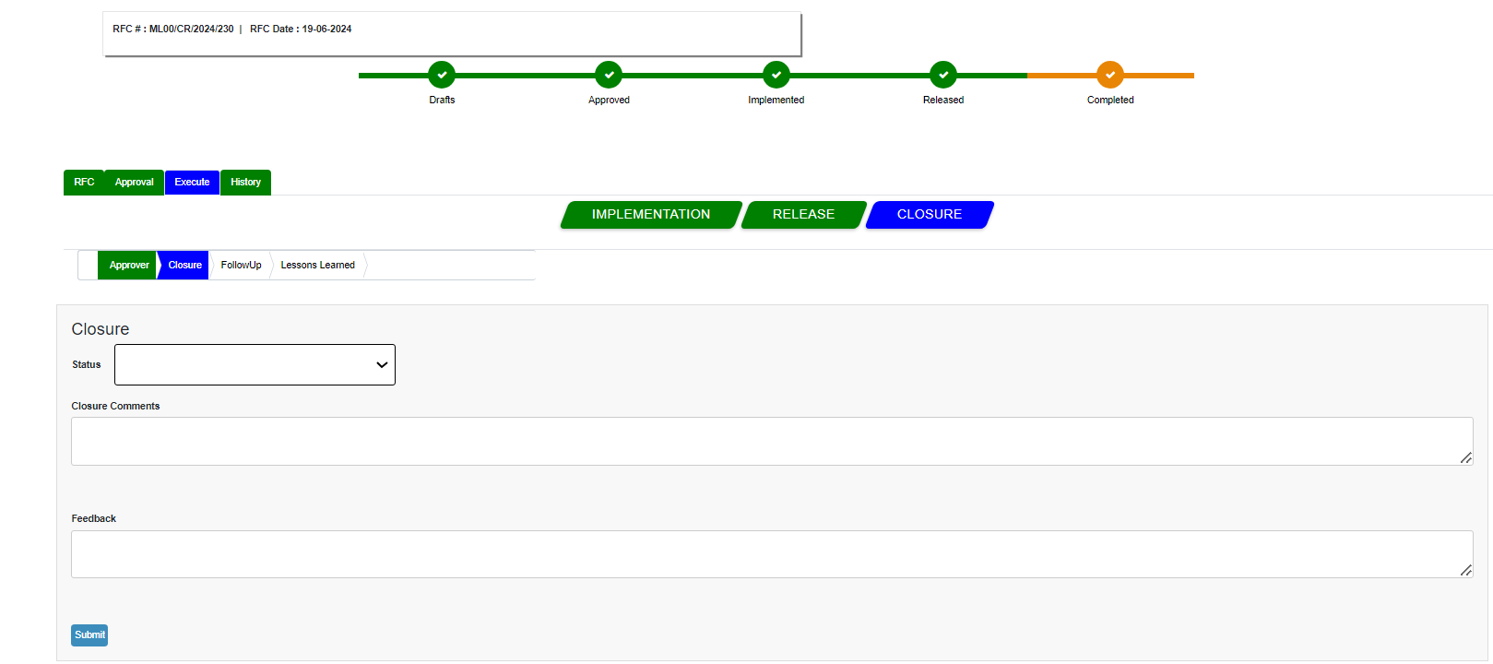

Here comes the final part of the particular CR where the Owner/Initiator Will close the CR by selecting based on Statuses in the Dropdown as shown below.

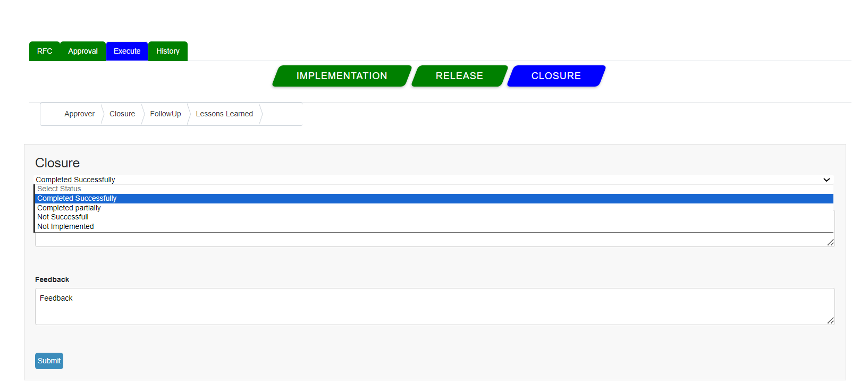

Once the closure is done based on selecting the Status from the Dropdown and capturing the closure comments and feedback as clicked on submit a popup message appears stating “Change ID 230: RFC Is Completed” as shown below.

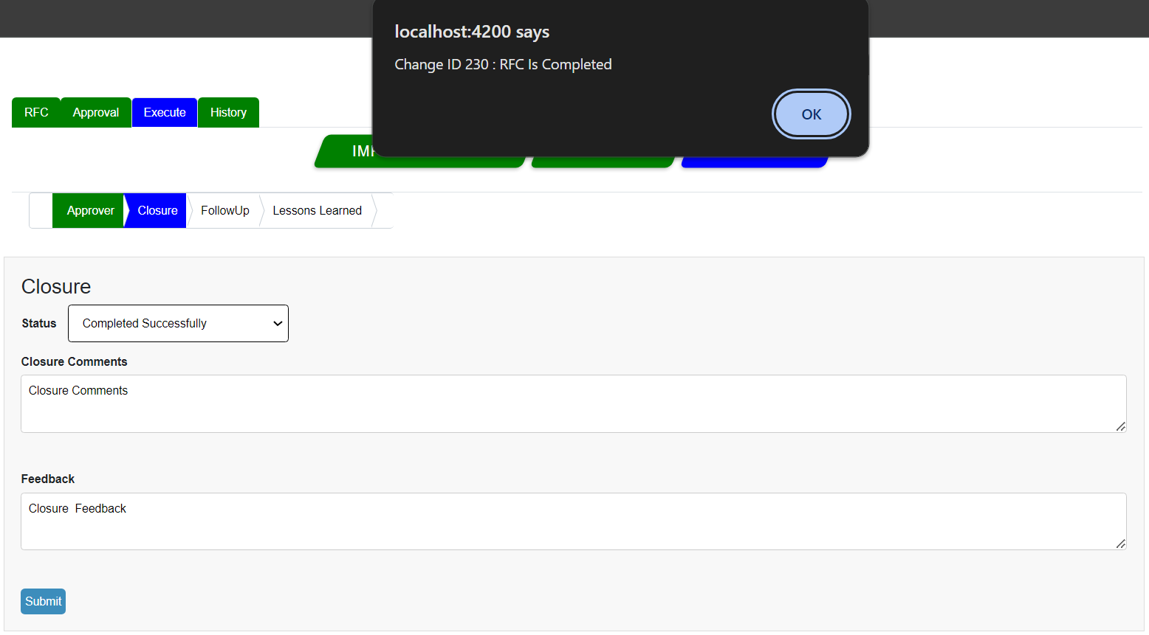

Once clicked on okay emails will get triggered to the, requestor and to CR owner with the current CR status.



The CR's stage shift to Closure and its status to Completed the status bar also get updated to completed as shown below.

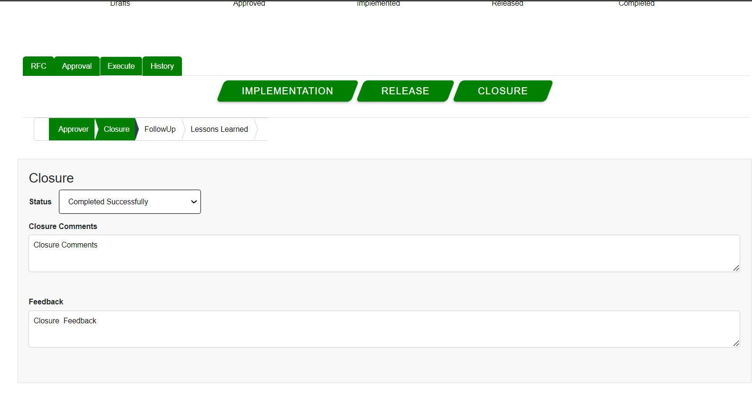

Once all the approvers levels are completed and closure is done the CR's stage will shift to Closure and its status to Completed.

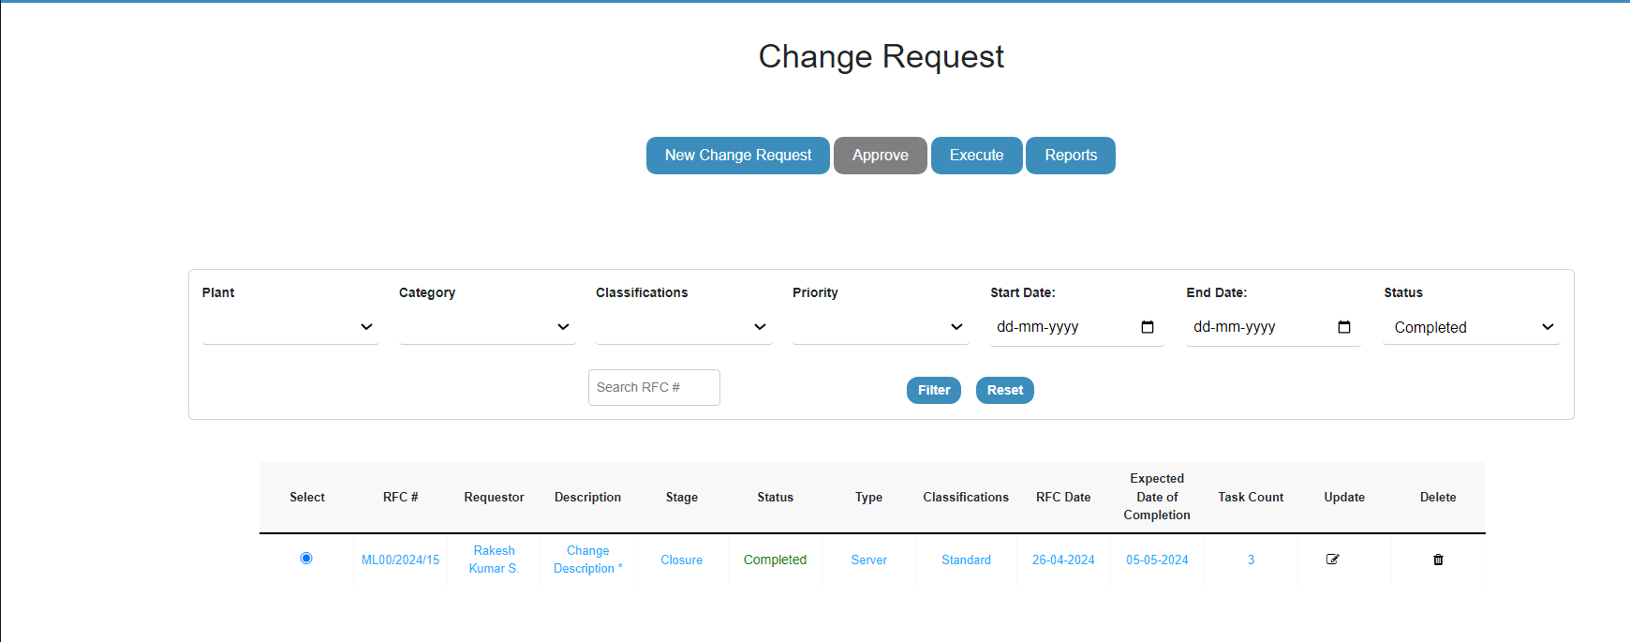

A support engineer can still do the follow-up on the same CR if have any and also can capture the Follow-up comments or the same and click submit button.

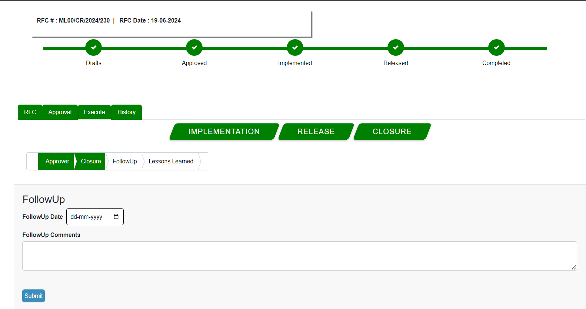

It will give a pop message saying follow up saved successfully.

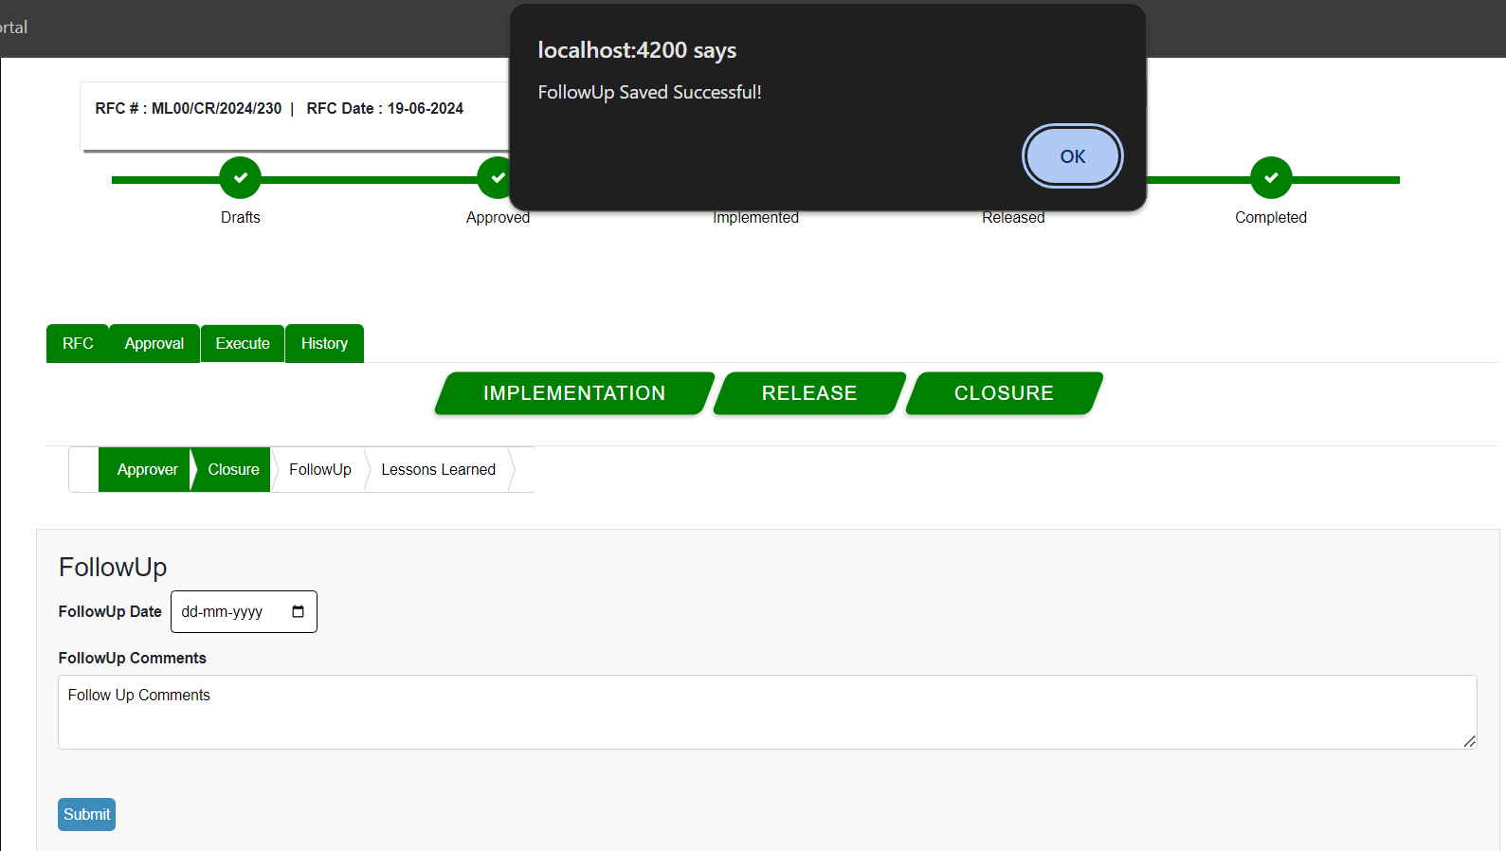

Also support engineer can also update lesson learned any also do add more by clicking on add Lesson button, user can also attach required document if needed.

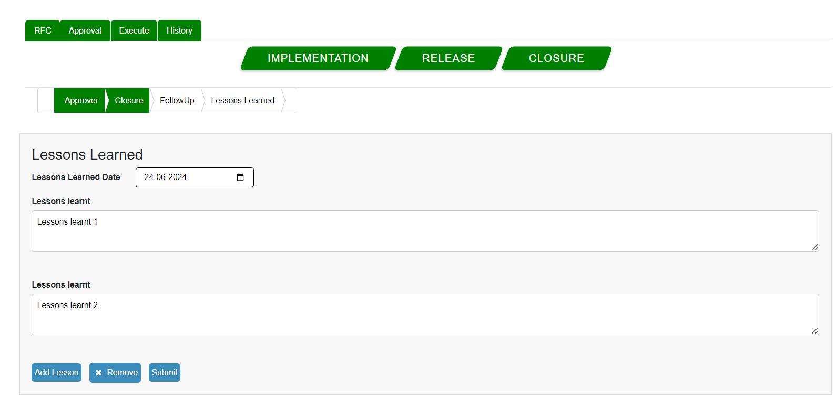

Once the all lesson learned submitted by the User it will give a pop up message saying lesson saved successfully.

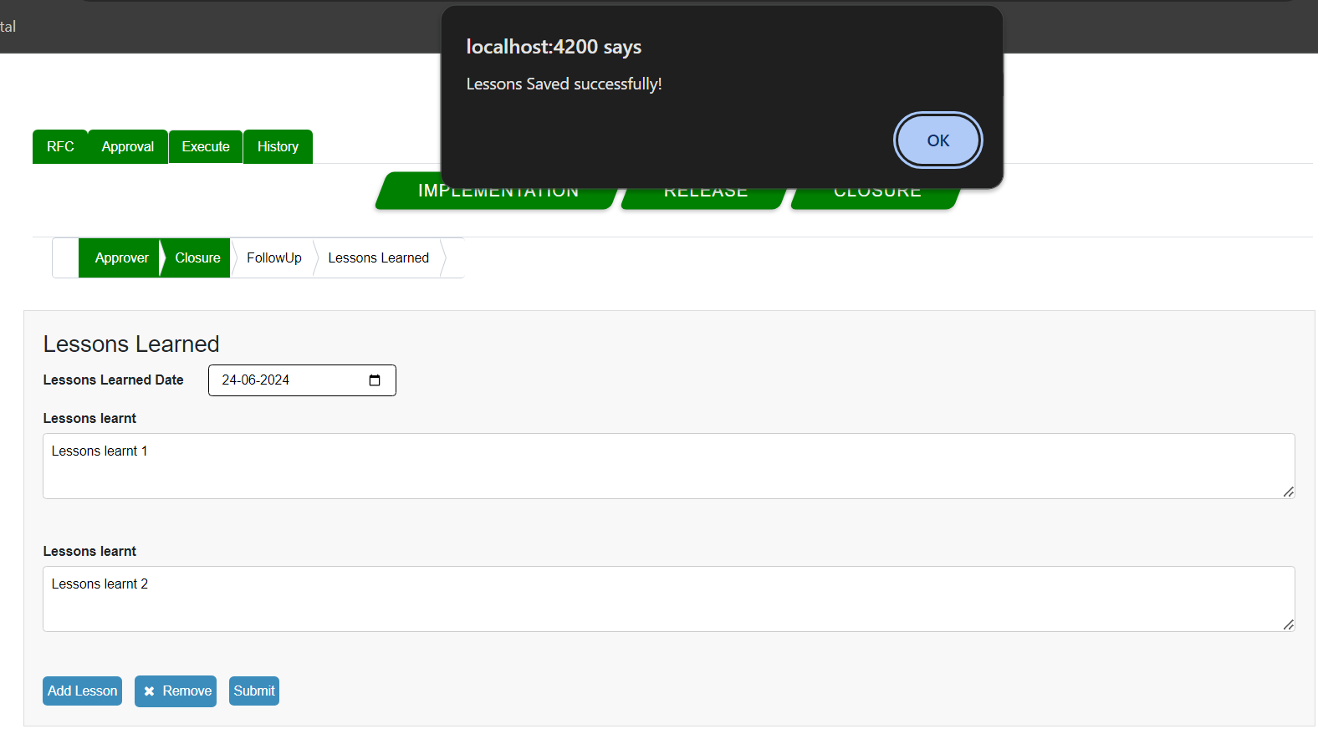

User can come and update the follow ups and lesson learned as many he wants.